The SOPs submitted to the challenge for each submission team are detailed in this document.

### DCE-NET Team SOP

**DCE-NET – *estimating DCE parameters with a physics informed neural network***

*P. Schouten & O.J. Gurney-Champion*

*Department of Radiology & Nuclear Medicine, Cancer Center Amsterdam, Amsterdam UMC, University of Amsterdam, Amsterdam, The Netherlands*

**General remarks**

- Our code is written in Python, thus an installation of Python is required (<https://www.python.org/downloads/>).

- Anaconda is recommended, so packages dependencies are easily installed (<https://www.anaconda.com/products/individual>).

- General information about anaconda environments: <https://docs.conda.io/projects/conda/en/latest/user-guide/tasks/manage-environments.html>

- The data set can be downloaded from the OSIPI website (<https://osf.io/u7a6f/>).

- It is highly recommended to run our program on a system that allows parallelization on multiple CPU cores and has CUDA enabled on its graphical card. Failure to do so will slow down the training and interference process of the neural network severely (<https://developer.nvidia.com/cuda-downloads>).

- Information about the population based AIF can be found here: <https://jnm.snmjournals.org/content/57/12/1843>.

**Disclaimer**

- Because the data set is large and we use a neural network approach, we load the data set as a whole in the computer memory, thus this Python script is pretty taxing on the memory usage (+64gb). If needed we can provide a version of the code which loads in the data per patient if the independent team runs in to memory issues. Please e-mail this request to [p.schouten@amsterdamumc.nl](mailto:p.schouten@amsterdamumc.nl) and/or [o.j.gurney-champion@amsterdamumc.nl](mailto:o.j.gurney-champion@amsterdamumc.nl).

- To allow quick evaluation on low resource systems, an option is included to use our per-trained neural network and pre-calculated concentration maps (see: *III.b in the guide*).

- To avoid any stochastic variations in the training of the neural networks and hence improve reproducibility, we have set a seed point for the random number modules of Pytorch and Numpy. Behavior with seed points can be version dependent, we thus advice Pytorch version 1.10.0 and Numpy version 1.19.2.

- For the ktrans maps Nifti files, an Identity affine transformation matrix is used.

**Guide**

**I. data set & dependencies**

1: Create a folder and unpack the OSIPI data sets with a folder structure similar to the names on the OSIPI website.

1.1: In the main data folder create two folders named: Clinical_Data & Synthetic_Data

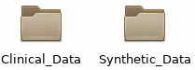

1.2: Unpack for example ‘Clinical_P1’ in a folder called ‘Clinical_P1’ and so on. Thus the folder structure should be ‘Clinical_Px’ and ‘Synthetic_Px’ with x the data set number. Move all the ‘Clinical’ folders into the ‘Clinical_Data’ folder and so forth for the ‘Synthetic’ folders.

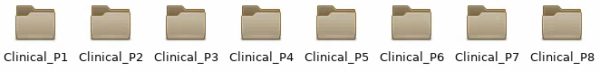

1.3: This should result in 8 clinical data sets each with 2 sub folders ‘Visit1’ & ‘Visit2’ and 2 synthetic data sets each with 2 sub folders ‘Visit1’ & ‘Visit2’, sorted by patient number.

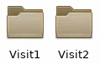

Note: All Visit 1 & 2 folders should contain folders with scan data.

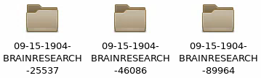

1: Unpack the zip file ‘DCE_NET.zip’ in a folder, the result should look something like this:



2.a: The dependencies are incorporated in the conda environment ‘dce_env.yml’ and can be found in the ‘DCE_NET’ main folder. Installation via this yml is tested on a Linux Red Hat system, but should work on Windows as well. After the installation of the Anaconda distribution:

- install the conda environment via:

- ‘conda env create -f dce_env.yml’

- browse to the main folder of the environment and activate in the console via:

- windows/linux: ‘conda activate dce’

2.b: The dependencies are also listed in ‘dependencies.txt’ and can be installed with ‘pip install [package name]’ as an alternative to the anaconda environment.

**II. running the program and enabling the conda environment**

1: To run the program open a console and follow the next steps:

- enter: ‘conda activate dce’ (or make sure python with the required packages is enabled if not running Anaconda)

- or enter: ‘conda activate <path to dce env>’

- browse to the DCE_NET folder where the python files are located.

**III.a training the network and make predictions *(default)***

1: this option converts the signal maps to the concentrations maps, trains the neural network and makes predictions for ktrans.

- enter: ‘python main.py’ or ‘python3 main.py’ depending on your Python version.

- note that two flags can be provided as input on the command line.

- ‘--njobs x’ where x is an integer that gives the number of cpu cores to parallelize the computation on. The default setting is 10.

- ‘--cpu’ to disable CUDA and graphic card computing. The default is CUDA enabled and recommended for speedy calculations.

- An example for 8 cores and no CUDA is:

‘python main.py --njobs 8 --cpu’

- Alternatively open main.py in a Python IDE, like Spyder, and press run to run the program under default settings.

**III.b make predictions on pretrained network and concentration data *(low system resources)***

1. This option uses pre-calculated concentration maps and our pre-trained neural network, which can be found in the ‘pretrained’ folder in the ‘DCE_NET’ main folder.

- enter: ‘python main.py --pretrained’ or ‘python3 main.py --pretrained’ depending on your Python version. This will automatically run on the CPU.

- this mode enables the interference on the concentration maps using our pre-trained neural network if your system resources are too low to run the full Python script *(contact us if questions remain about the procedure)*.

**IV. enter the OSIPI data directory**

1: A prompt will appear which asks you to select the main folder of the OSIPI data set. This should be the top folder containing all the ‘Clinical_Px’ and ‘Synthetic_Px’ sub folders. Click the directory and proceed. If the prompt fails, a command line input appears asking for the directory, enter it and press [enter]. Make sure the slashes / or \ are correct in the file pathway.

**V. ktrans maps location**

1: The resulting ktrans maps can be found in the ‘results’ map of the DCE_NET main folder after the program has finished.

*Feel free to contact us at* [*pschouten@amsterdamumc.nl*](mailto:pschouten@amsterdamumc.nl) *if anything is unclear.*

### Madym Team SOP

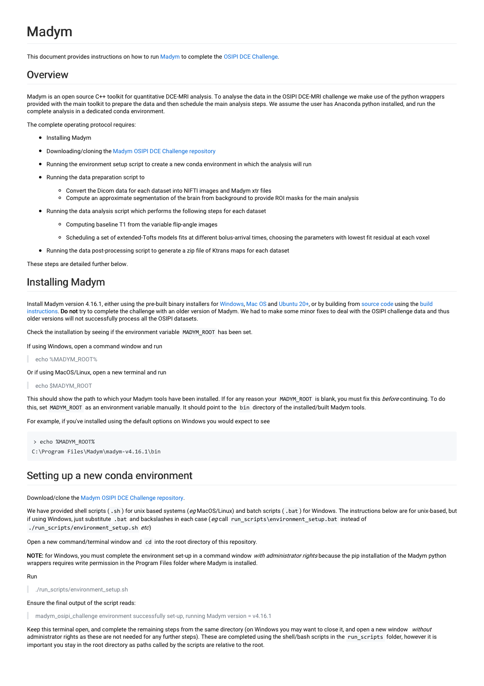

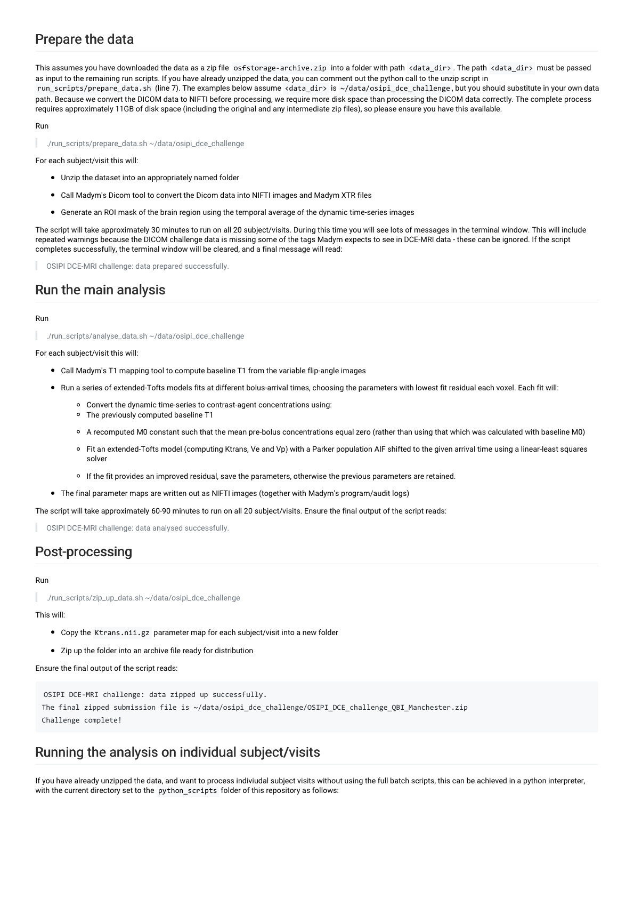

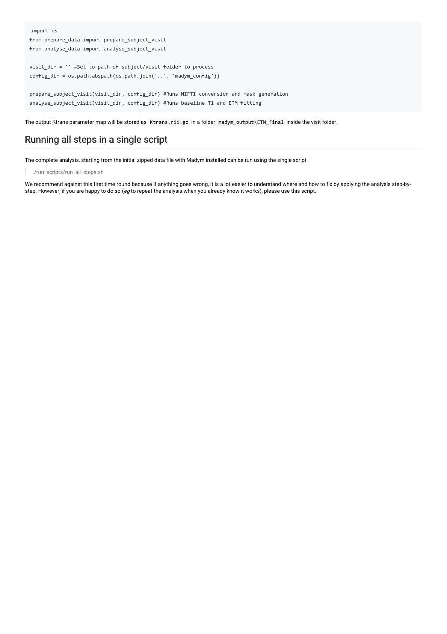

### PerfLab Team SOP

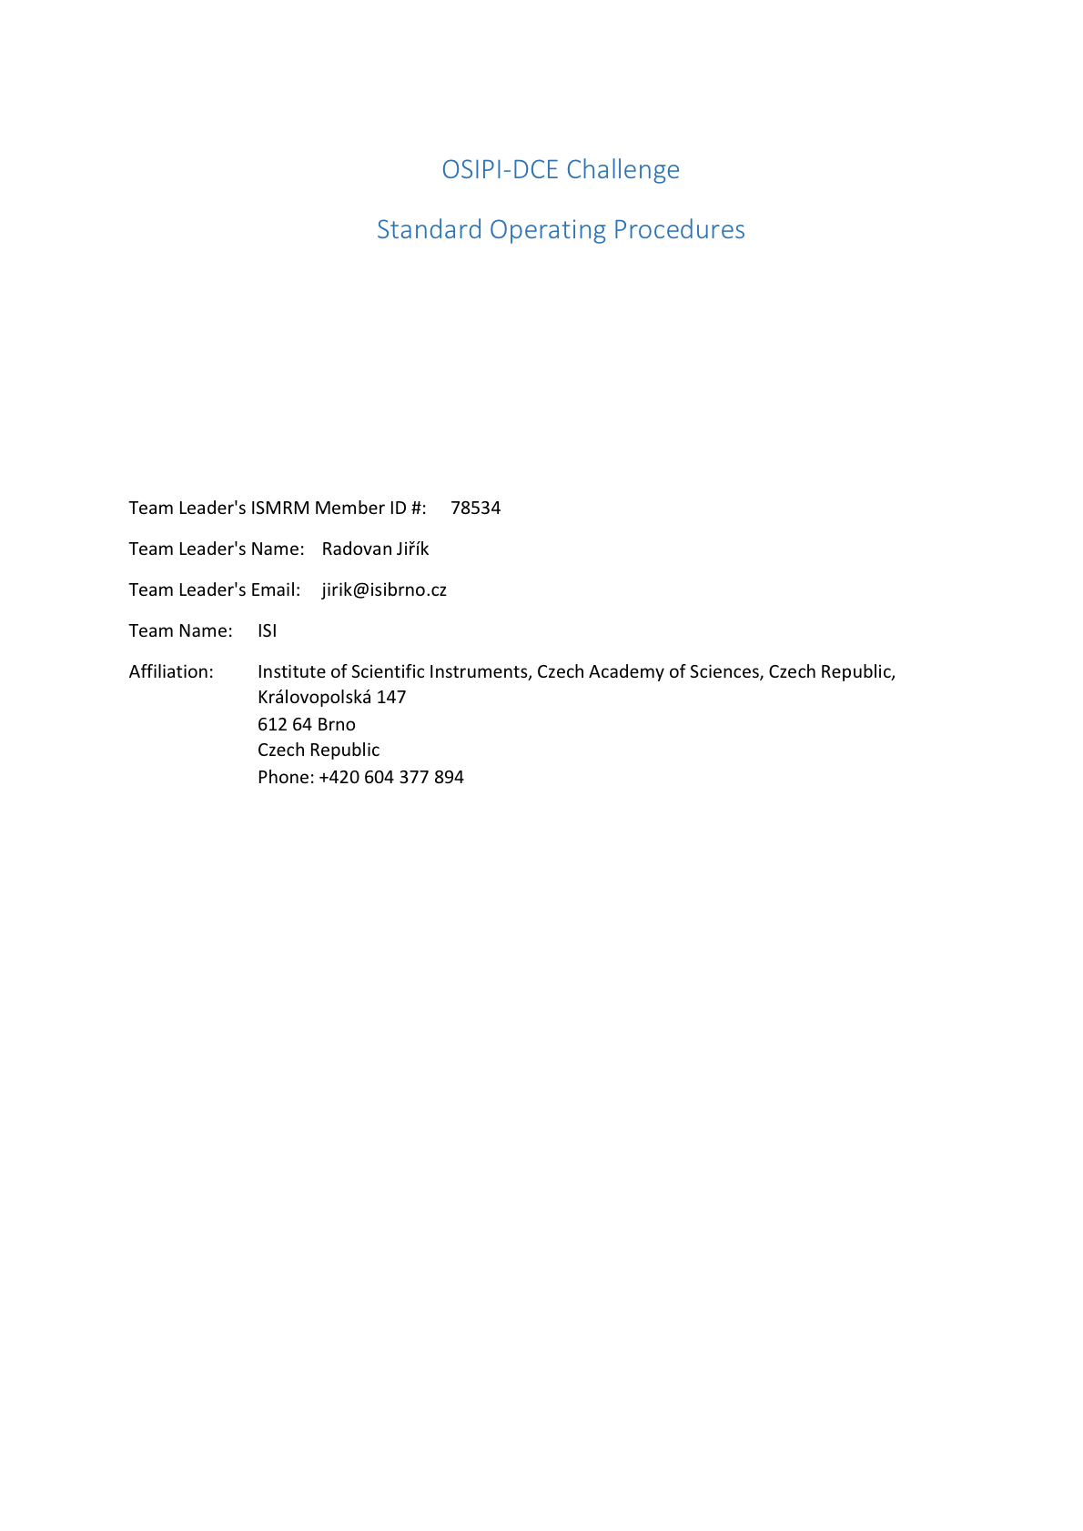

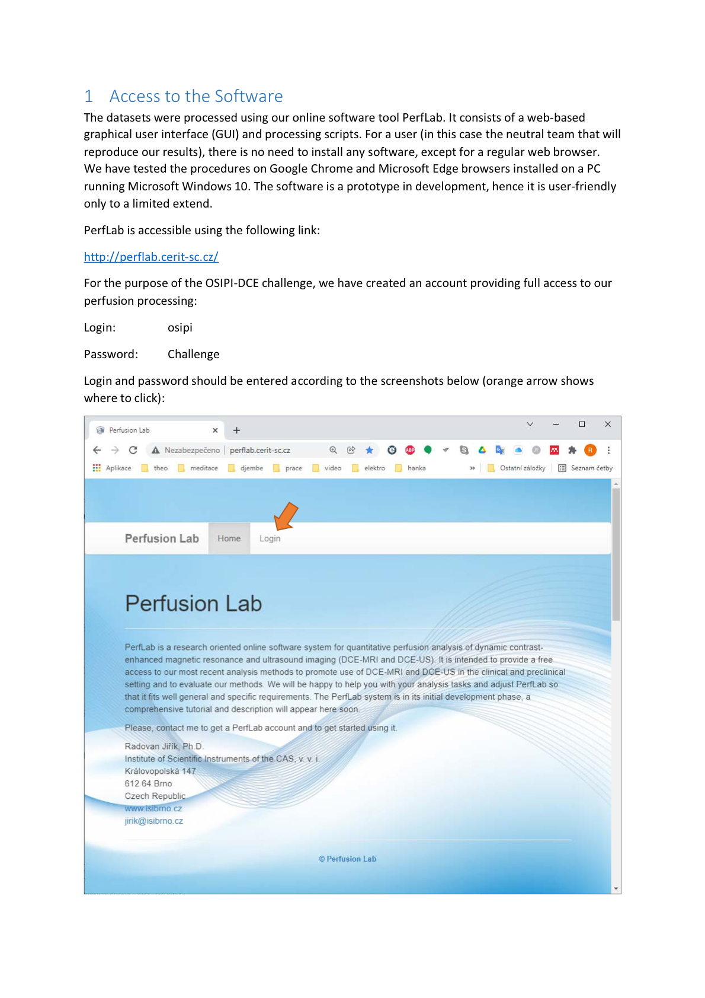

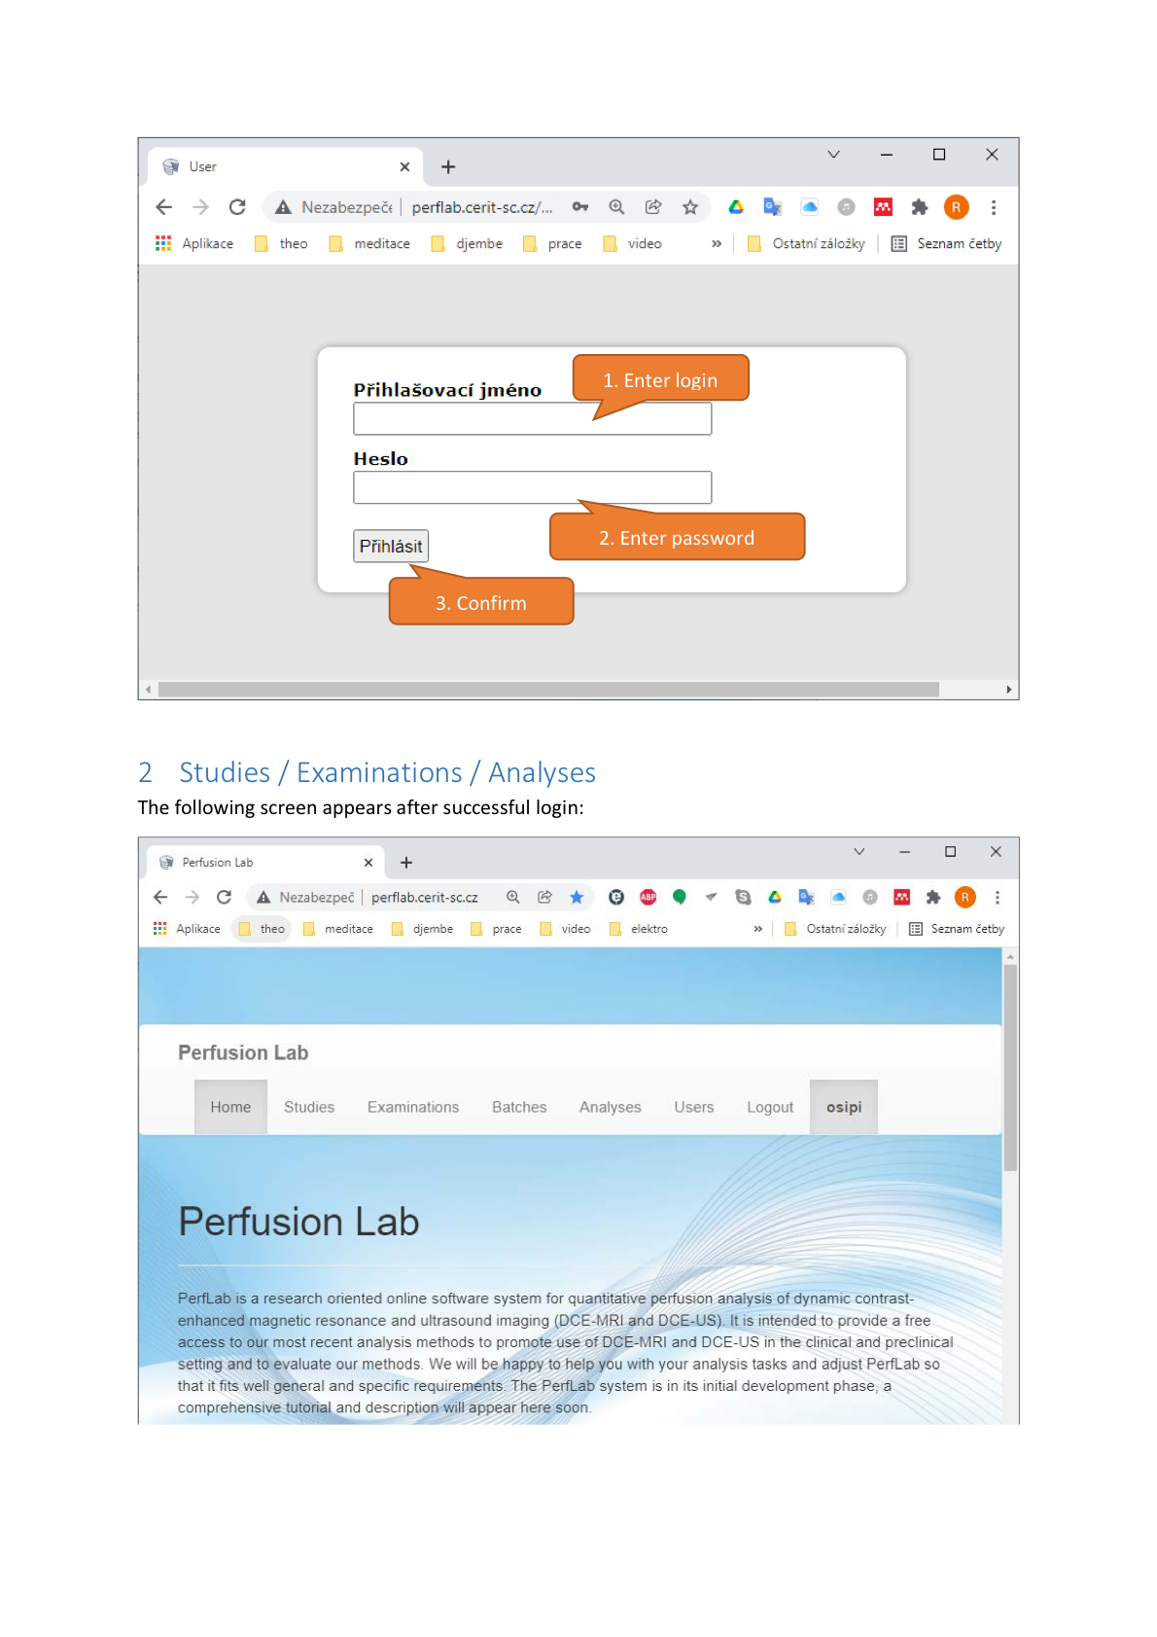

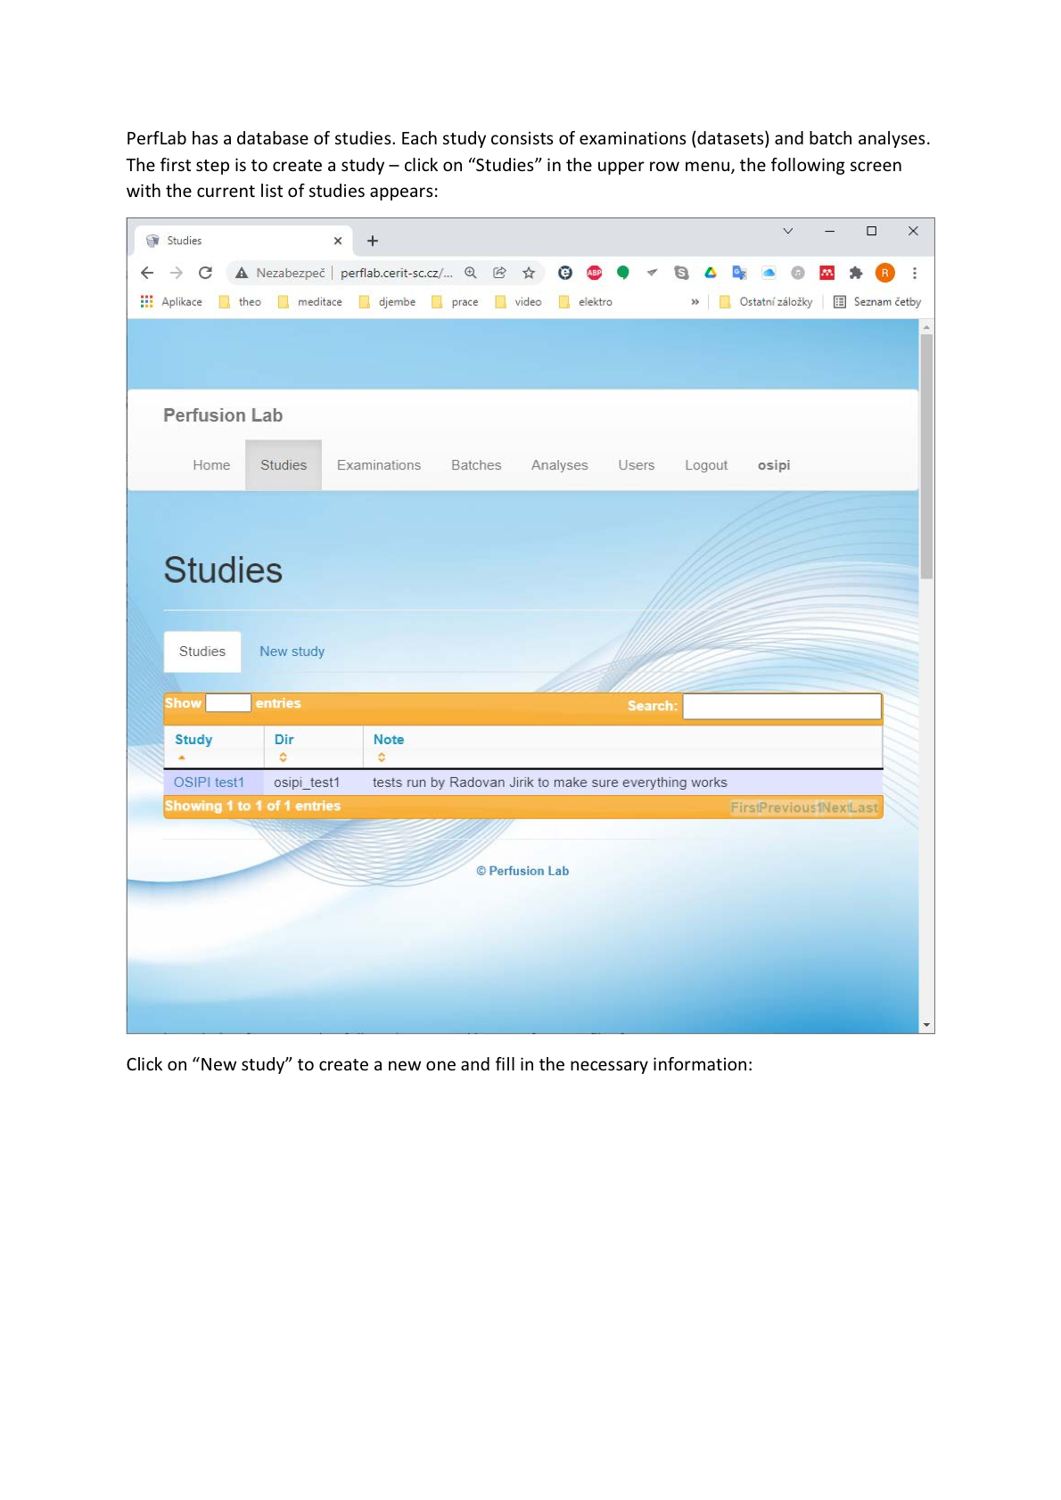

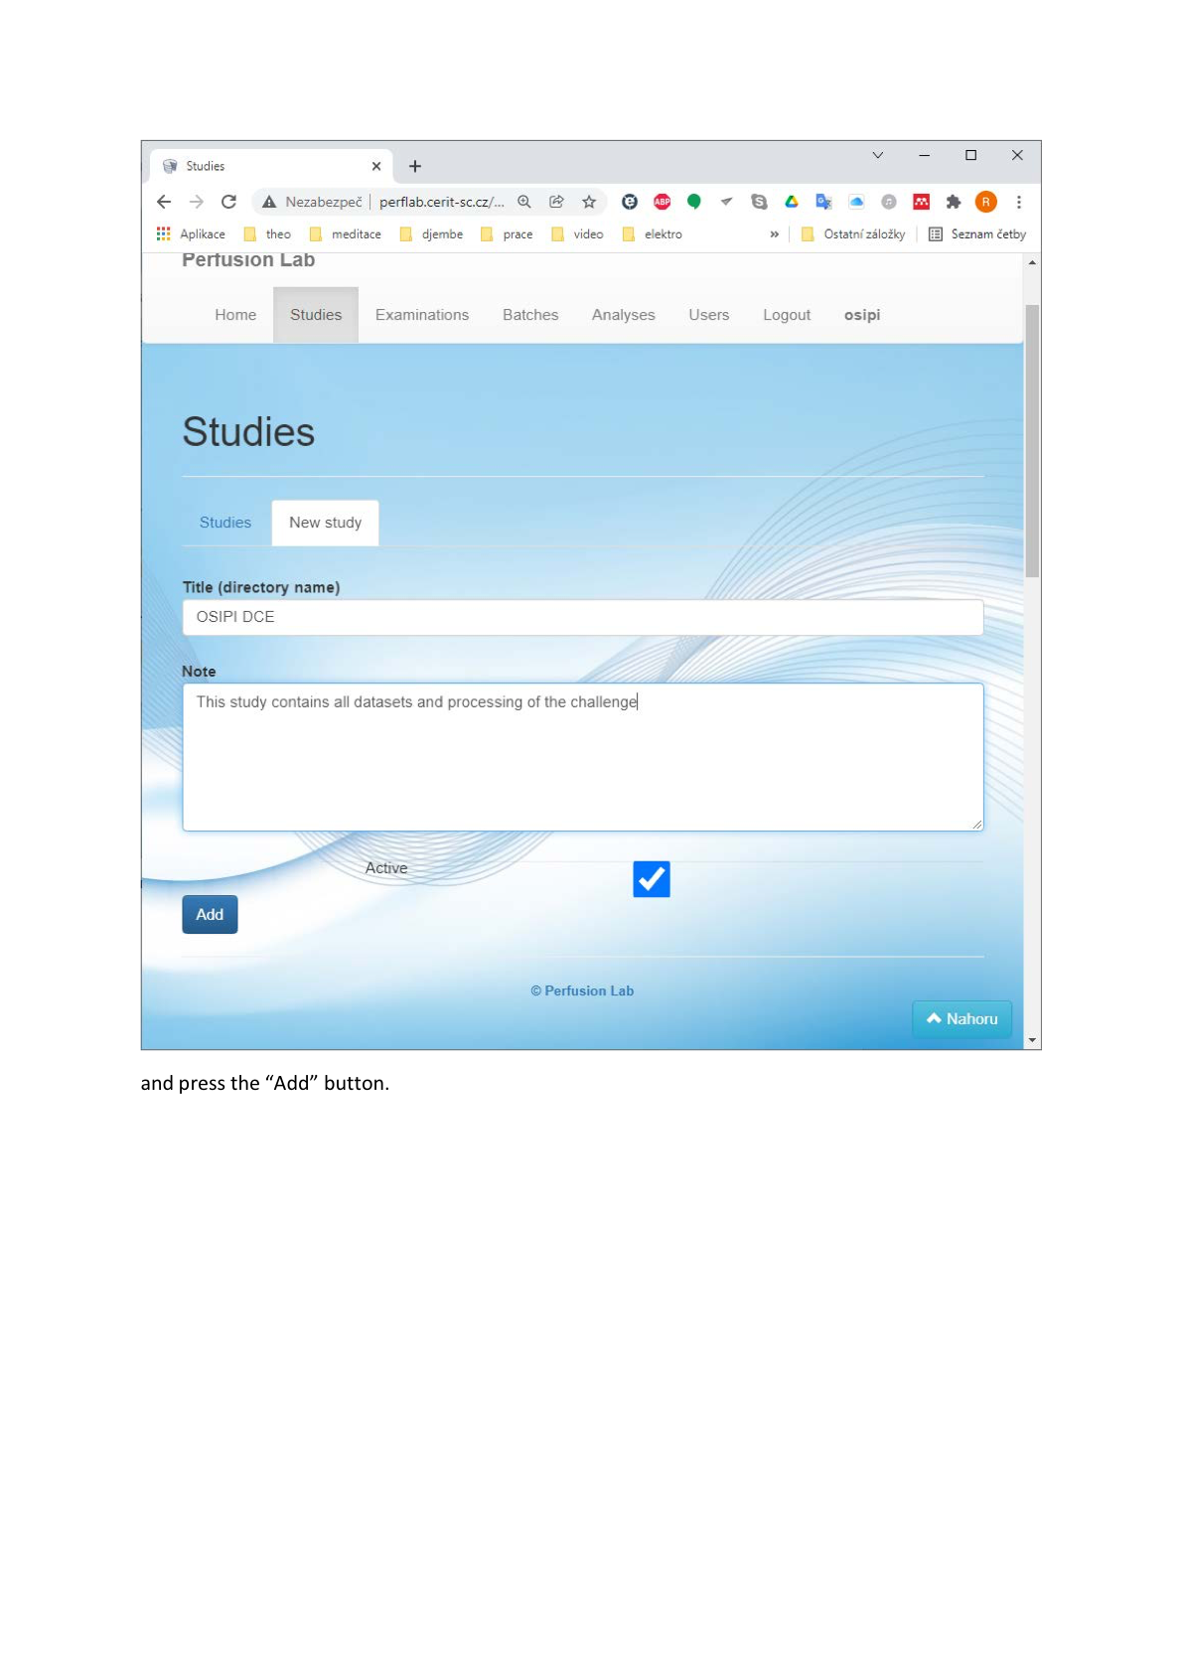

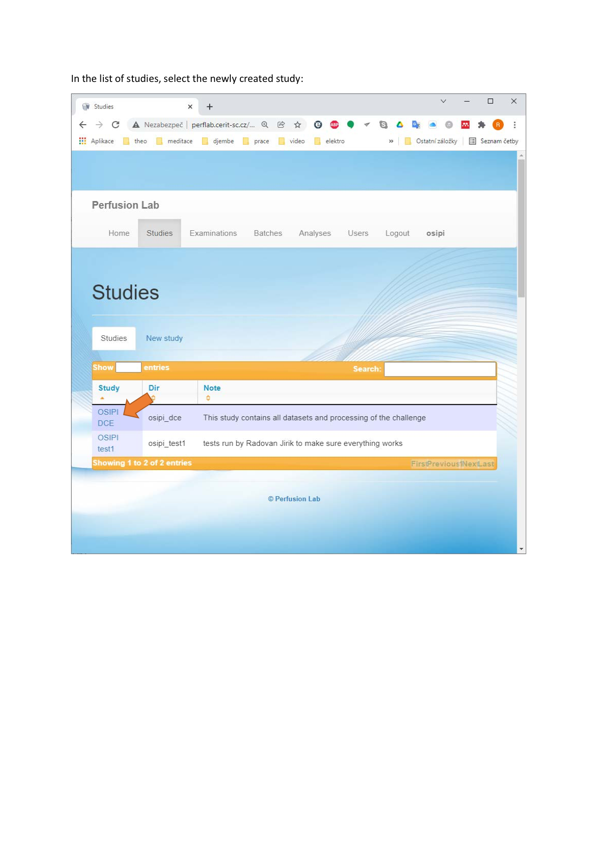

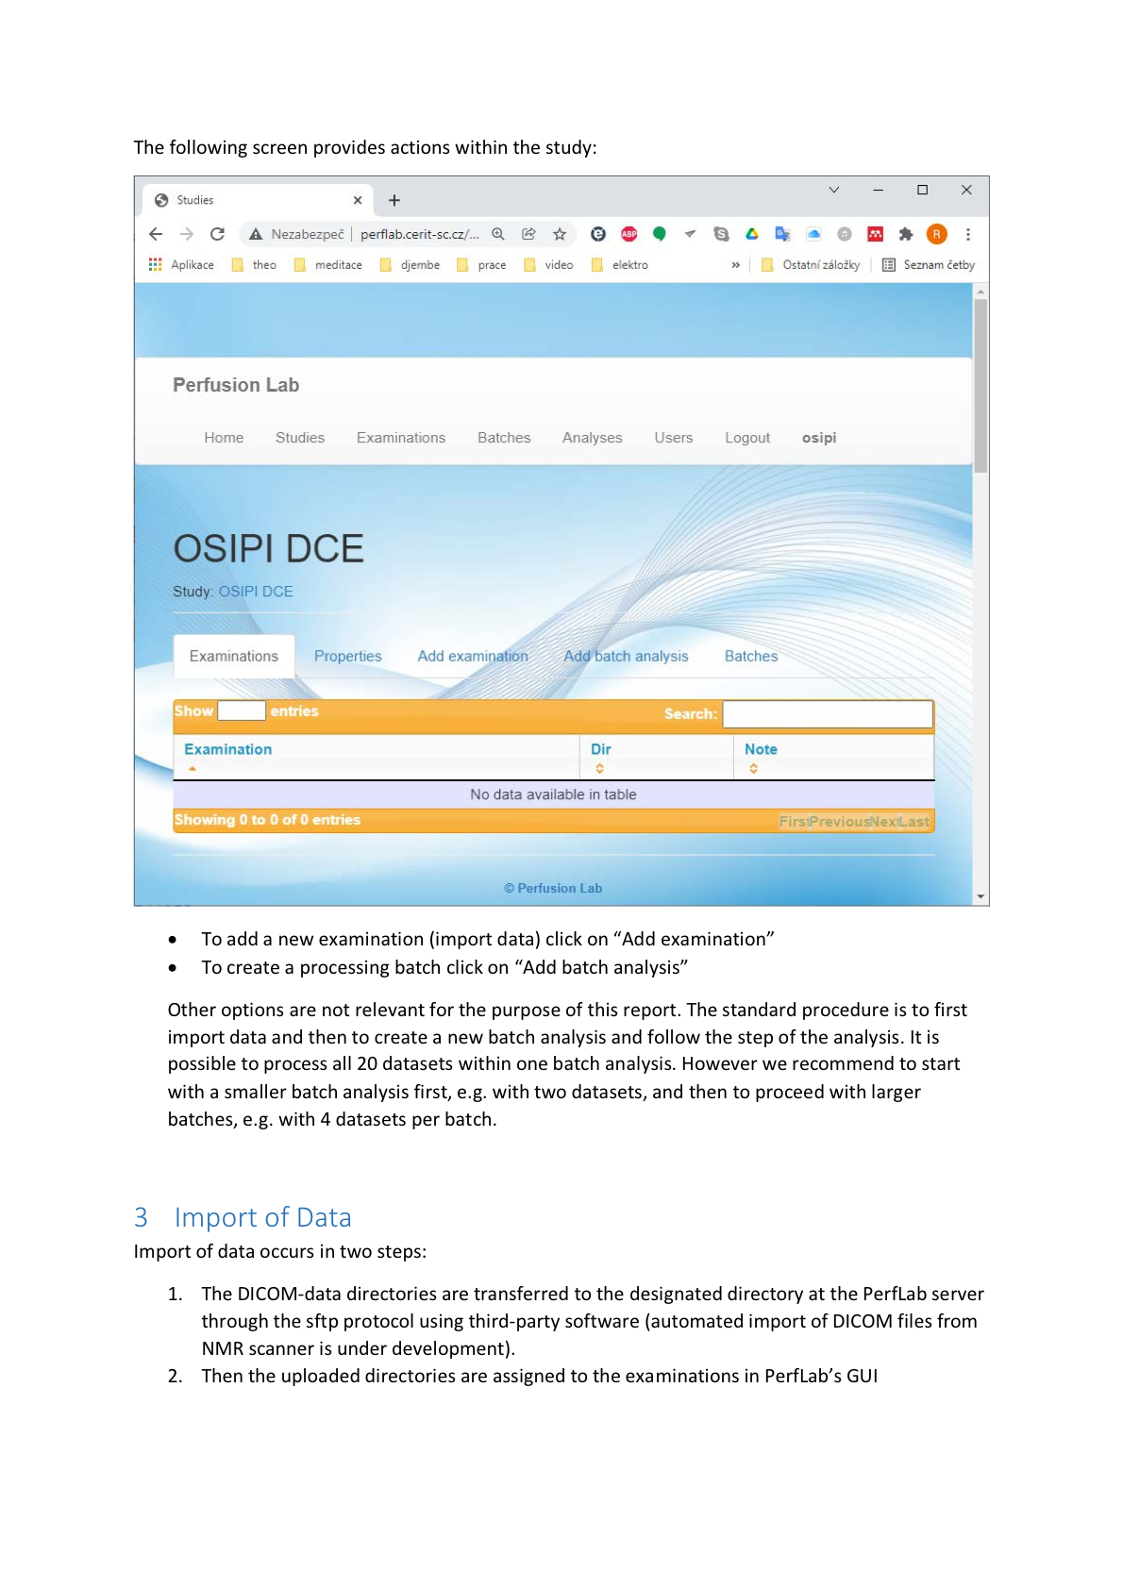

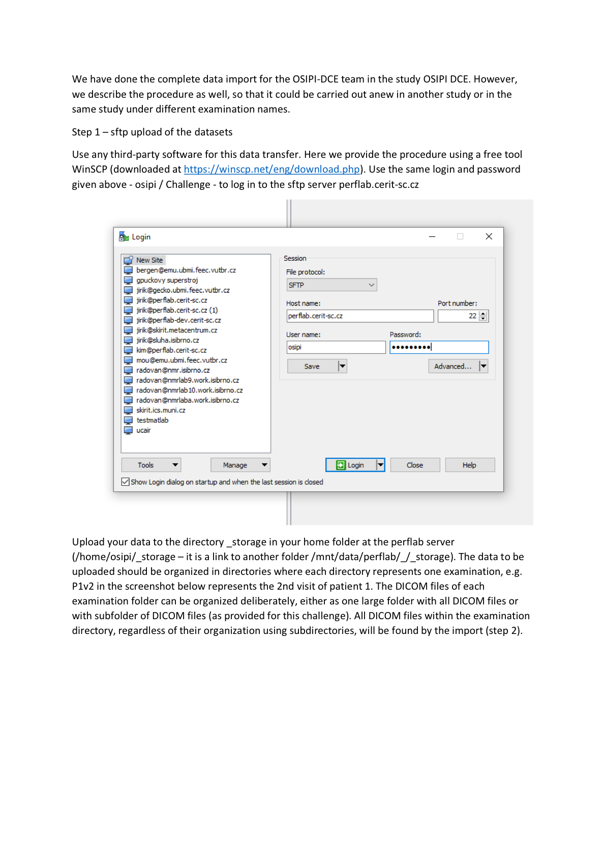

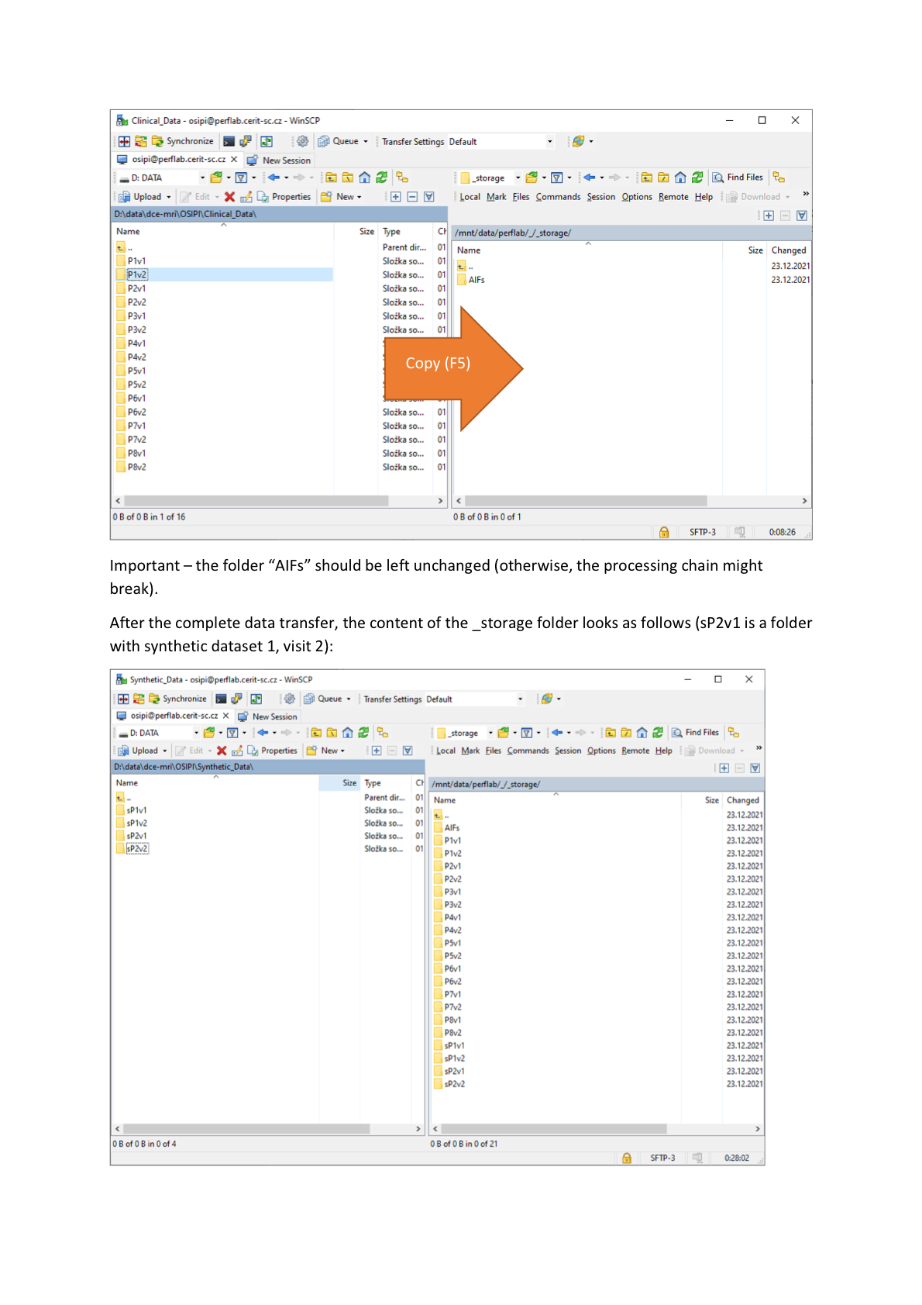

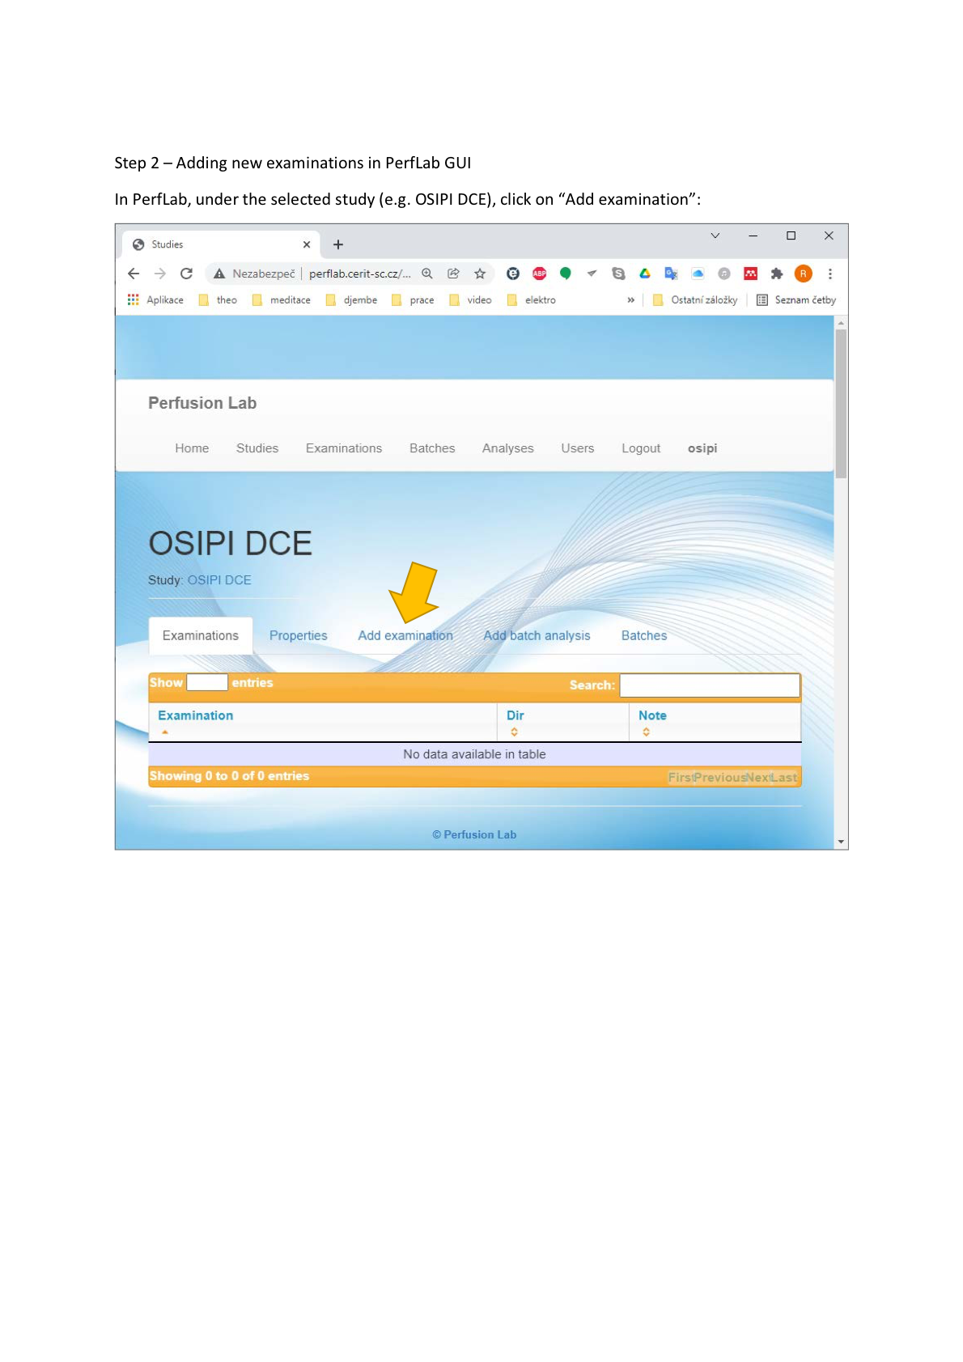

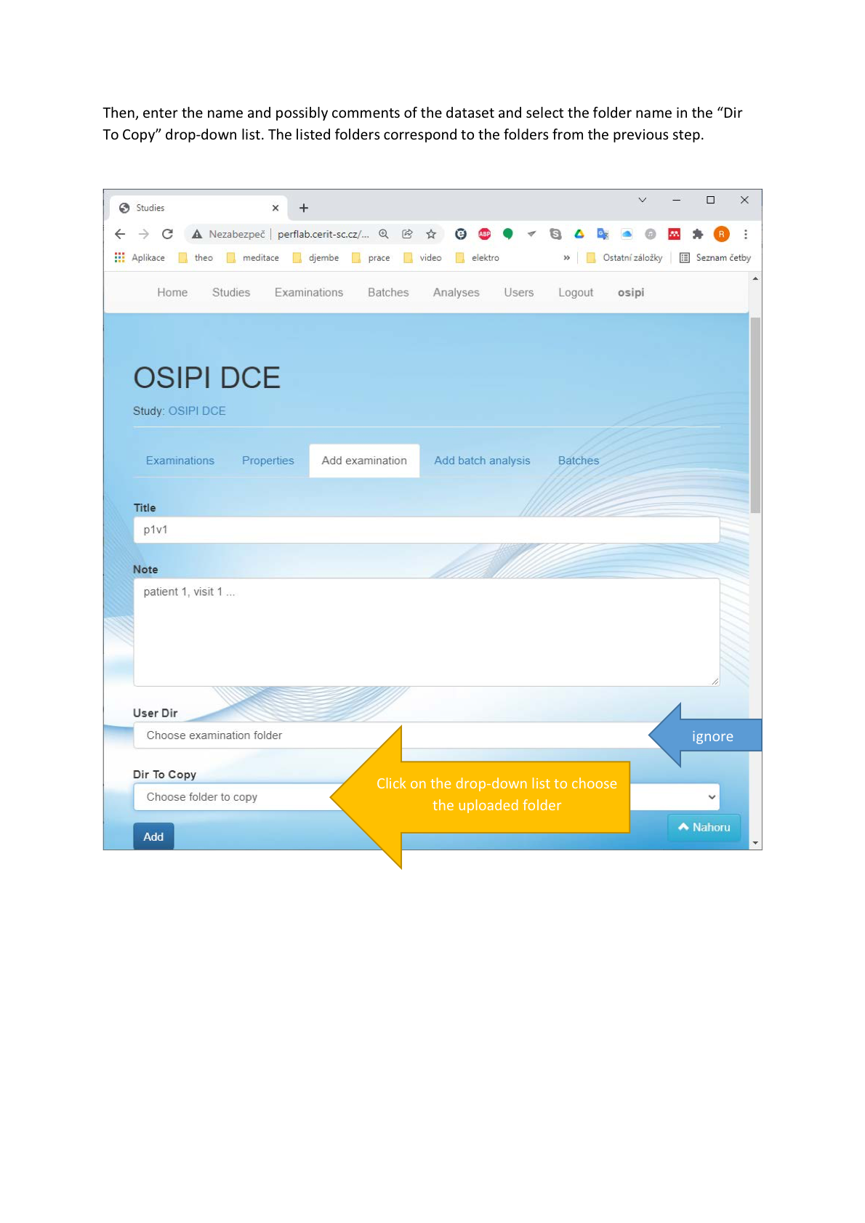

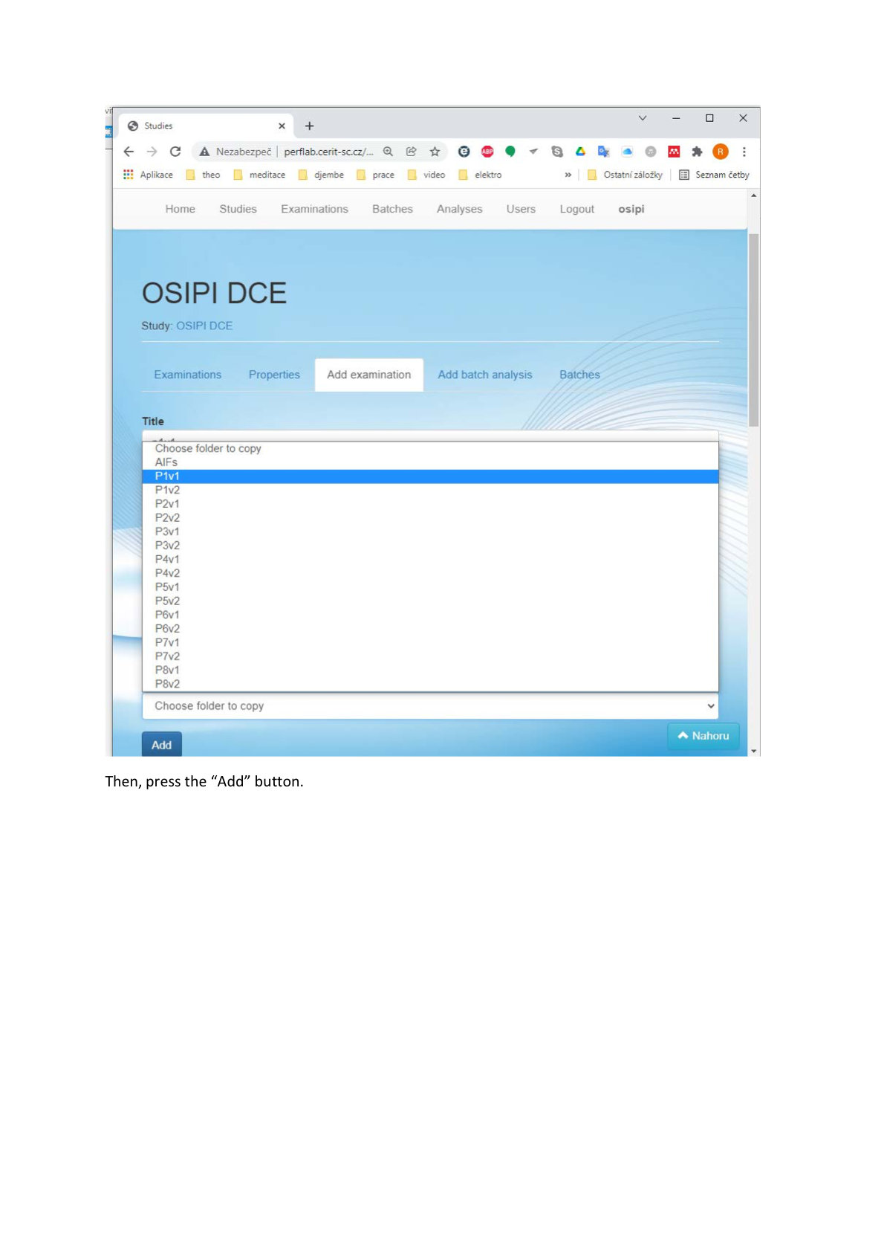

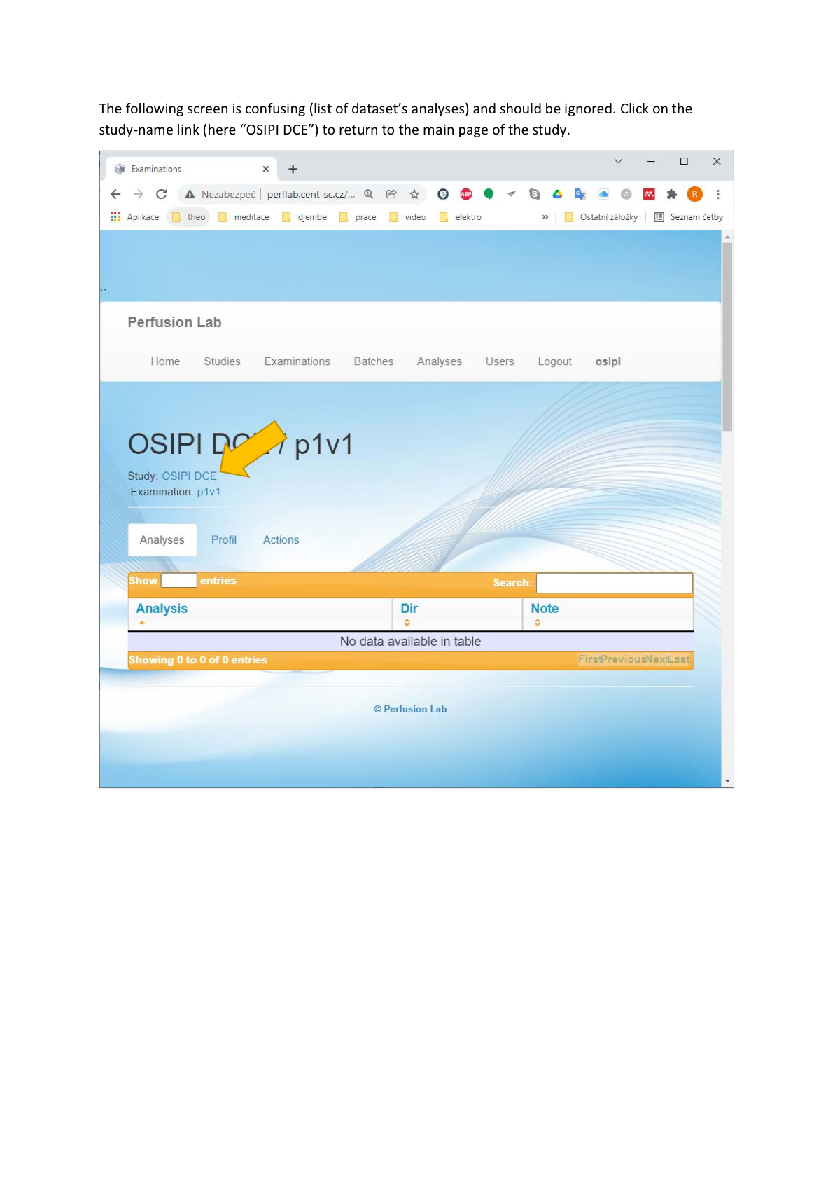

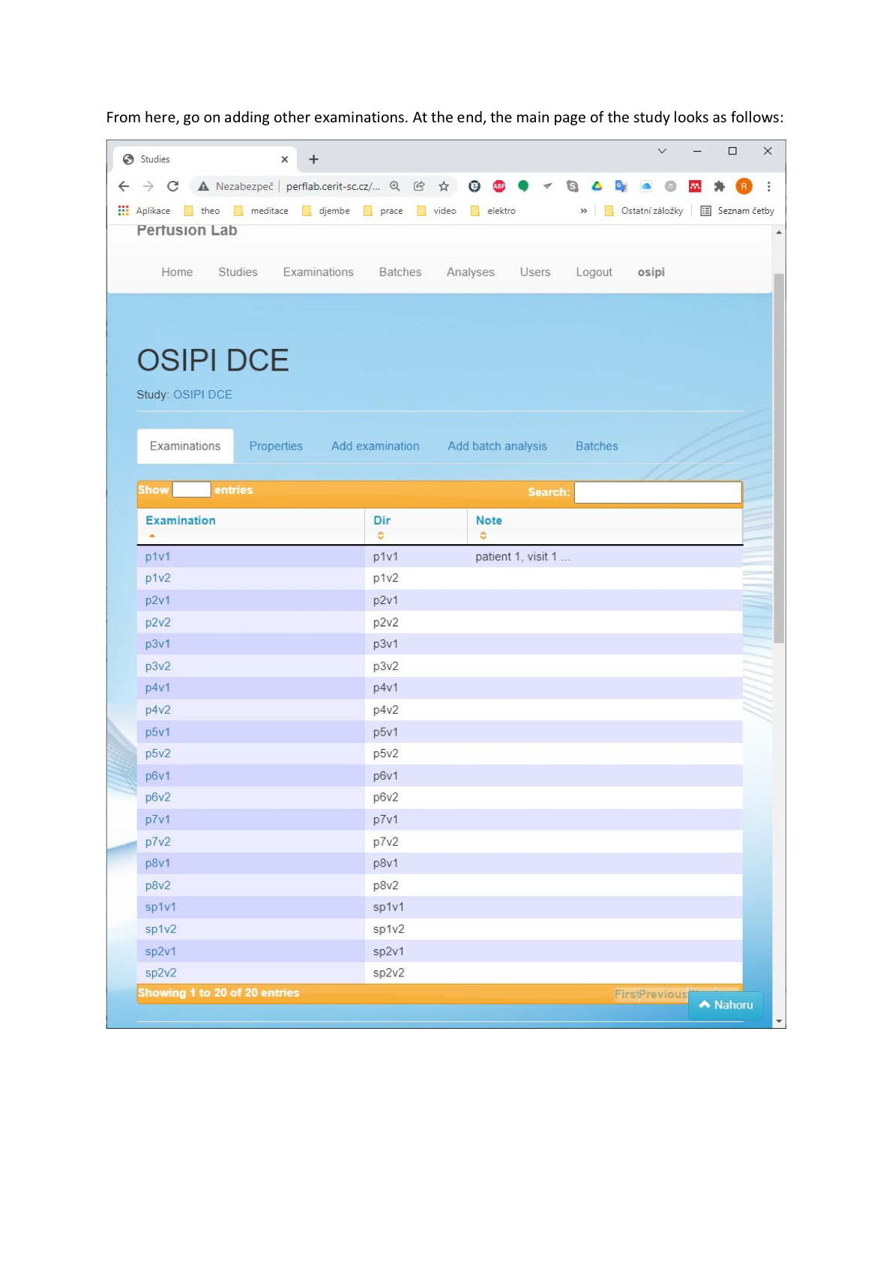

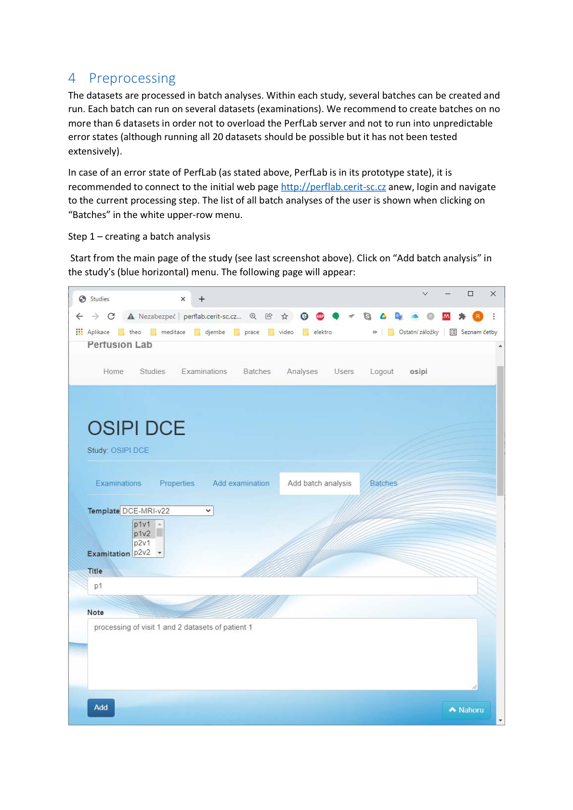

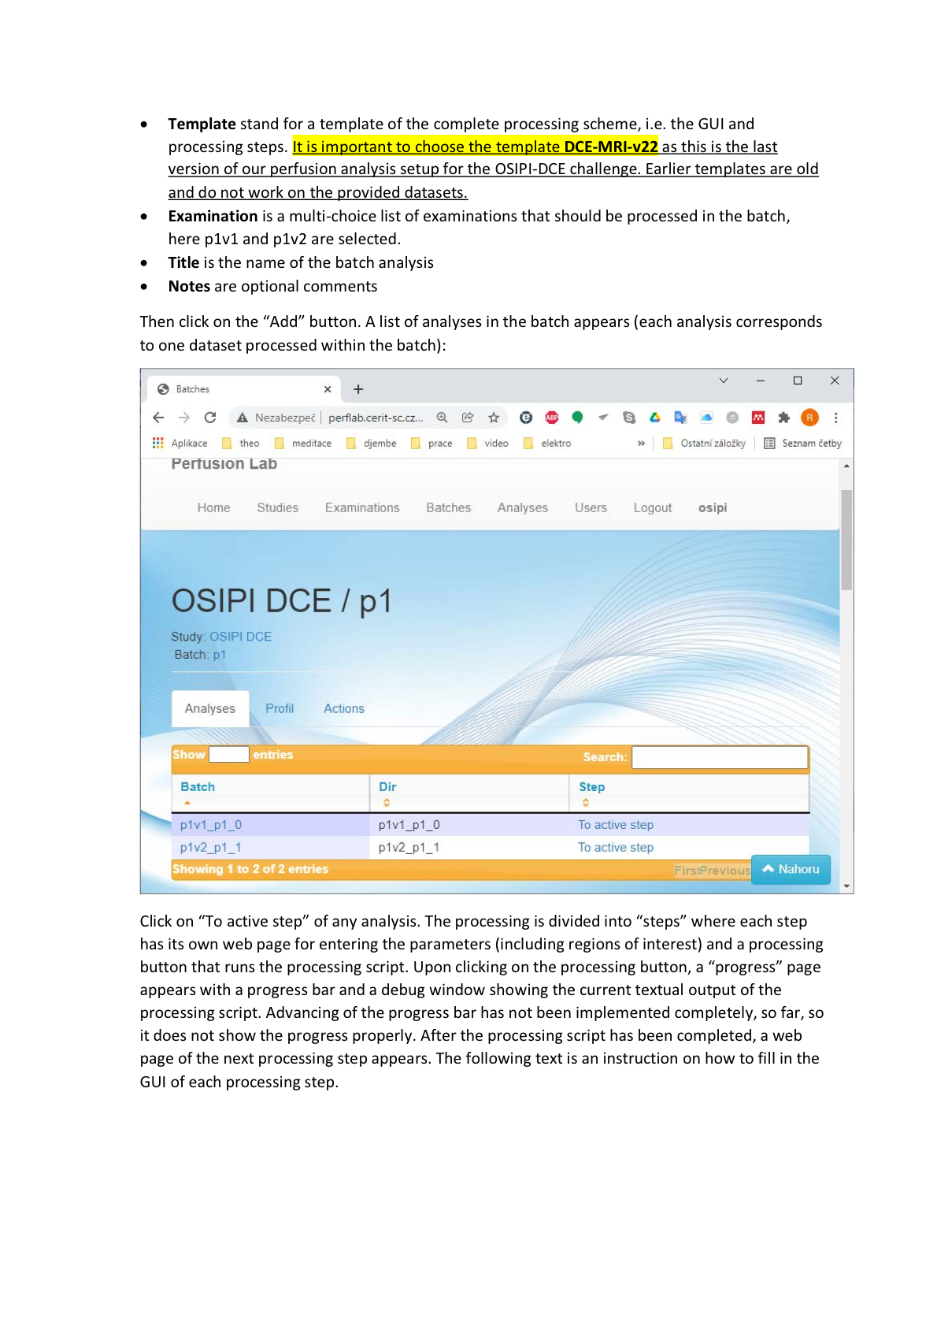

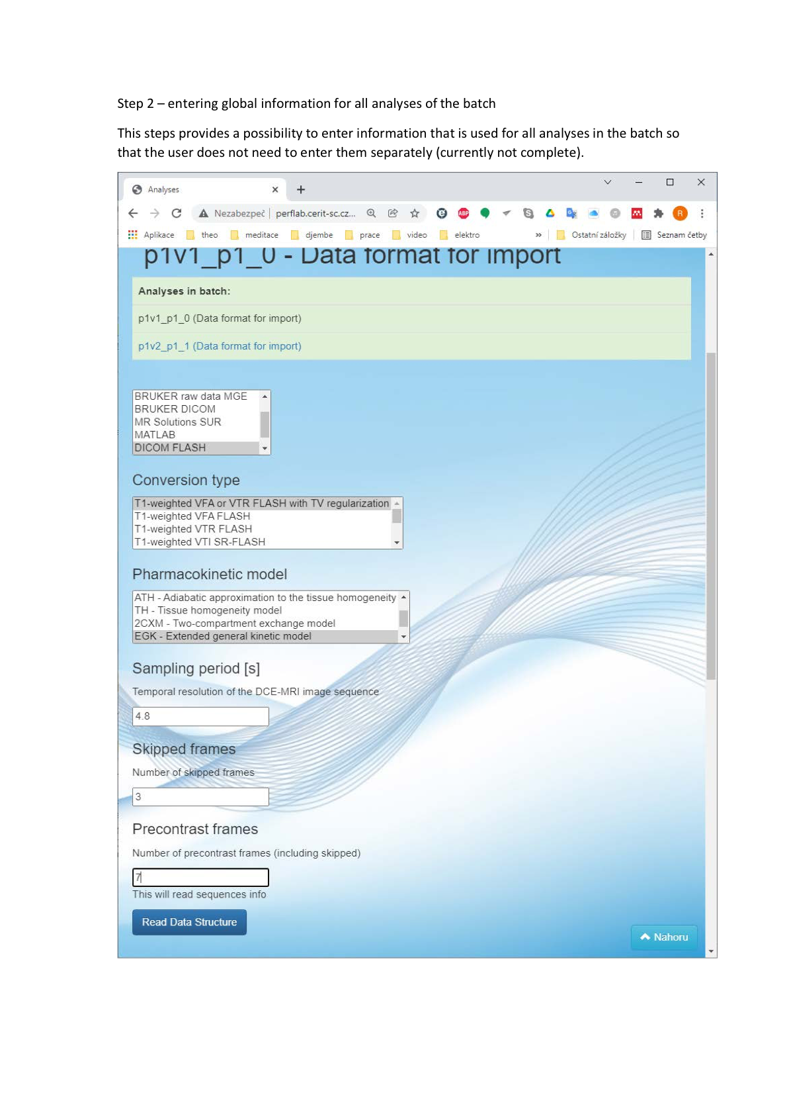

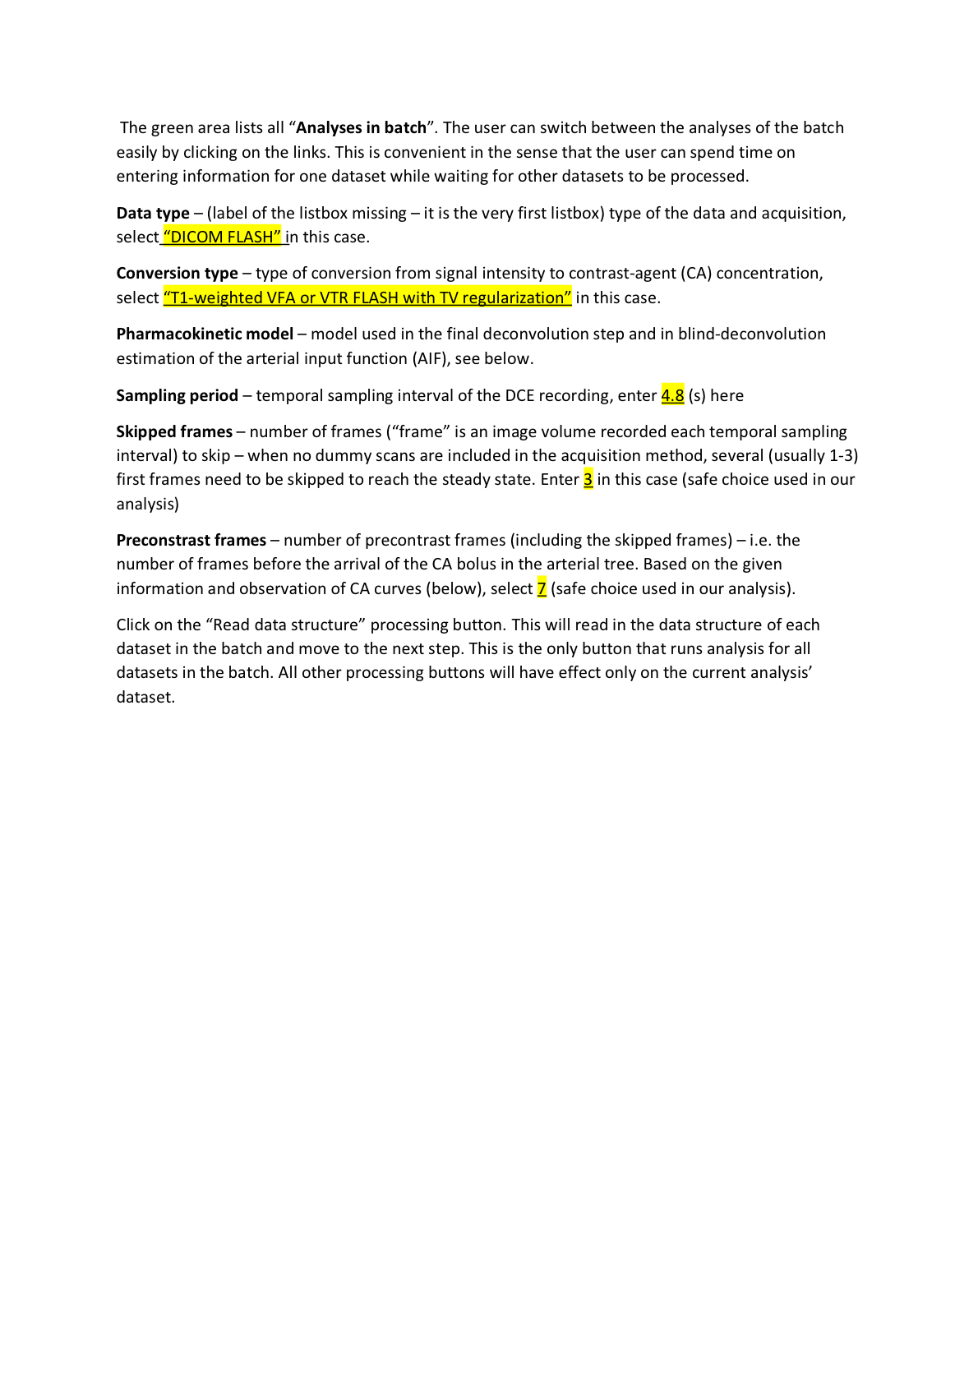

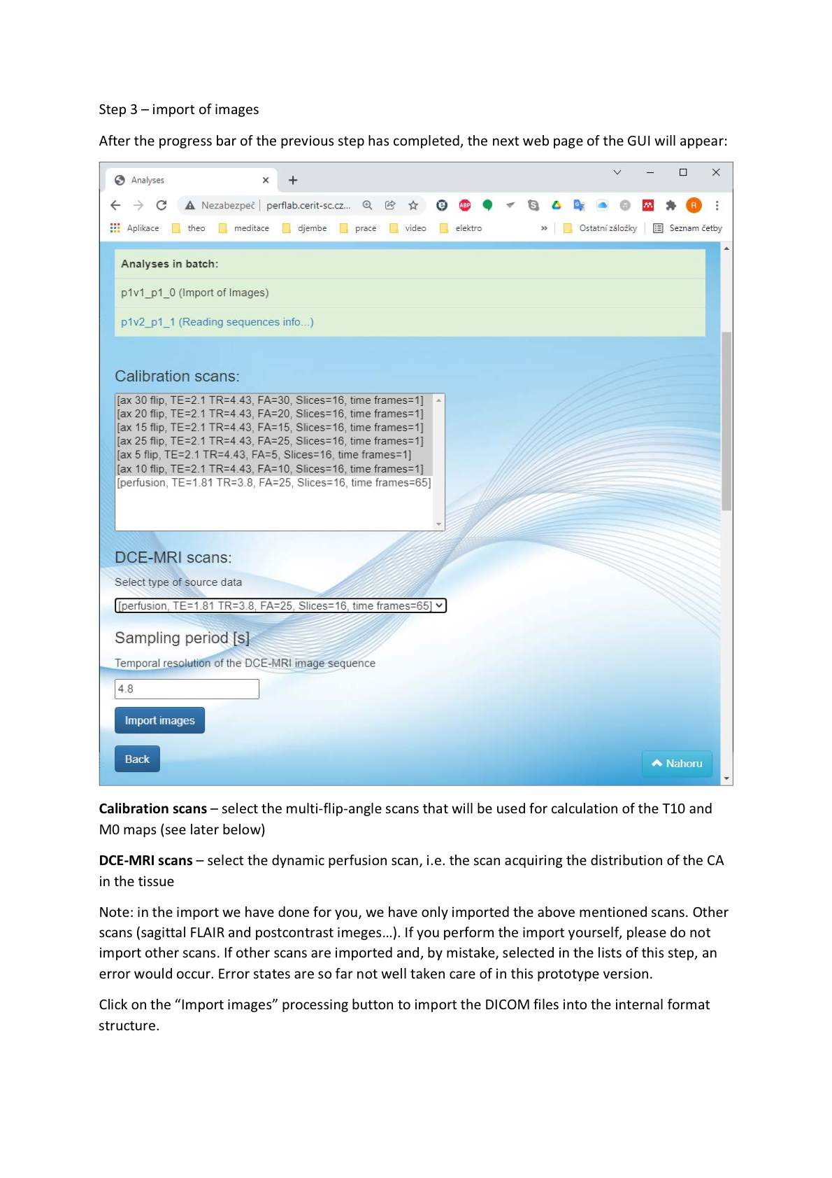

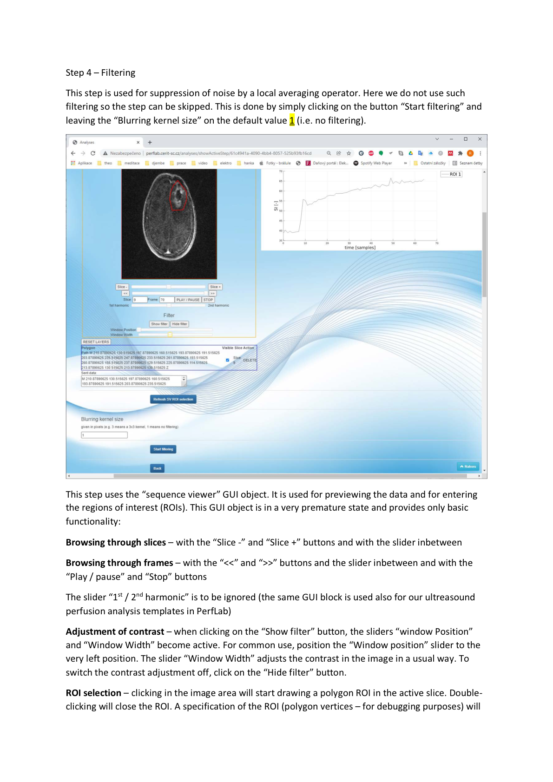

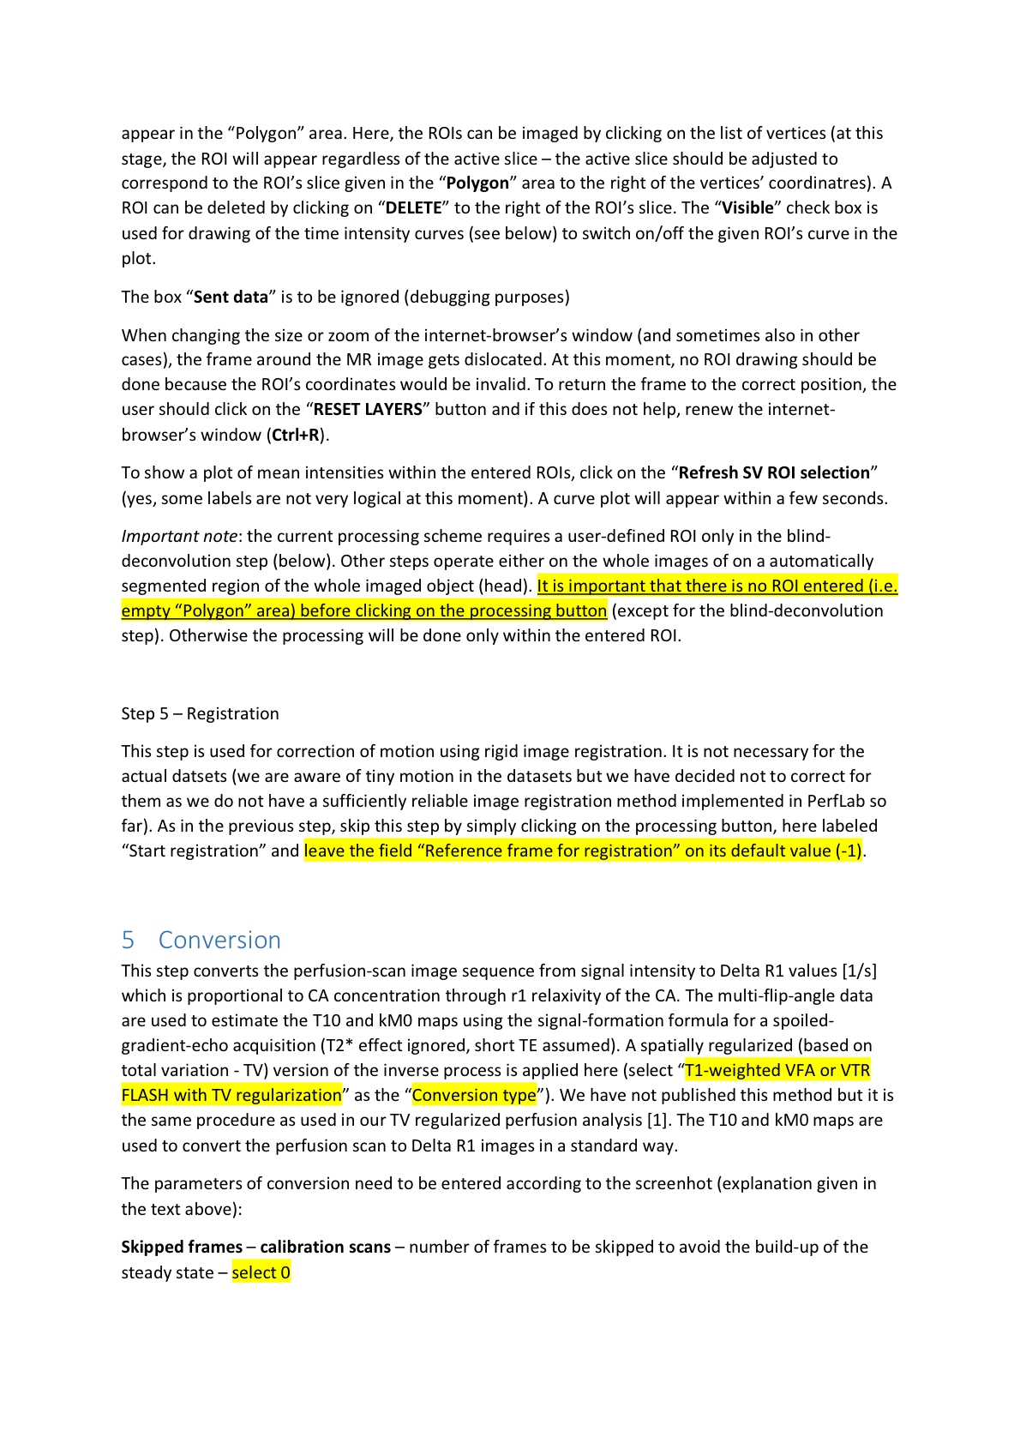

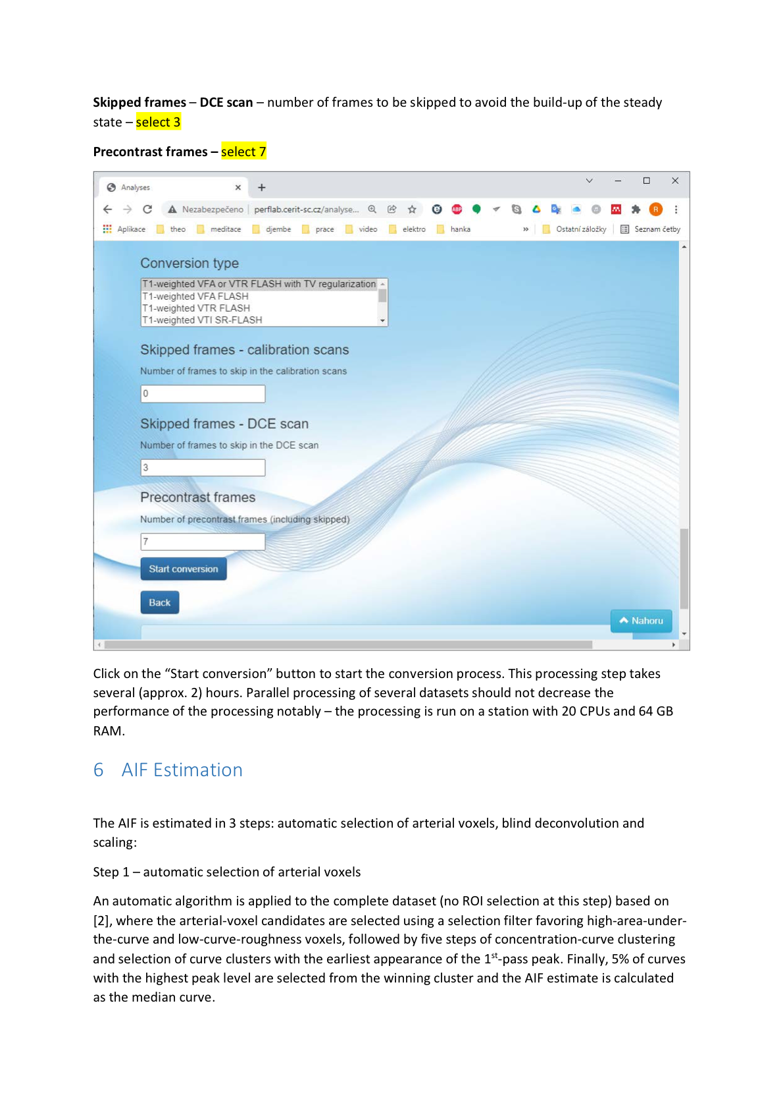

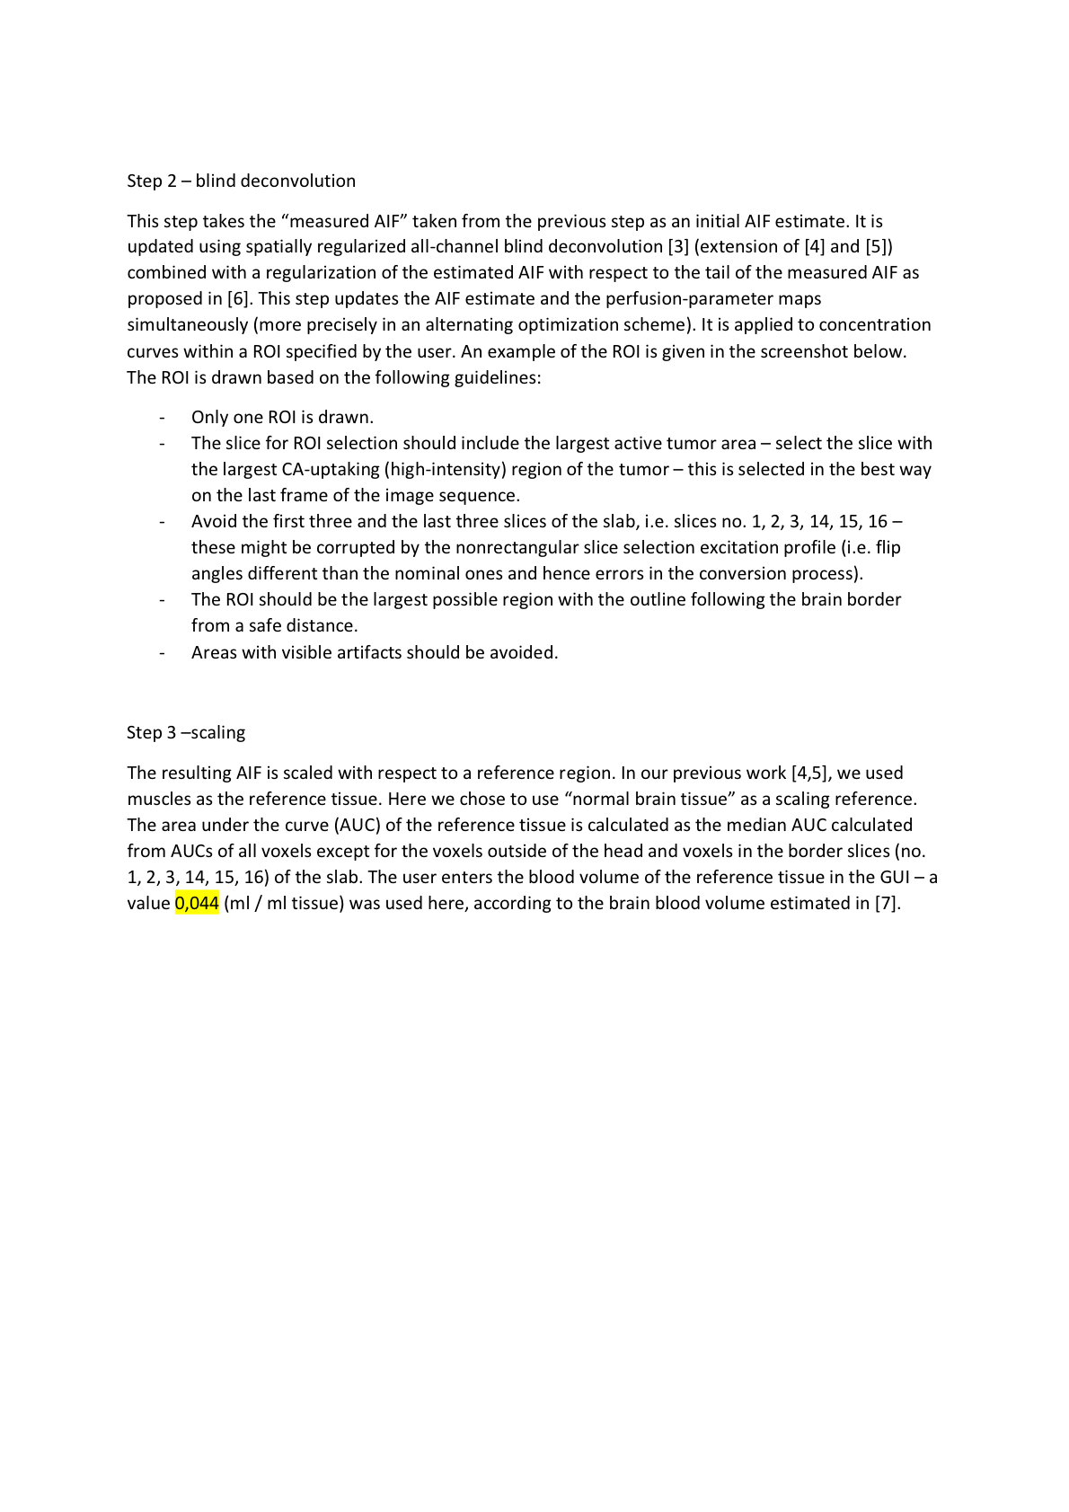

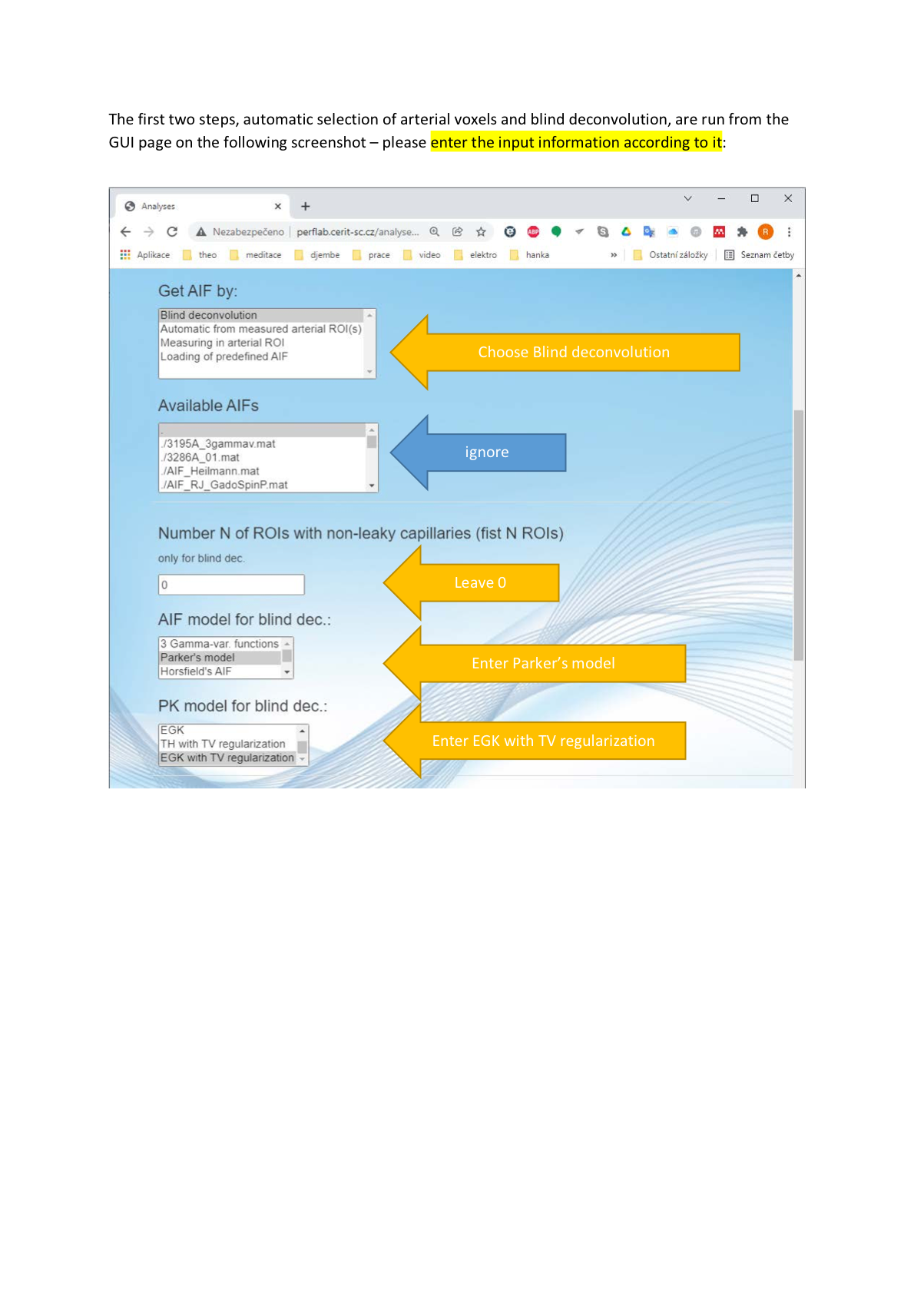

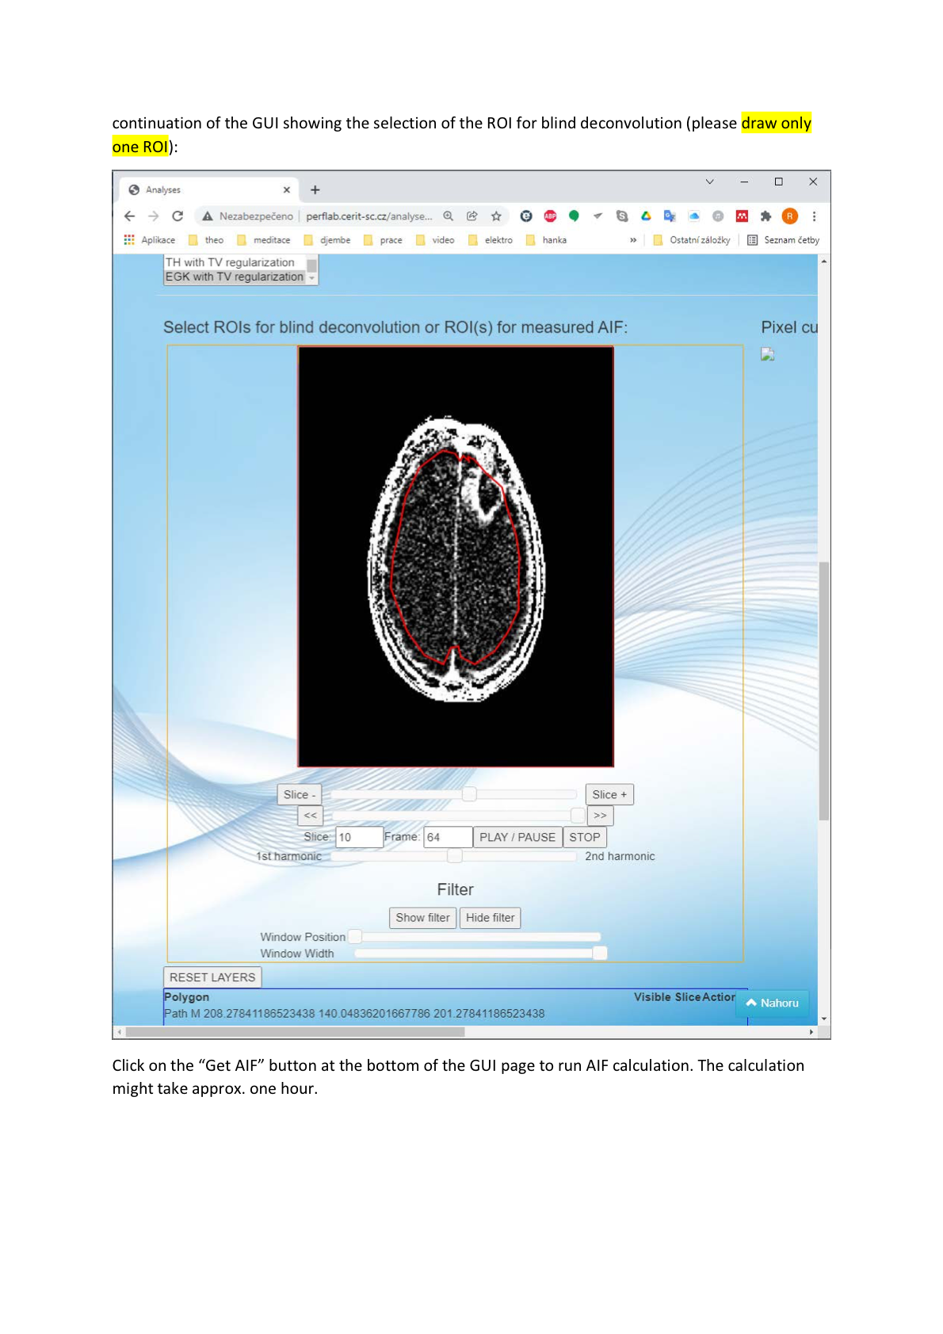

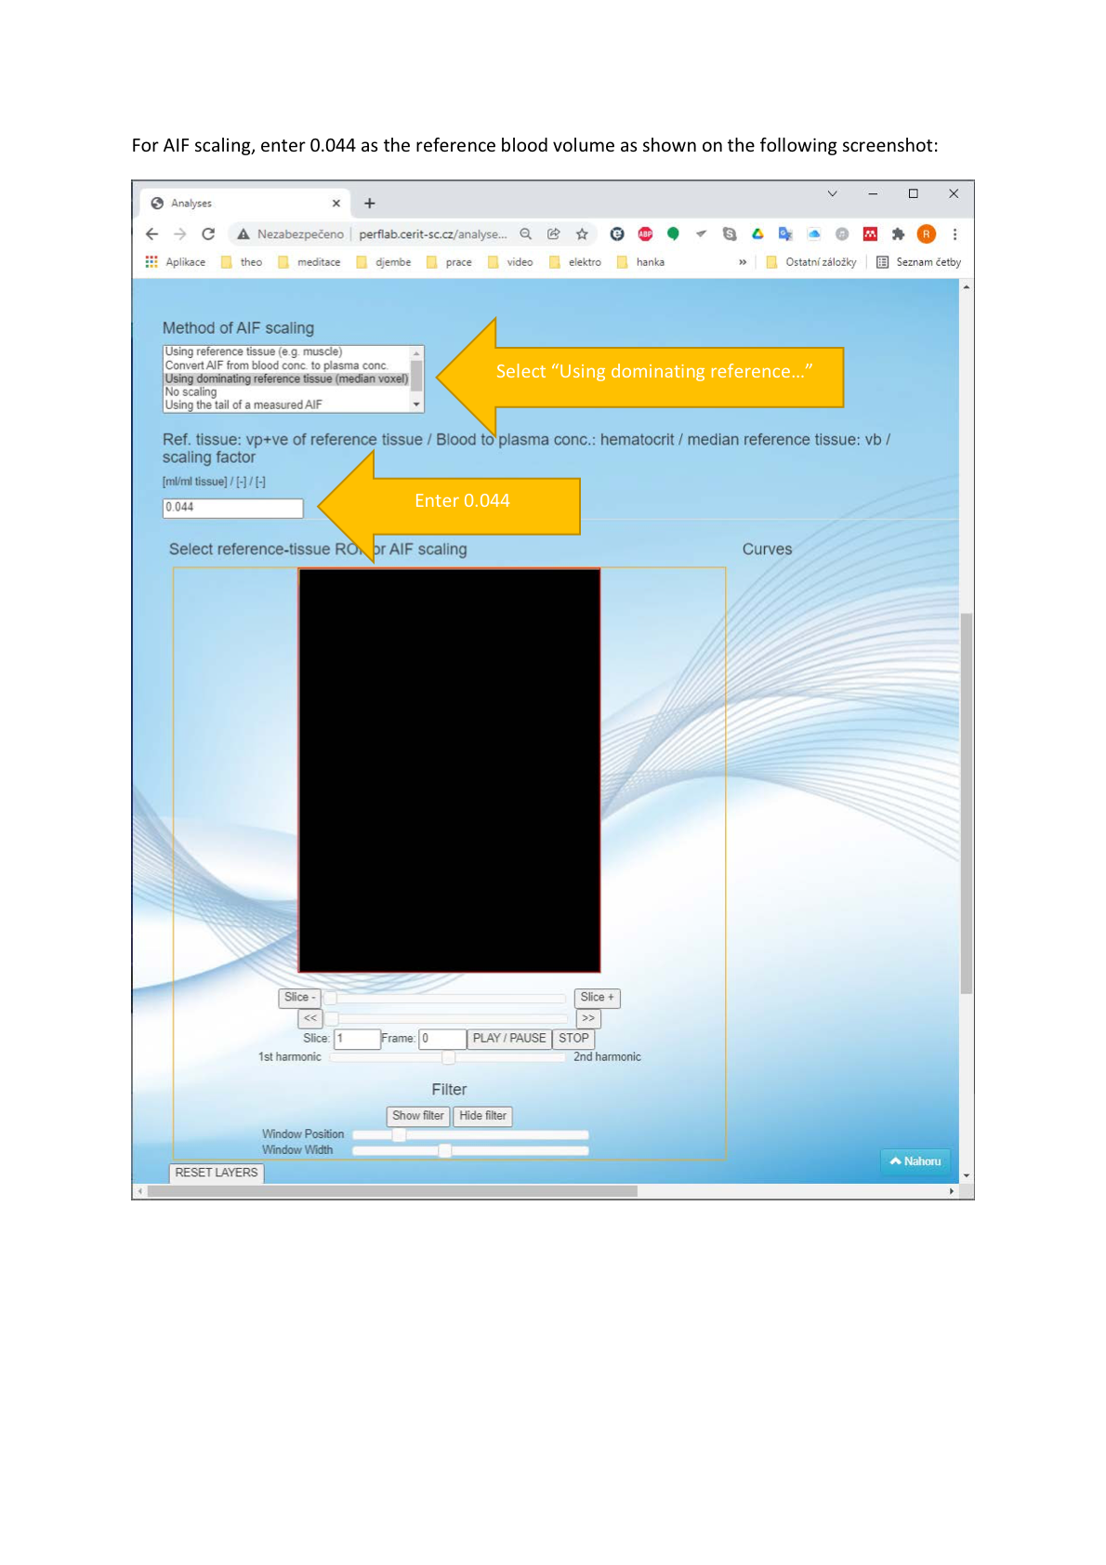

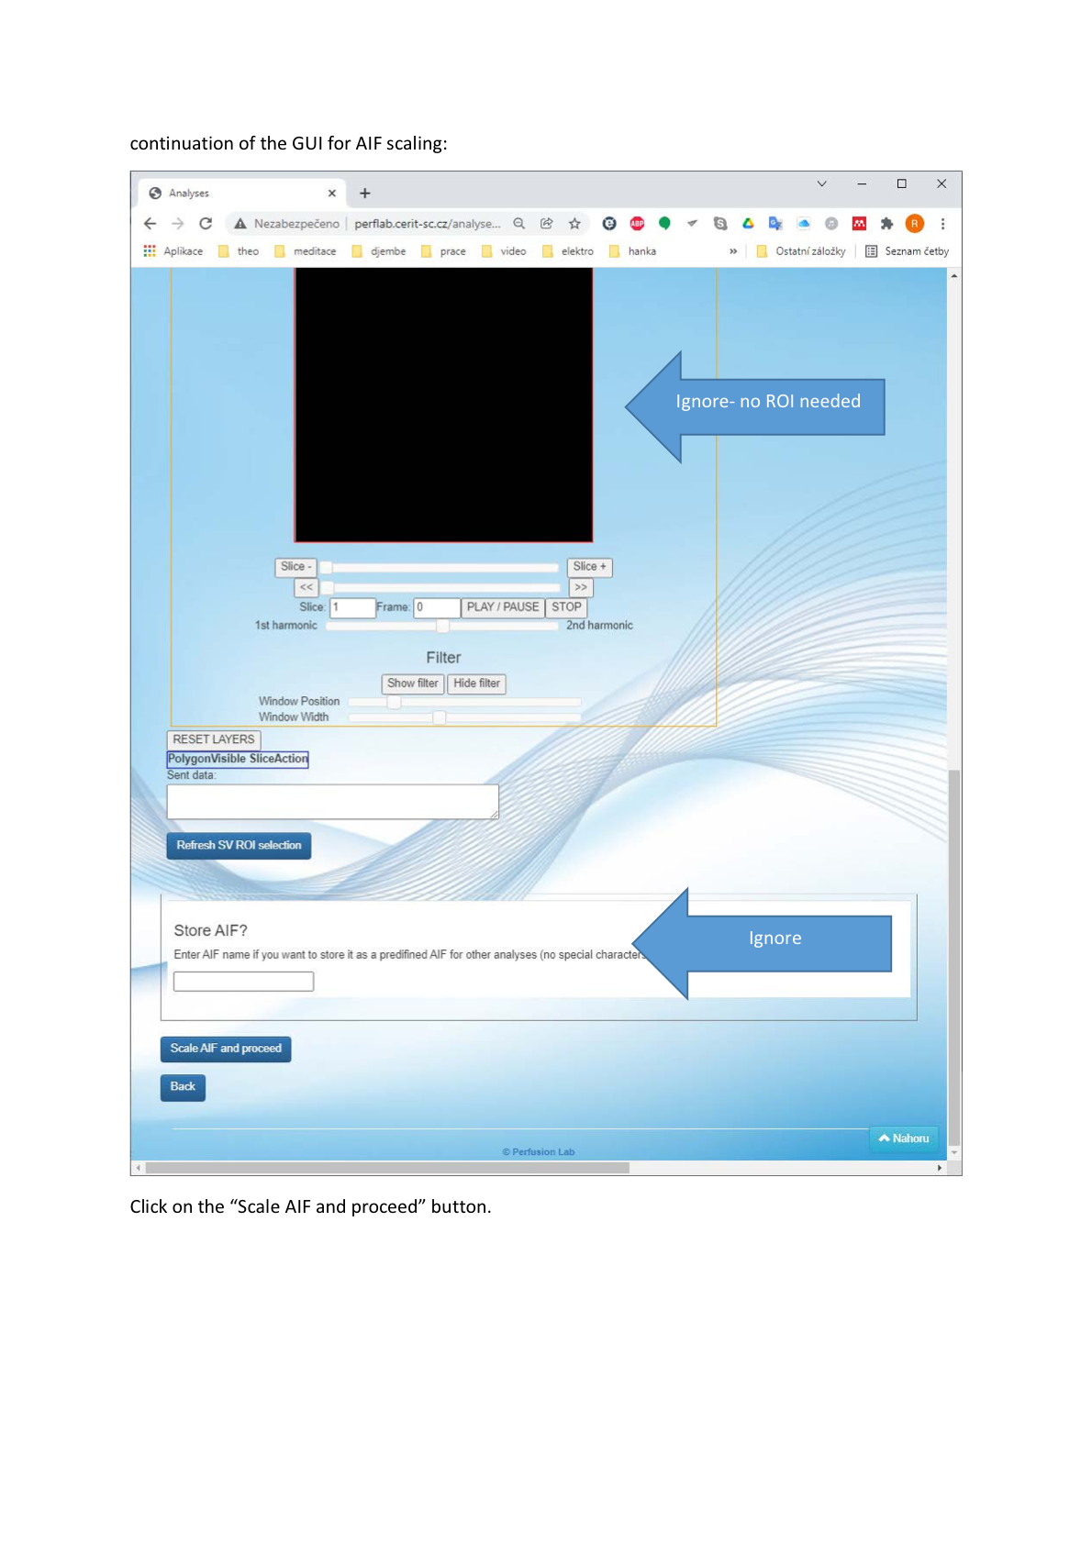

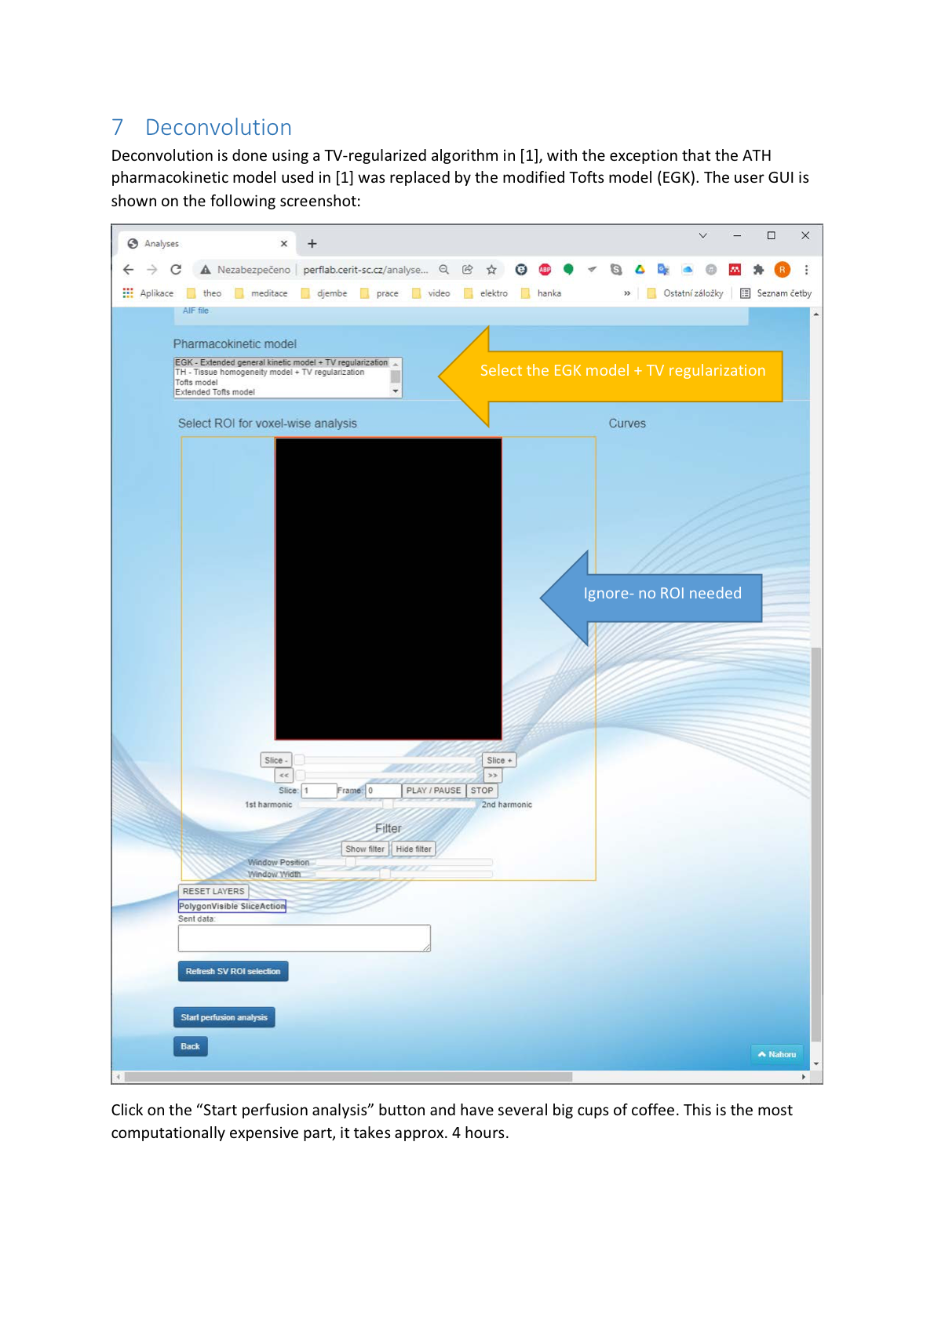

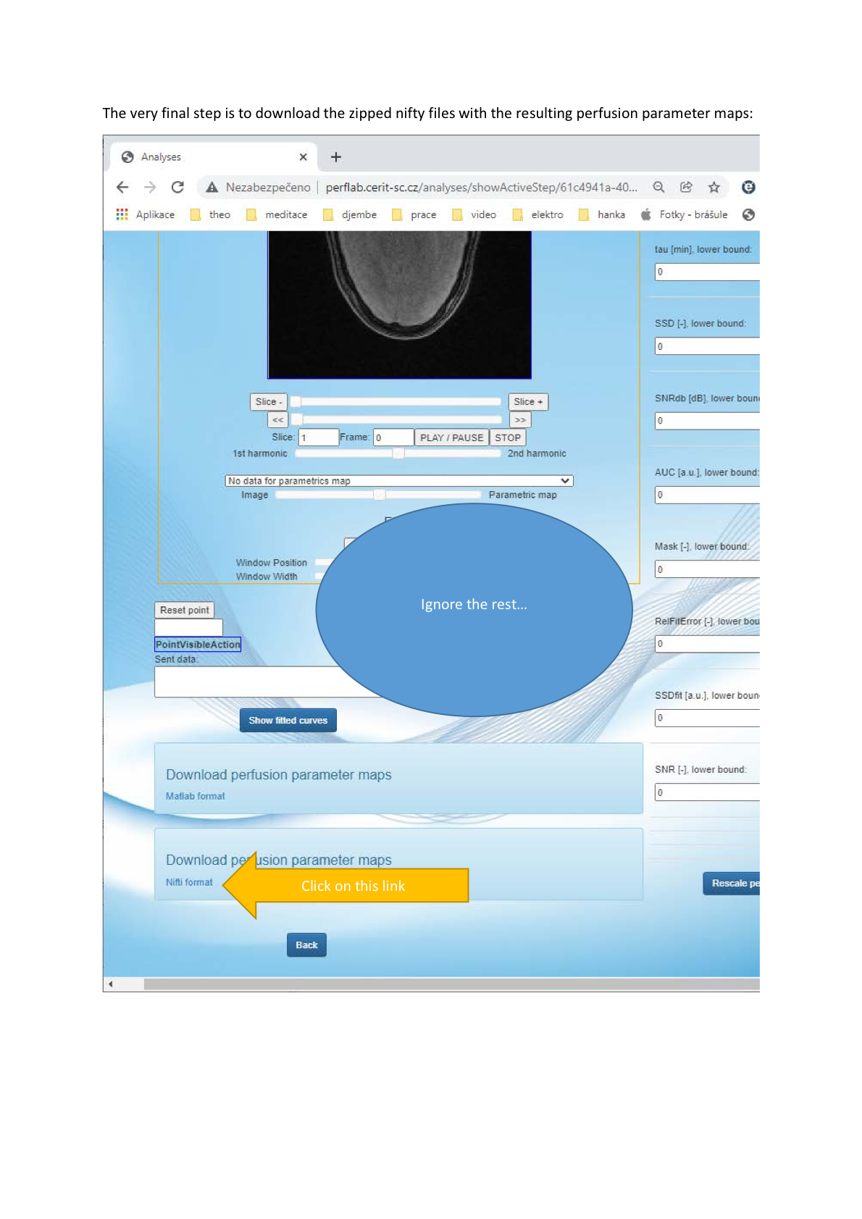

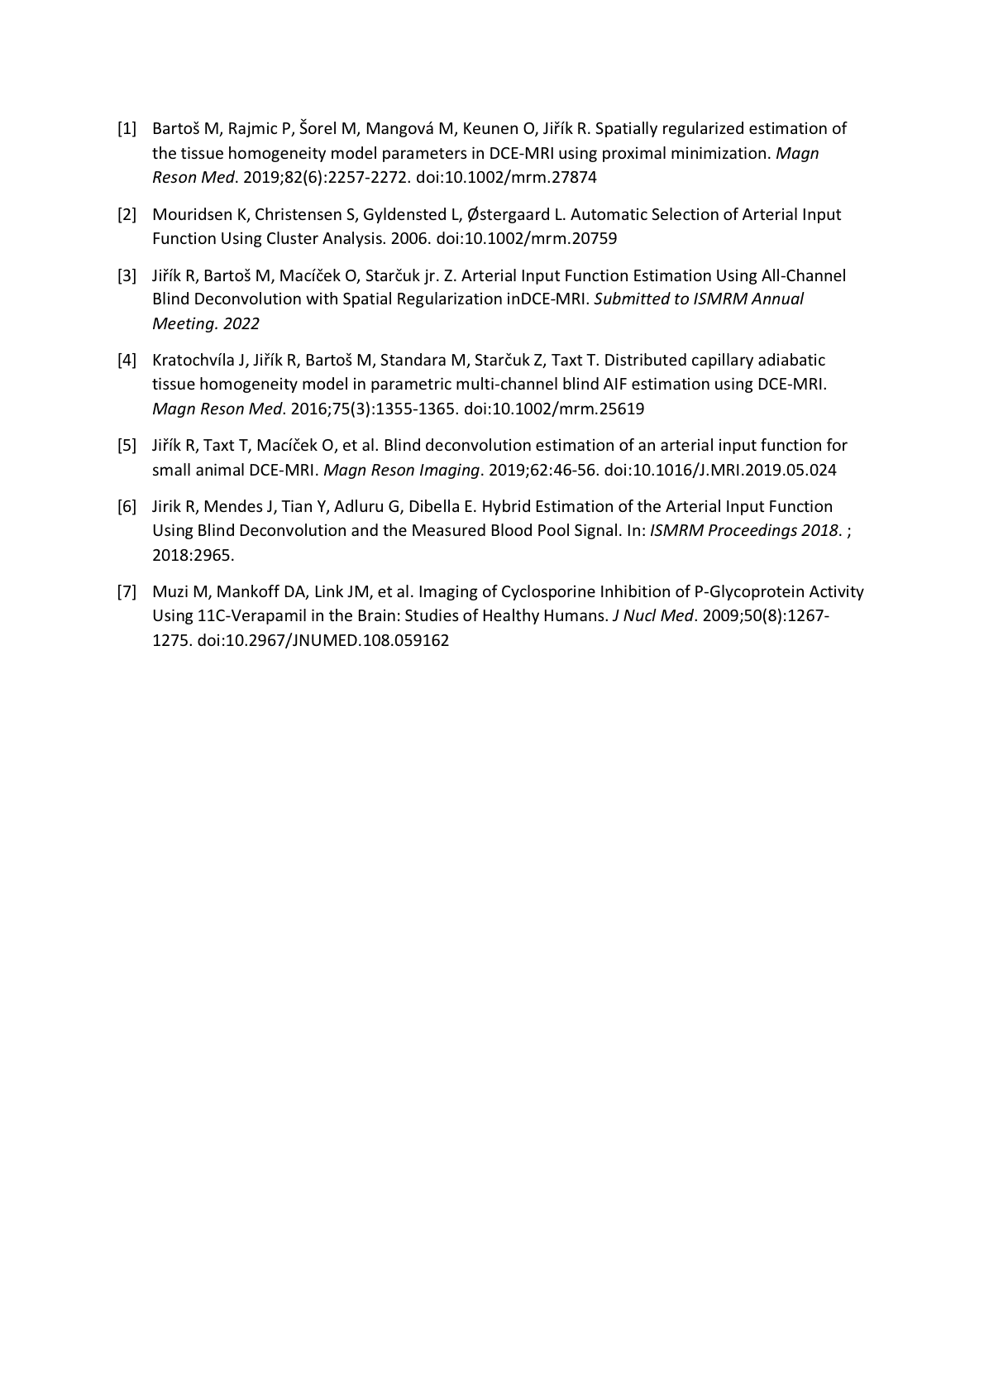

### MRI-QAMPER Team SOP

Team members: Eve LoCastro ([locastre@mskcc.org](mailto:locastre@mskcc.org)), Amaresh Konar Shridhar ([konarsha@mskcc.org](mailto:konarsha@mskcc.org)), Ramesh Paudyal ([paudyalr@mskcc.org](mailto:paudyalr@mskcc.org)), Amita Shukla-Dave ([davea@mskcc.org](mailto:davea@mskcc.org))

The software used to generate the Ktrans maps for this challenge is “Quantitative Analysis and Multiparametric Evaluation Routines for MRI” (MRI-QAMPER). MRI-QAMPER is implemented as a toolkit in MATLAB and provides some functionality for converting DICOM images (via dcm2niix and

The processing for each patient visit and synthetic set of images were processed as follows (adapted from Paudyal et al 2019) :

ROI were manually drawn by A. Konar Shirdhar around brain parenchyma on DCE images for each timepoint. The analysis was performed within this designated ROI in two steps: 1. T1 Signal Fitting was performed to determine voxel-wise magnetization M0 and T10 signal in order to determine pre-contrast R10 (≡ 1/T10) values. Fitting routines were performed for all images using the lab’s in-house developed MRI-QAMPER software by E. LoCastro. Procedural document was written by R. Paudyal, A. Konar Shirdhar and E. LoCastro.

#### T1 Signal Fitting Method and Implementation

The signal intensity in a voxel, measured from a spoiled gradient recalled echo (SPGR) T1wacquisition is given by:

$S\left(t\right)=\frac{M_{0}\sin\left(θ\right){ e}^{{-TE R}_{2}^{*}\left(t\right)}\left(1- e^{-TR{ R}_{1}\left(t\right)}\right)}{\left(1-\cos\left(θ\right) e^{-{TR R}_{1}\left(t\right)}\right)}$ [1]

where S(t) is the voxel signal intensity at time *t*, *M*0 is the equilibrium magnetization of the protons, *q* is flip angle, TR is repetition time, and TE is echo time. *R*1(t) (*R*1 = 1/*T*1) and *R*2*(*t*) (*R*2* = 1/*T*\*2) are the time courses of longitudinal relaxation rate and transverse relaxation rate, respectively.

For the *R*1(*t*)calculation, TE << *T*2*, and so approximating ${ e}^{{-TE R}_{2}^{*}(t)}≈1$, then Equation [1] becomes

$S\left(t\right)= M_{0}\sin{(θ)\left(\frac{1-e^{-TR R_{1}(t)}}{1-\cos{(θ)}e^{-TR R_{1}(t)}}\right)}$ [2]

The solution for the relaxation rate *R*1 (*t*) follows from Equation [2] and is given by:

$R_{1}\left(t\right)=\frac{1}{TR}ln\left(\frac{1-\left(\frac{S\left(t\right)\cos\left(θ\right)}{ M_{0}\sin\left(θ\right)}\right)}{1- \left(\frac{S\left(t\right)}{M_{0}\sin\left(θ\right)}\right)}\right)$ [3]

In the limit of fast water exchange, the change in water proton relaxation rate (ie, Δ*R*­1 [s-1]) due to CA relaxivity, r1 [(mM)-1s-1], is linearly related to the tissue CA concentration, *C*t (mM),

${R_{1}\left(t\right)= R_{10}{+r}_{1} C}_{t}\left(t\right) →R_{1}\left(t\right)=r_{1}C_{t}(t)$, [4]

where R10 is the pre-contrast longitudinal relaxation rate.

The QAMPER software solves Equation [3] for each voxel in the using nonlinear least squares (lsqcurvefit) method across all available flip angles (q = 5,10,15,20,25,30) in the challenge data. Upper and lower bound limits were imposed on the parameter solutions as follows: T10 = [0,2]; M0 = [0,1E5].

#### Pharmacokinetic Modeling with the Extended Tofts Model

Extended Tofts models (ETM) is based on a two-compartment model (vascular space and extravascular extracelluar space (EES)). The ETM expression for modeling $C_{t}(t)$ is given by:

$C_{t}(t)=K^{trans}\int_{0}^{t}{{e^{-k_{ep}\left(t-τ\right)}C}_{p}\left(τ\right)}dτ+ {v_{p}C}_{p}(t)$ [5]

where, (min-1) is the volume transfer constant of CA, $C_{p}(t)$ is the time-course of plasma CA concentration, which is called arterial input function (AIF). The rate constant describing CA back-flux into the vascular space from the EES is defined as $k_{ep}$ ≡ $K^{trans}$/ $v_{e}$, where $v_{e}$ and $v_{p}$ are the volume fractions of the EES and blood plasma, respectively.

For each case, an individual arterial input function (AIF) was determined from the perfusion imaging using a cross-correlation method. An “ideal” waveform was identified from an arterial region in the first patient and used as the reference signal. Cross-correlation was performed between the reference signal and the perfusion signal timecourse for every voxel in the perfusion volume. The waveform from the voxel with the highest cross correlation coefficient of agreement was selected as Cp(t) for performing the ETM fitting routine.

QAMPER performs 3-parameter Extended Toft Model analysis, solving Equation [5] using nonlinear least squares. The integration is trapezoidally discretized (cumtrapz). The routines performs 4 iterations per voxel and selects the fitted result with the lowest residual error. Upper and lower bounds were imposed on the fitting parameter solutions as follows: Ktrans = [0,5], ve = [0,1], vp = [0,1].

Software available for evaluation upon request.

#### References:

Paudyal R, Lu Y, Hatzoglou V, Moreira A, Stambuk HE, Oh JH, Cunanan KM, Aramburu Nunez D, Mazaheri Y, Gonen M, Ho A, Fagin JA, Wong RJ, Shaha A, Tuttle RM, Shukla-Dave A. Dynamic contrast-enhanced MRI model selection for predicting tumor aggressiveness in papillary thyroid cancers. NMR Biomed. 2020 Jan;33(1):e4166. doi: 10.1002/nbm.4166. Epub 2019 Nov 4. PMID: 31680360; PMCID: PMC7687051.

Tofts PS, Brix G, Buckley DL, Evelhoch JL, Henderson E, Knopp MV, Larsson HBW, Lee T-Y, Mayr NA, Parker GJM, Port RE, Taylor J, Weisskoff RM. Estimating kinetic parameters from dynamic contrast-enhanced T(1)-weighted MRI of a diffusable tracer: standardized quantities and symbols. *J Magn Reson Imaging*. 1999;10:223–232.

### ROCKETSHIP Team SOP

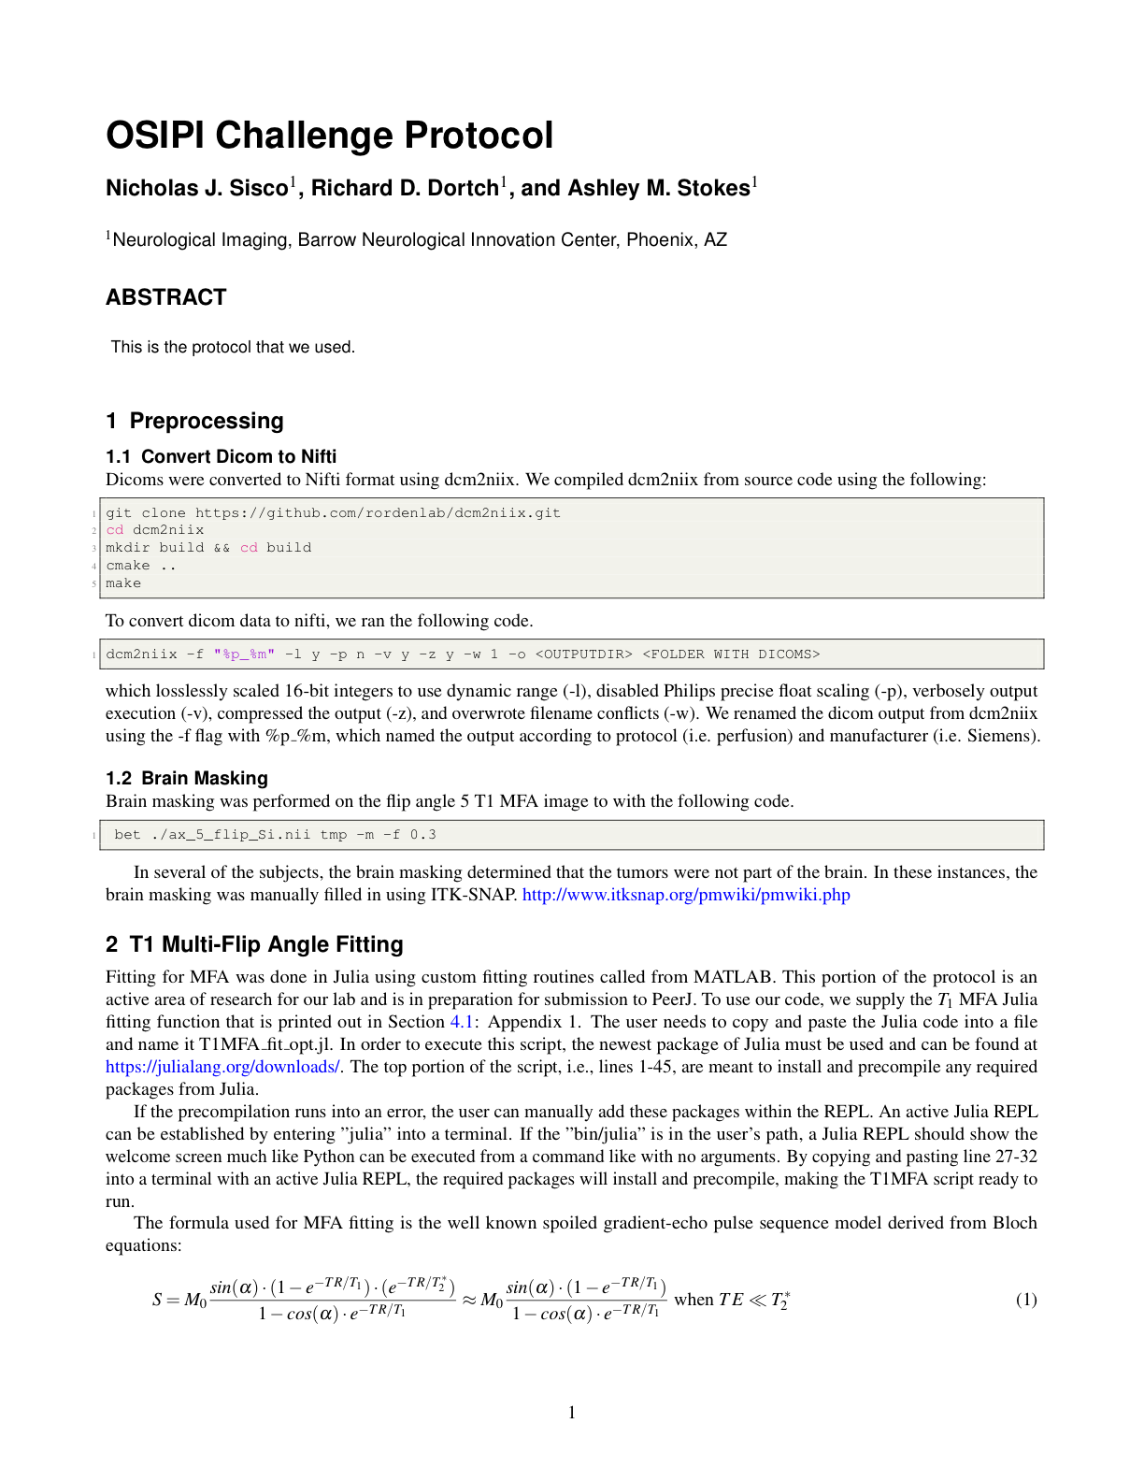

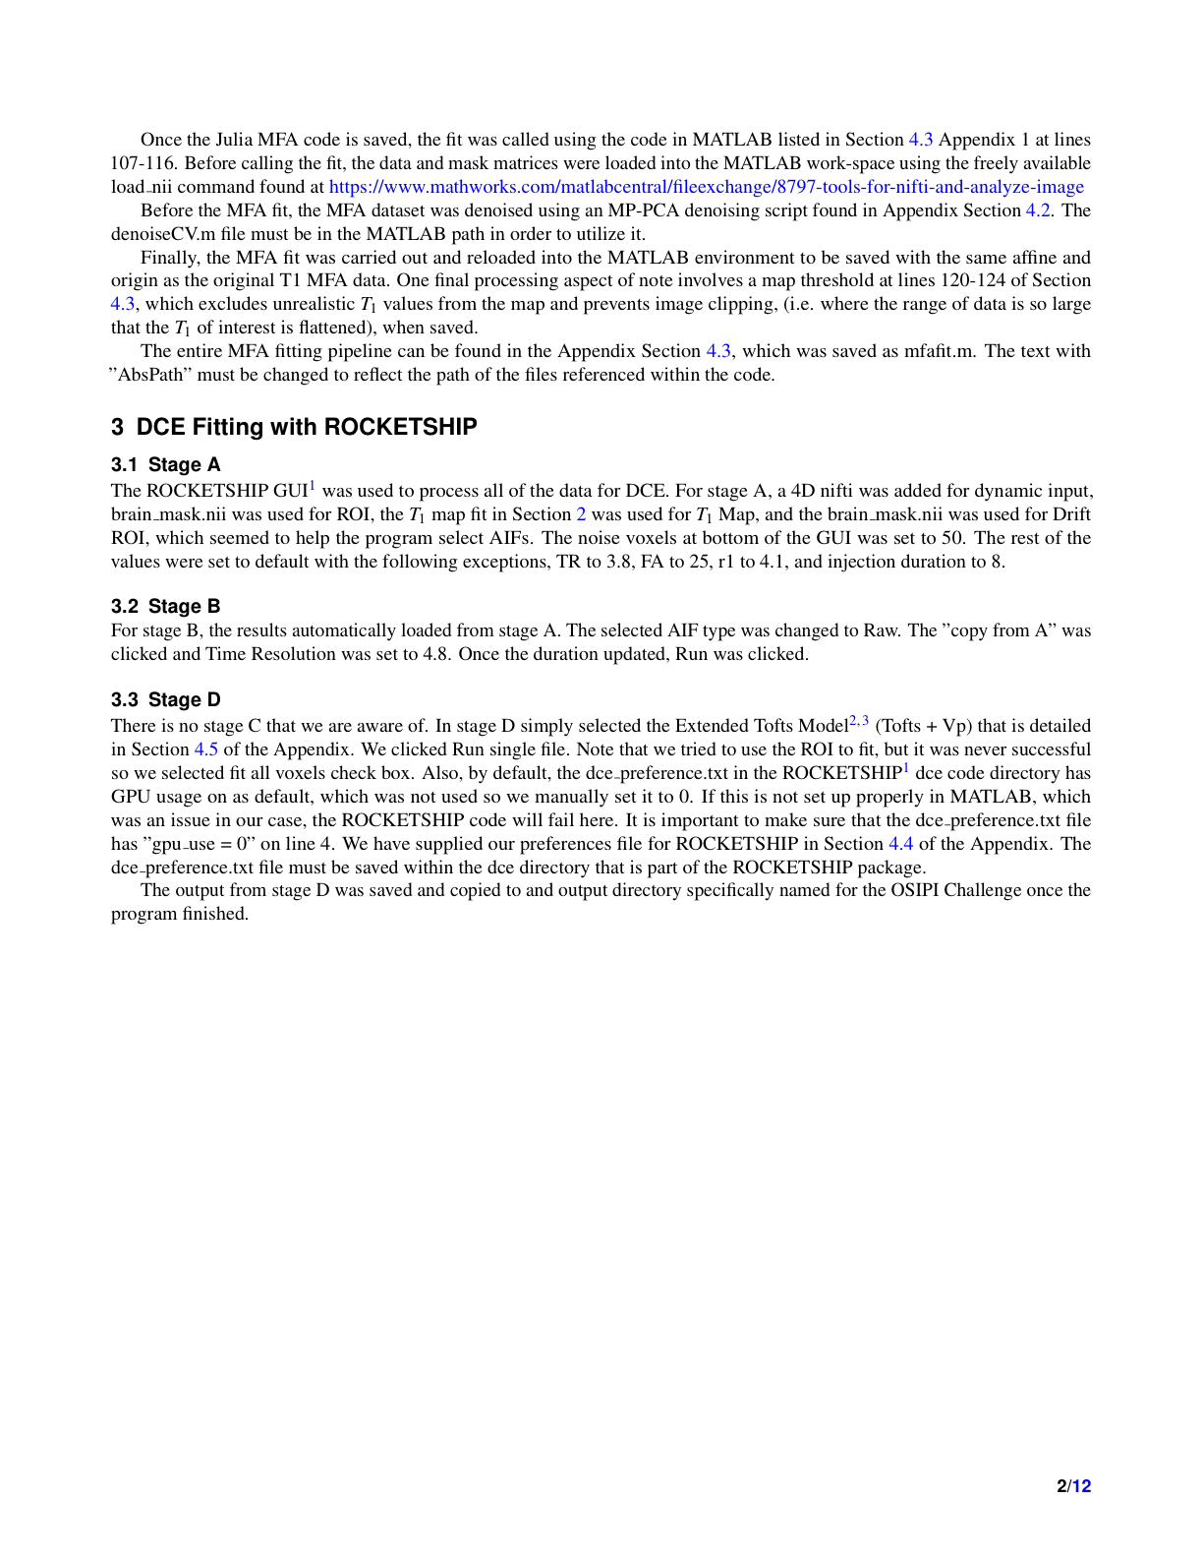

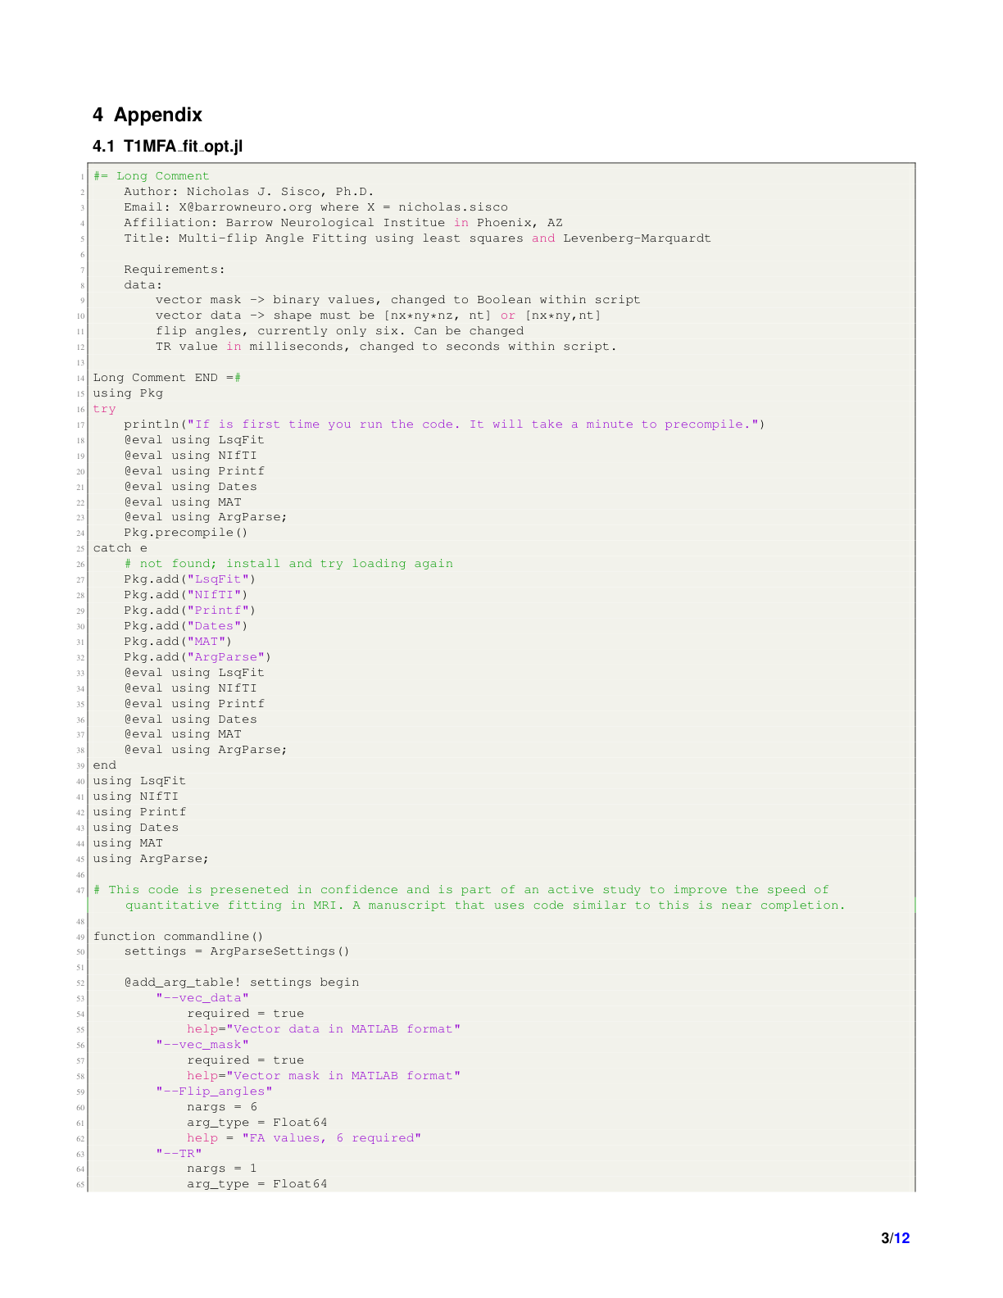

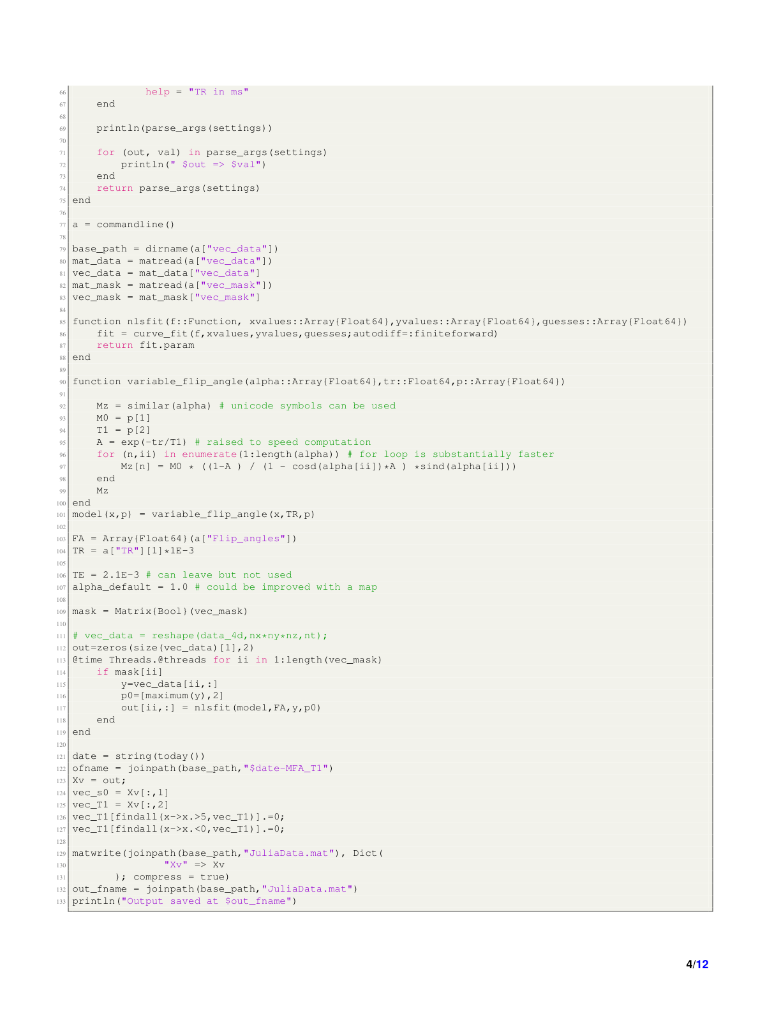

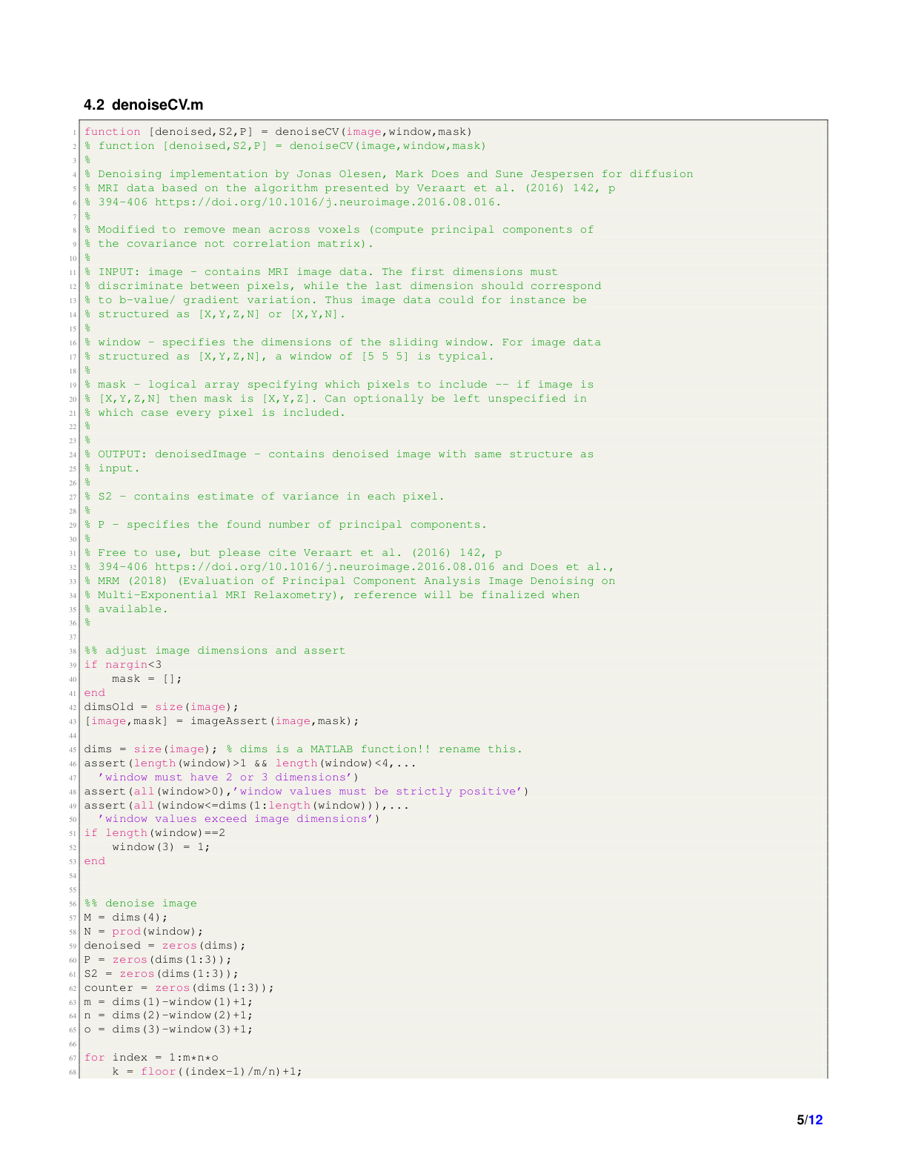

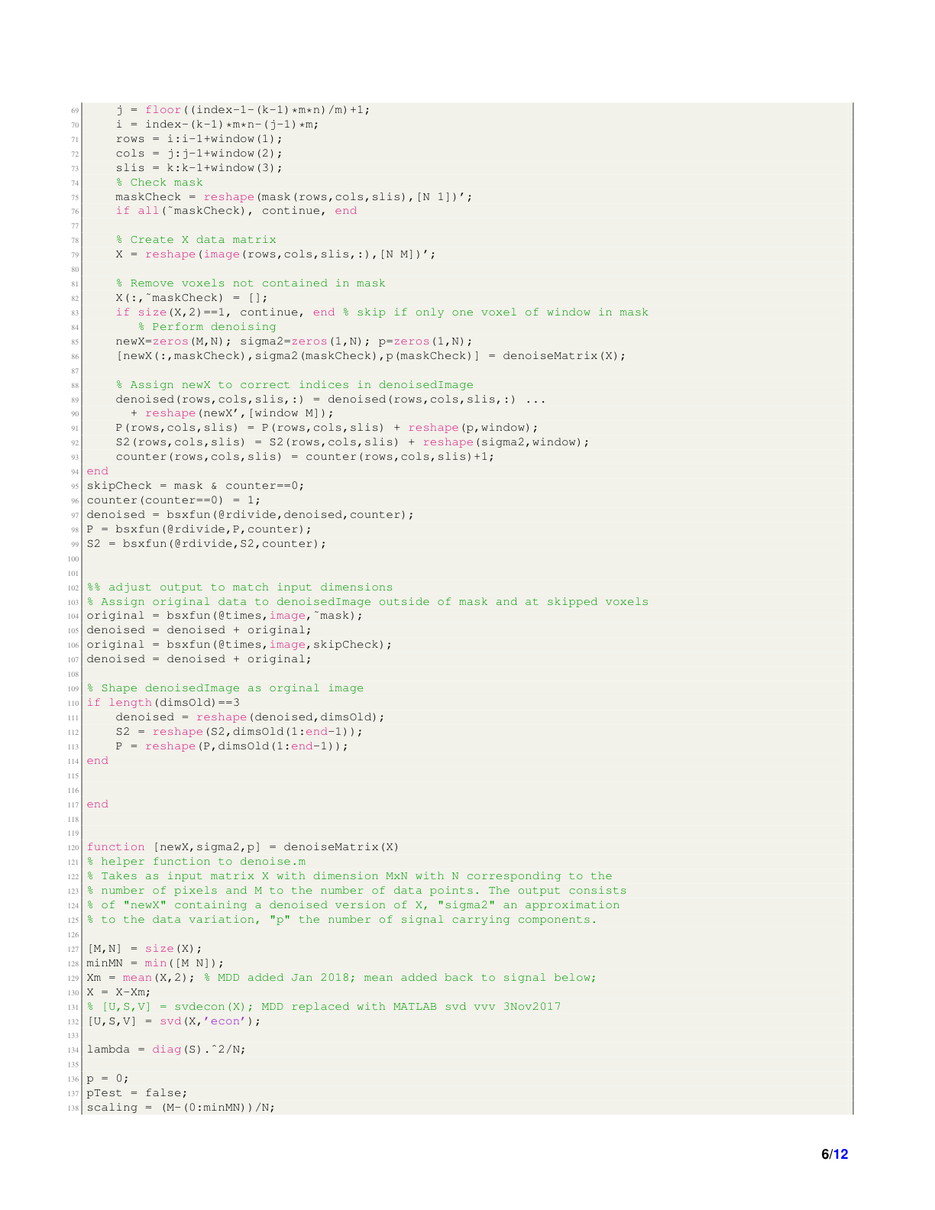

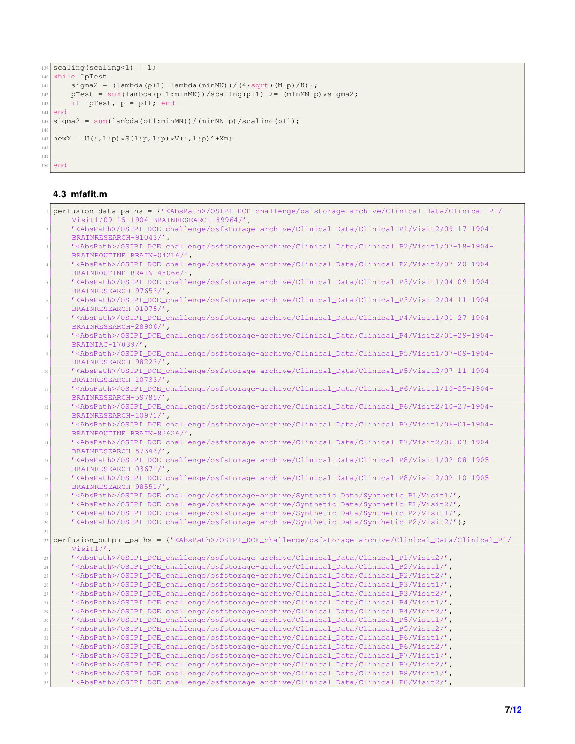

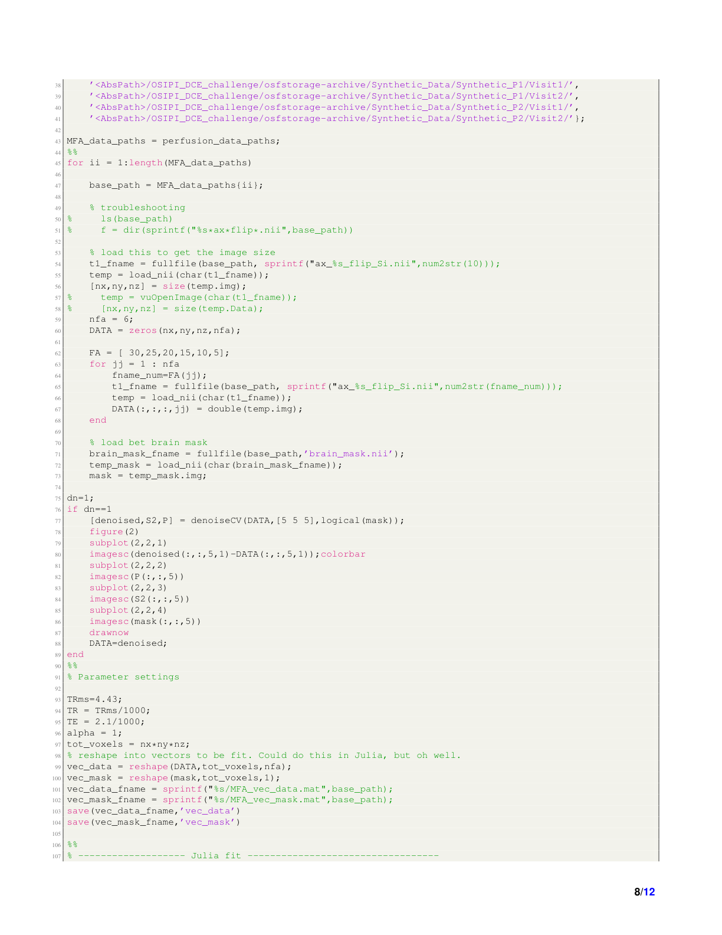

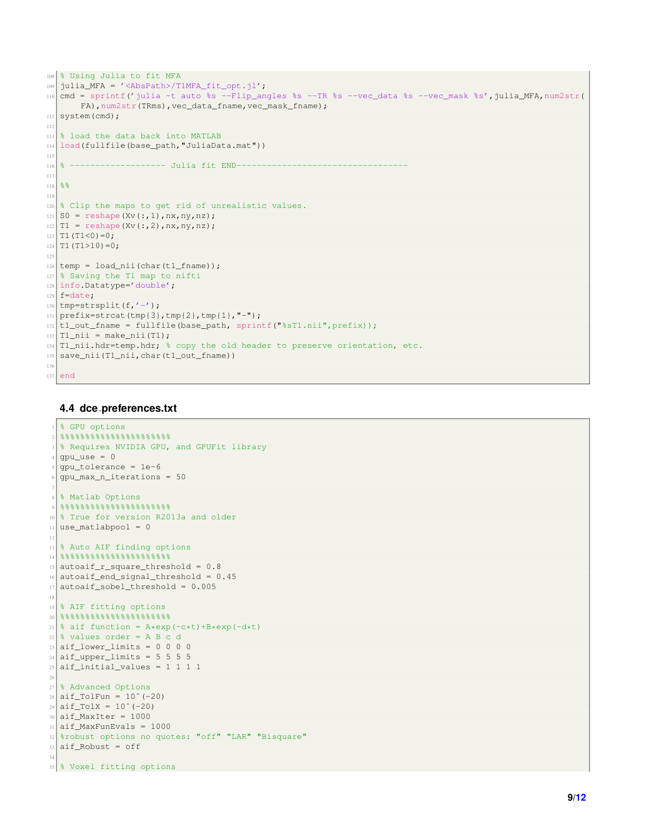

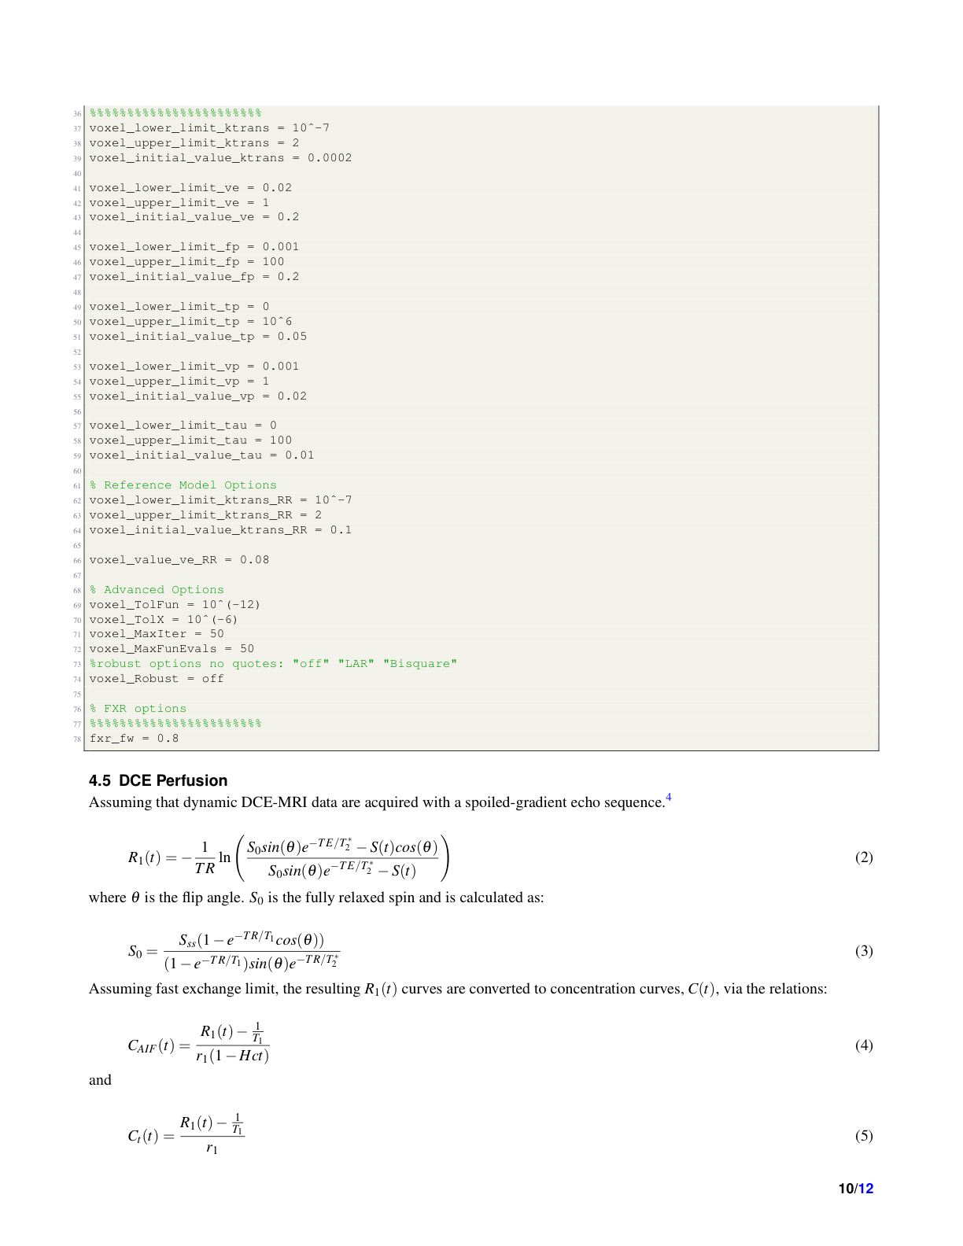

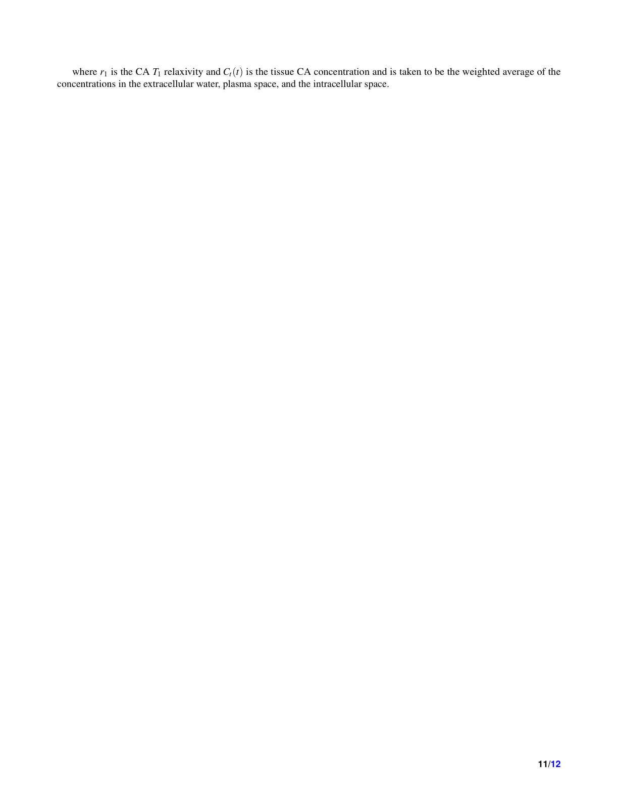

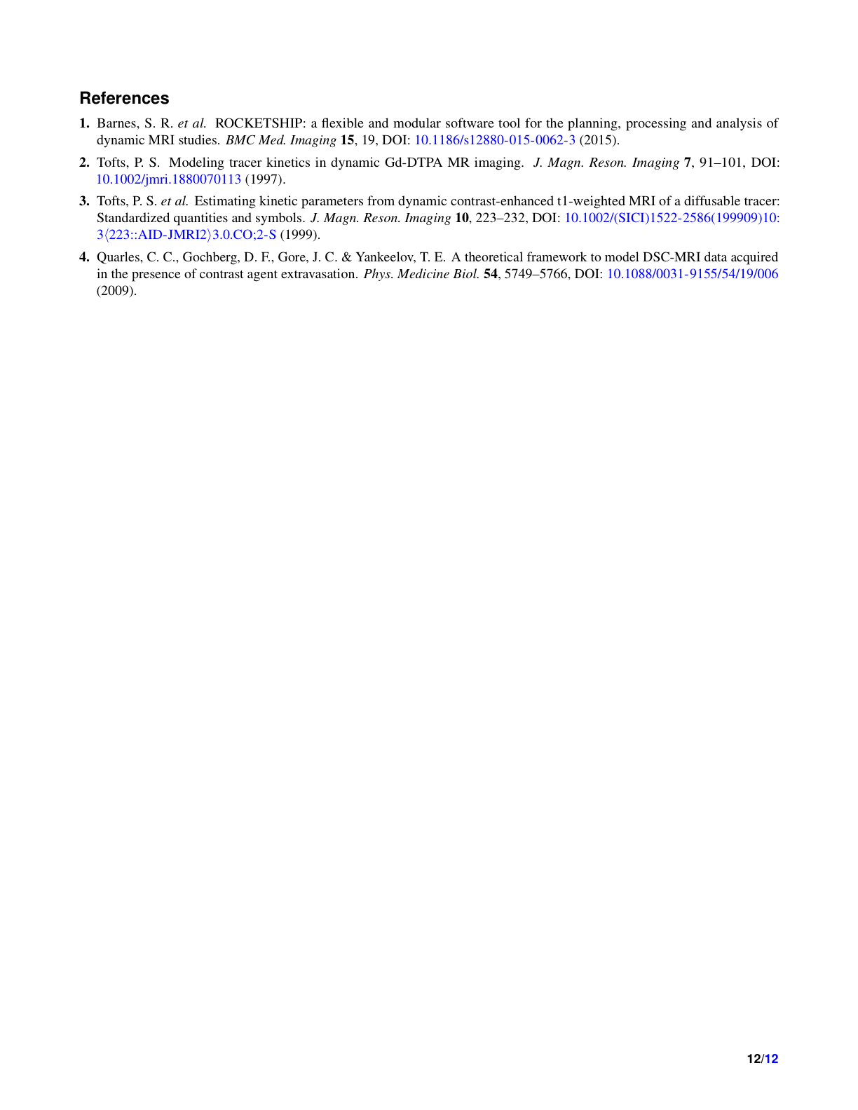

### FireVoxel Team SOP

**DCE MRI Processing in FireVoxel for OSIPI Challenge**

Ayesha Das (abd4004@med.cornell.edu), Gene Kim (sgk4001@med.cornell.edu) (Weill Cornell Medical College) and

Louisa Bokacheva (louisa.bokacheva@gmail.com), Artem Mikheev (artemmikheev@gmail.com), Henry Rusineck (hr18@nyu.edu) (NYU School of Medicine)

**Data:** Multiple flip angle (mFA), perfusion.

1. Follow the installation instructions on the Firevoxel website to download Firevoxel: <https://firevoxel.org/download/>
   1. Firevoxel requires a key (a small file named as FireVoxel.key), which is specific to each computer ID. As illustrated in the instruction of the above link, a key can be obtained by sending an email request with a computer ID to [hr18@nyu.edu](mailto:hr18@nyu.edu). The computer ID is nonspecific to any user on the computer. However, if it is necessary to maintain anonymity of the user/evaluator, the computer ID of the evaluator can be sent via the OSIPI email or an organizer to [hr18@nyu.edu](mailto:hr18@nyu.edu). Please also note that the FreVoxel keys are handled via automated email.
   2. Firevoxel is only accessible on a PC with 64-bit Windows (Win7 and up).
2. Open Firevoxel
3. Construct T1-map.
   1. **File> Open DICOM** > **Single document**. Select multiple flip angle data (mFA). The series is opened in a new document window.
   2. **Save FireVoxel document** (.fvx).
   3. Smooth data. Volume > Smooth over (optional) ROI (Process 3D: No (uncheck), Kernel Type: Median, Radius (vox): 2 (default)). Result: New layer, same name as original.

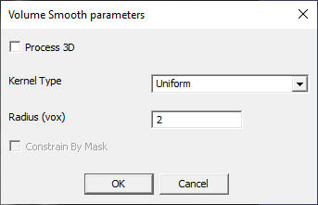

* 1. Active layer: Smoothed data. **Dynamic Analysis** > **Calculate Parametric Map**. Methods: Model 24. Hyperparameters: Noise > default [Noise x5]. Fitting options: Process All. Result: T1-map (real-valued layer). Result: New layer (T1.im).
  2. Save FireVoxel document (overwrite).

1. Segment the brain.
   1. Load perfusion data. Open DICOM > Single document. Perfusion data is opened in a new document window.
   2. Save FireVoxel document.
   3. Navigate to the last time frame (frame 65). **Workflows** > **Brain MR** > **Find White Matter Seed** – **Axial**. Result: VROI.
   4. **EdgeWave Basic**. SI interval: [0.5 2.5]. Process each frame individually? No. Result: Brain mask (ROI layer).
   5. Clean up. Fill holes: **ROI** > **Morphology** > **Fill 2D contours** (F7) and/or **Close broken contours and fill 2D**.
   6. Clear ROI on the two edge slices at the top and two at the bottom (because they often contain wraparound artifact): **ROI** > **Clear ROI slices** > **Outside [Z0, Z1].** Z0=3, Z1=14 (Z is the depth coordinate measured from zero). Result: A new brain mask (ROI layer). Slices 1, 2, 15, and 16 are empty.
2. Coregister T1-map to perfusion.
   1. Active document: Perfusion. Also open document: mFA (Active layer: mFA image). **Register** > **Using Orientation\Position tags**. Result: new document window labeled DICOMn_ax_5_flp_reg (reg for registered). This new window contains all layers from mFA document (now coregistered with perfusion data).
   2. Active document: Registered. Open Layer Control. Click and drag the T1-map into perfusion document window.
   3. Active document: perfusion. Layer Control. Rename T1_reg > T1-map.
   4. Close mFA document (optional).
3. Determine the input function.
   1. Active document: perfusion. Navigate to the last time frame by clicking the right arrow on the keyboard (frame 65).
   2. Draw a VROI enclosing the brain parenchyma on a middle slice (slice 7) (exclude olfactory bulb and eyes, if they are present in the slice). Double-click VROI, set Depth to 3 slices [VROI covering slices no. 6-8. In VROI properties, Z-coordinate is shown as 5-8, as coordinates start from zero].

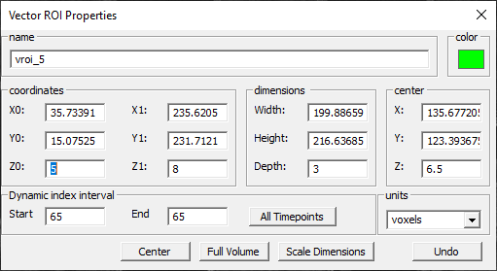

* 1. May use **View orthogonal projections** to adjust the VROI position manually.
  2. **Dynamic Analysis** > **Image Derived Input Function**. Data conversion: Enhancement. Max length: 10 mm. Max turn: 90°. Other parameters at default values.

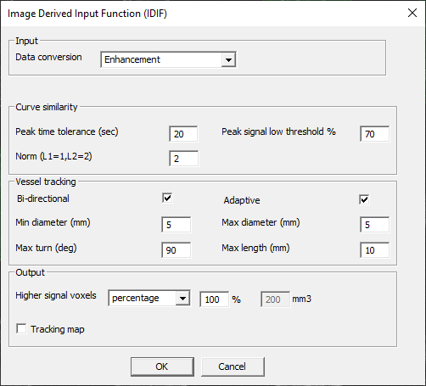

* 1. Result: AIF signal intensity curve (ROI Stats 4D plot opens automatically), new layer: idif (ROI layer) (optional: tracking map, real). **ROI Stats 4D** > **Save** (save the IDIF signal intensity as .txt).

1. Convert perfusion signal to concentration.
   1. Active layer: perfusion. Visible: T1-map, brain ROI.
   2. 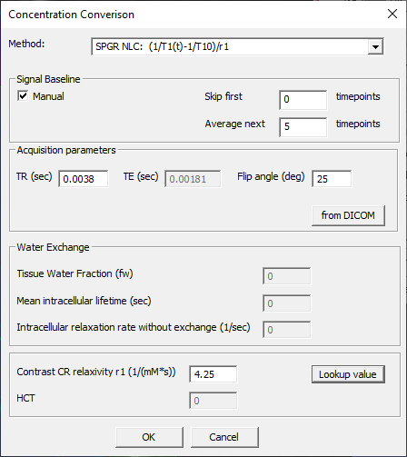**Dynamic Analysis** > **Convert volume to concentration** > **using T1-map** > **Concentration Conversion** dialog (SPGR NLC, manual baseline – enter the number of baseline points, acquisition parameters from DICOM, select or enter contrast agent relaxivity, no HCT correction for tissue). Result: Concentration vs time layer (4D image, real).
   3. Optional: rename this new layer to “concentration.”
2. Perform model analysis.
   1. Active layer: Concentration (real). Visible: brain mask (ROI). Other layers (T1-map, idif): invisible.
   2. **Dynamic Analysis** > **Calculate Parametric Map** (Model 9).
      1. 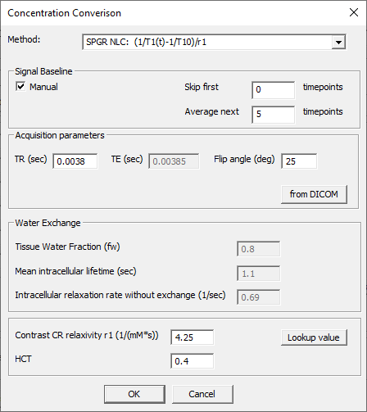Load aif.txt. Attributes: T10 (1.5 T: 1.48 s). AIF concentration conversion: (SPGR NLC, parameters as for tissue, but Hct=0.4 for whole blood to plasma conversion).
      2. Tissue concentration: No conversion.
      3. Hyperparameters: Ktrans max: 2 (1/min); ve max: 1. Min and max arterial delay (s): [-7, 2]. L1 or L2: L2. Use balanced solution (0\1): 1. Optimization: Simplex (amoeba). Grid: 5. #Iterations: 2000. Outputs: **Ktrans, ve, va, IF delay, residual** (3D, real layers).

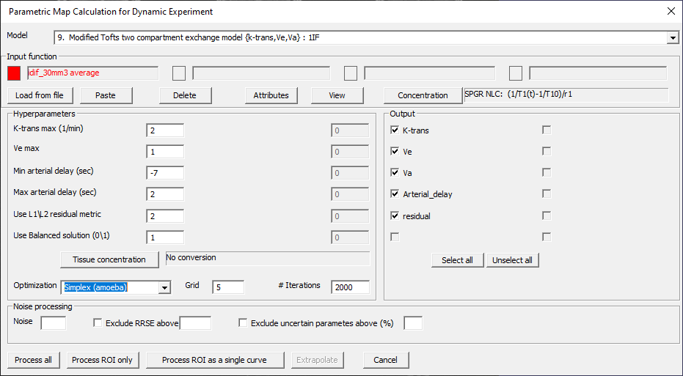

* 1. Generate the Ktrans map by clicking “Process ROI only”

1. Save FireVoxel document.
2. Save parametric maps as .nii files. Layer Control > (select layer) > Save Image > Save as type NIFTI (*.nii, etc.).

A few tips to ease use of Firevoxel

* Film view can be accessed by double clicking the right mouse button
* The layer control can be accessed by double clicking the left mouse button
* 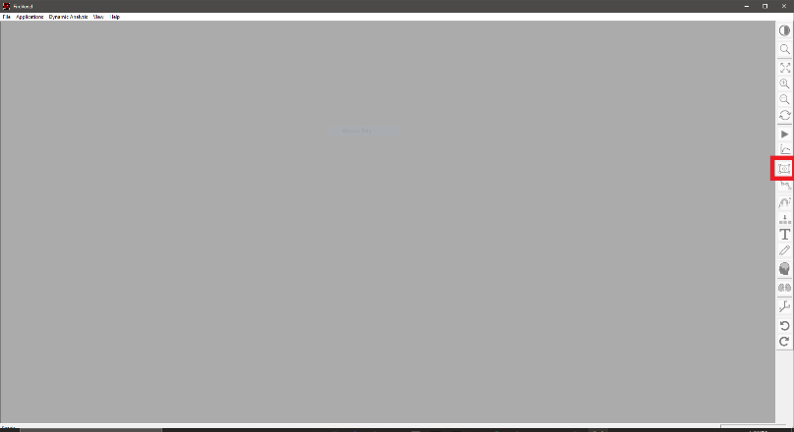A vector ROI (VROI) can be created by clicking the shortcut on the right sidebar (circled in red in the below screenshot)
* The active layer is the most recently selected on the layer control. To activate a specific layer, simply check the box next to the layer on the layer control. If the layer was priorly selected, by unchecking and then rechecking the layer, you have reactivated the layer

ImageJ/MRIcron Team SOP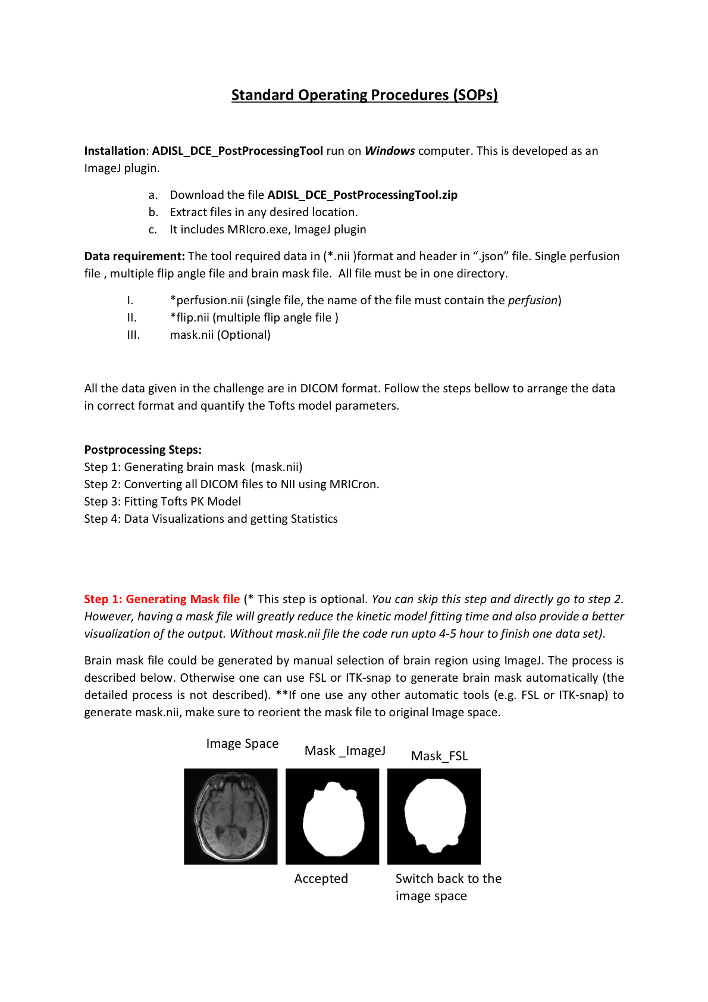

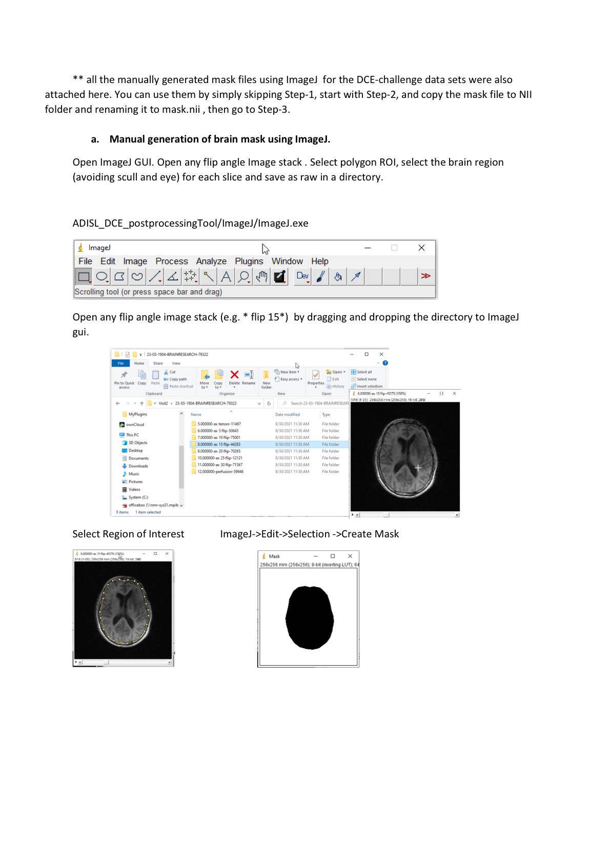

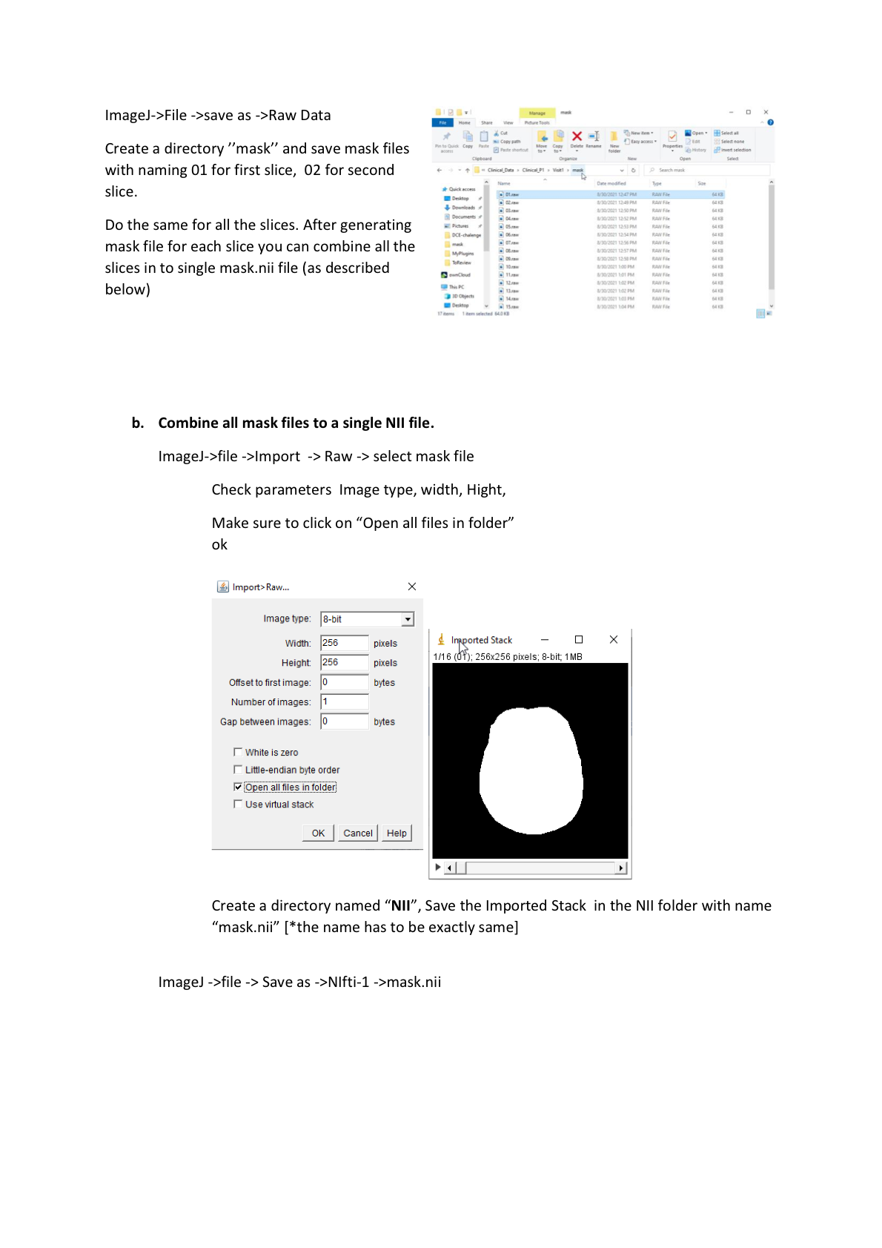

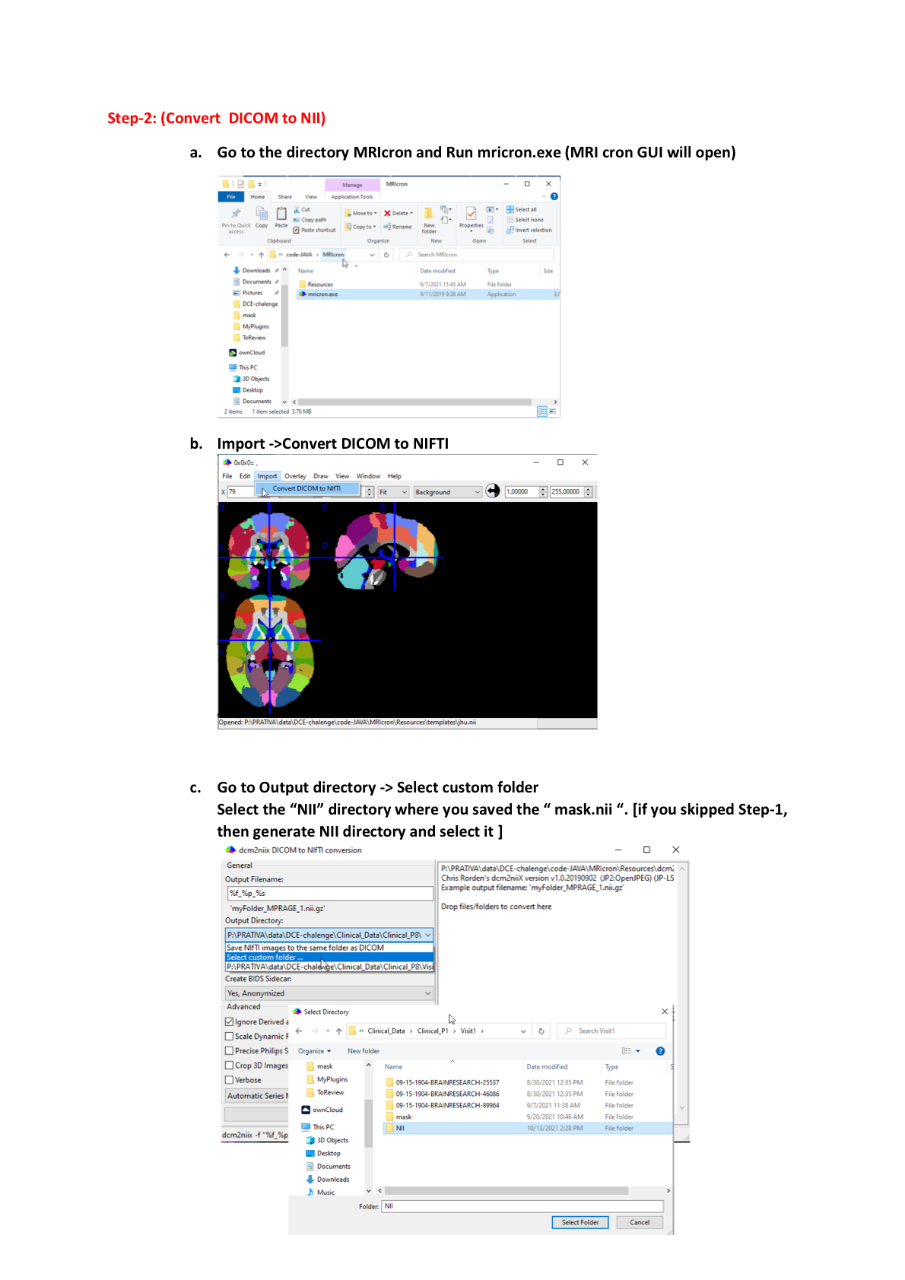

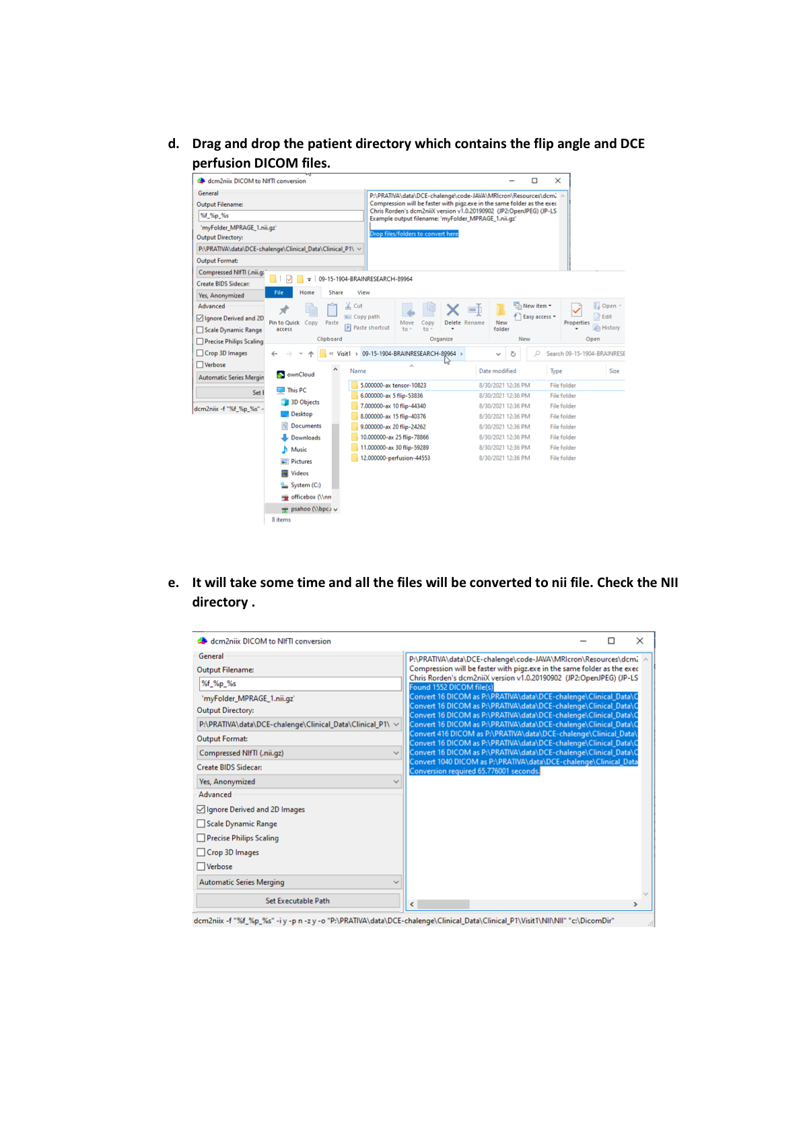

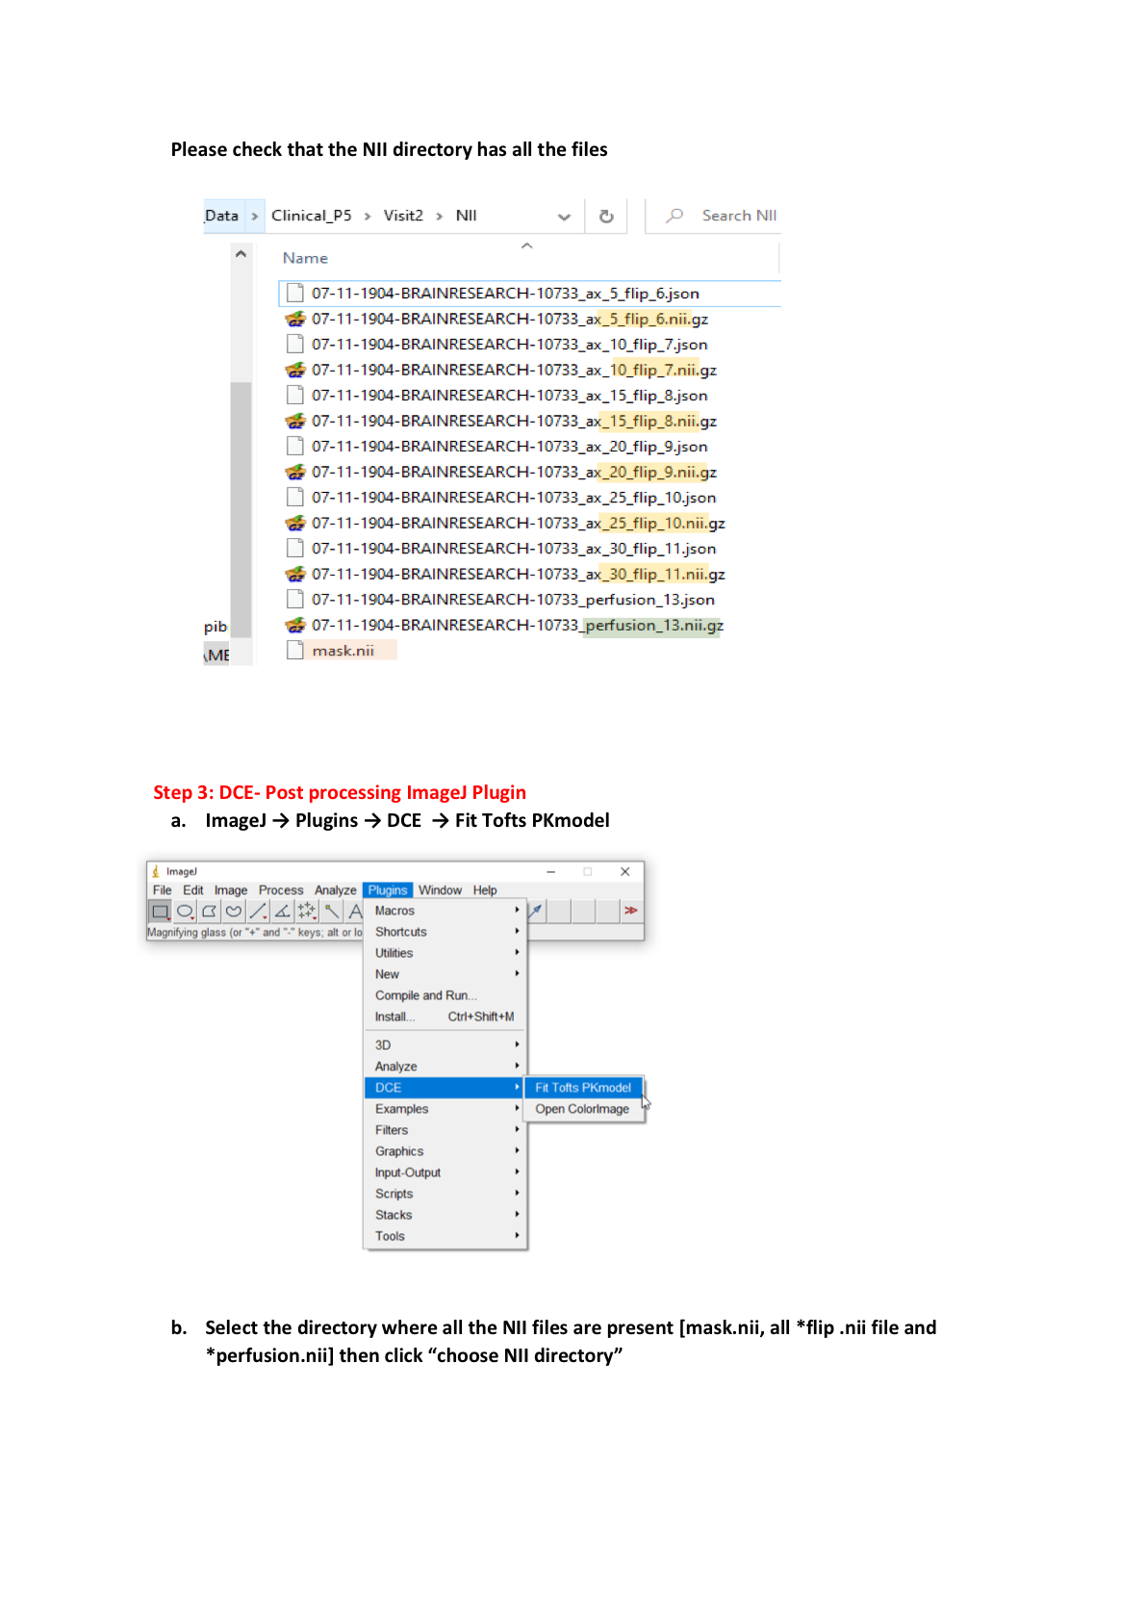

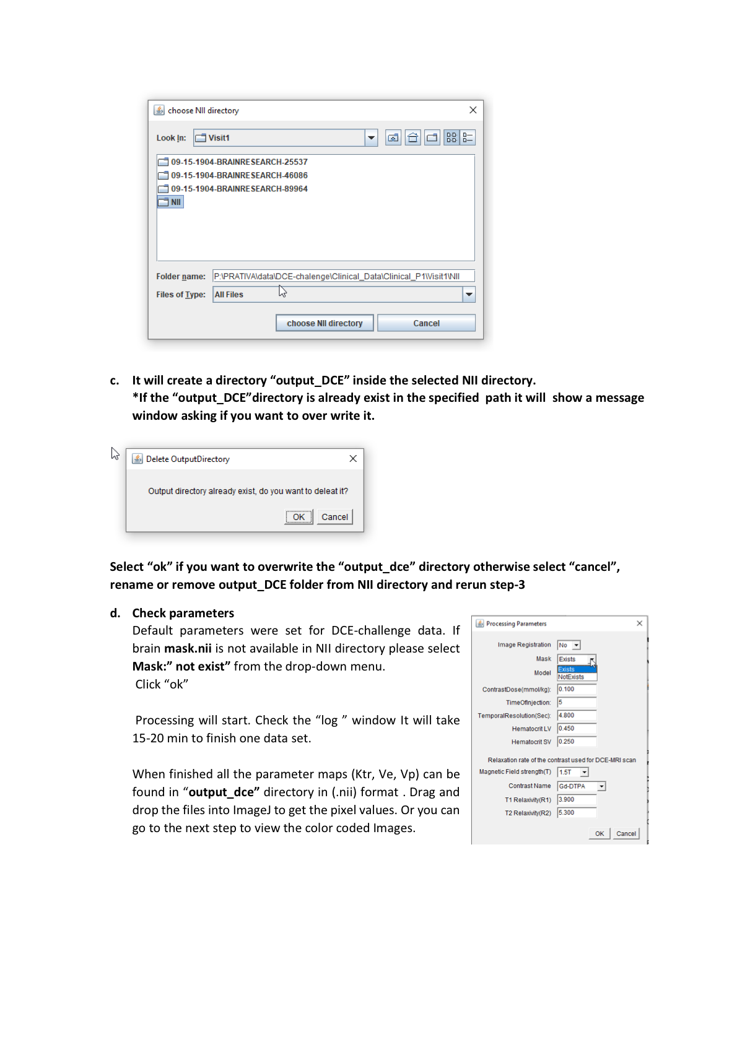

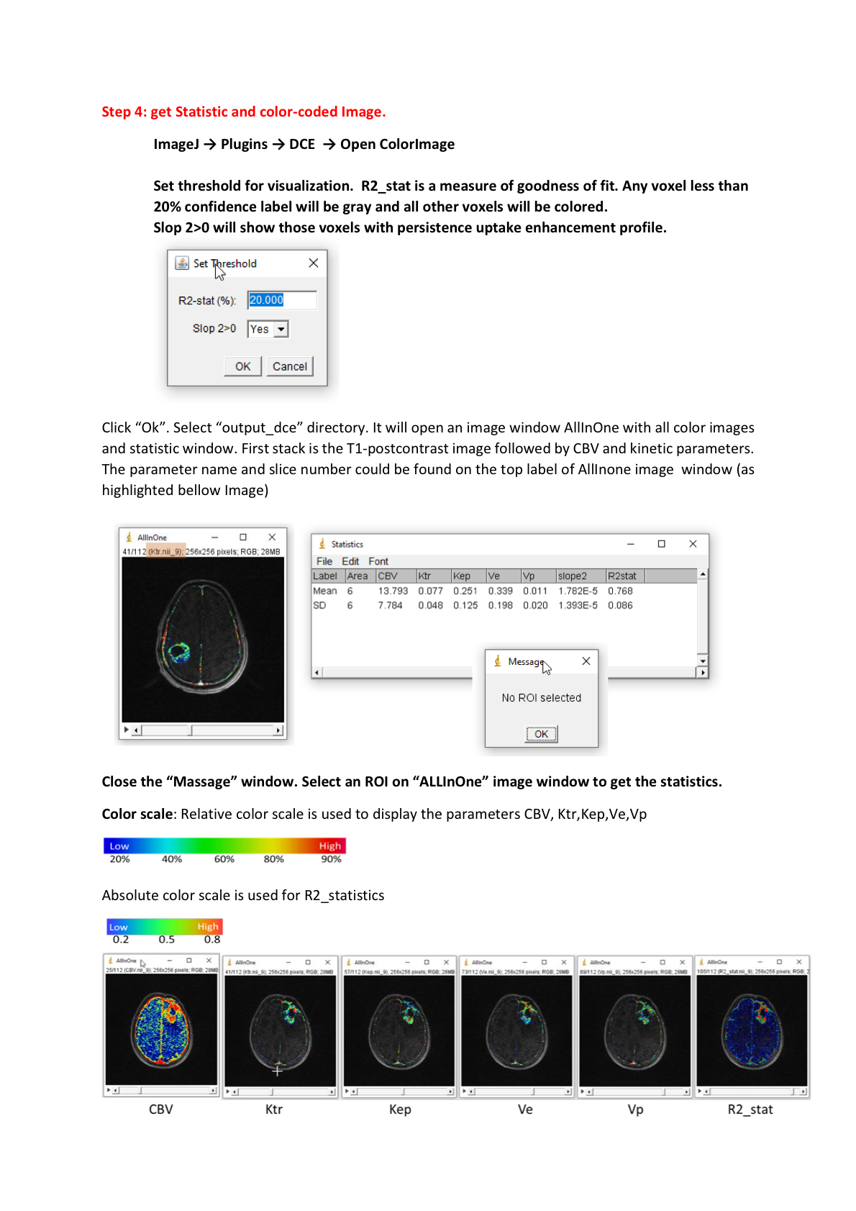

### OHSU Team SOP

Procedures

==========

Pre-Requisites

--------------

You will need a computer / virtual machine running Ubuntu 20.04 (other

recent Debian based distributions are likely to work too, but this is

not gauranteed). You will need administrator rights (at least access to

install packages with "apt"). The computer must have internet access

and at least 8GB of RAM.

If you have a pre-existing (not fresh) Linux install that already has

"pyenv" installed, make sure it is fully up-to-date and on the PATH.

Make sure all of the shell scripts in this directory have execute

permissions before continuing.

Installing

----------

Run the "install.sh" file in this directory, it will prompt for a

password to install some system packages.

You can manually run the two "apt" commands from this script with "sudo"

and then comment them out from the "install.sh" script if you are

uncomfortable passing your password into it.

Unpacking Data

--------------

Place the "osfstorage-archive.zip" file in this directory and then run the

"unpack_data.sh" script in this directory to unpack the data from the zip

archive into the required directory structure.

Processing Data

---------------

Run the "proc_all.sh" script to process all of the data.

### UW QBI Lab Team SOP

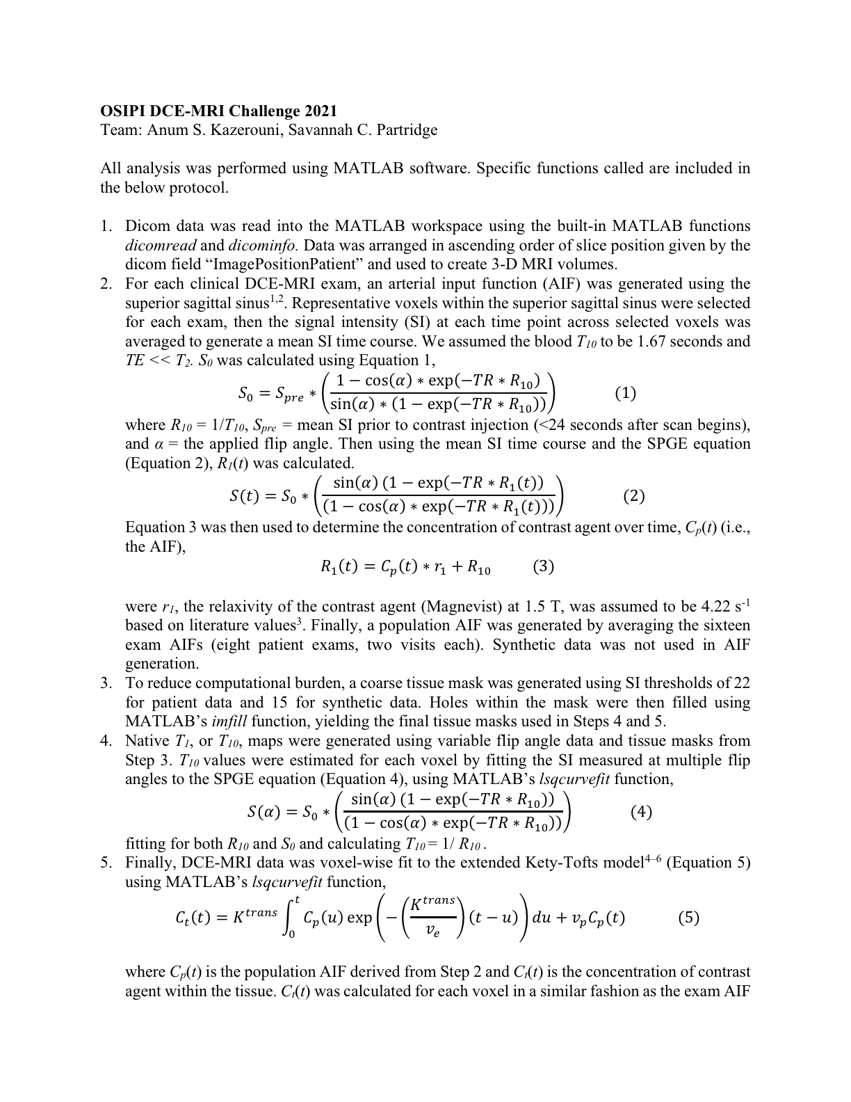

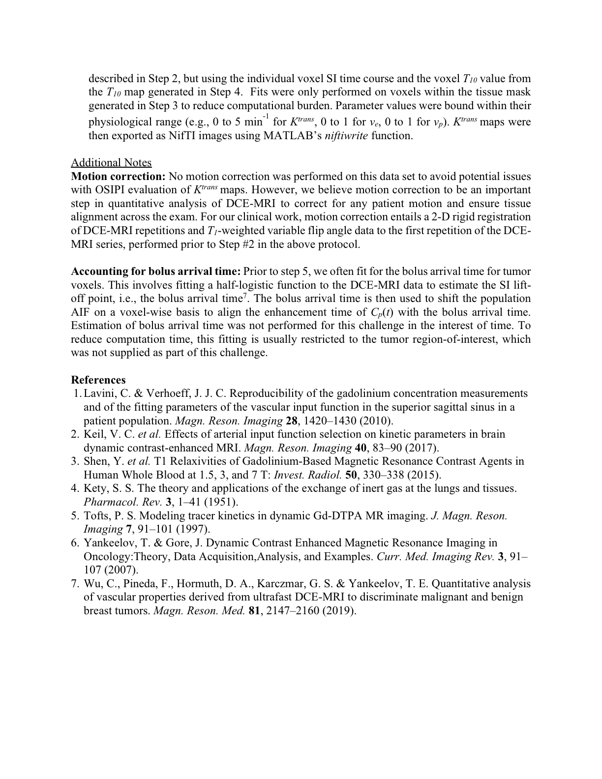

### ALICE Team SOP

**OSIPI-DCE Challenge**

Team leader’s name: Marianna Inglese

Team name: Alice

Affiliations: Department of Biomedicine and Prevention, University of Rome “Tor Vergata”, Italy; Department of Surgery and Cancer, Imperial College London, UK

**Standard Operating Procedures**

**Introduction**

Dynamic contrast-enhanced magnetic resonance imaging (DCE-MRI) is a non-invasive methodology that allows tissue perfusion and permeability to be quantified through analysis of T1-weighted MR images acquired before, during and after an intravenous (IV) injection of a gadolinium-based contrast agent (CA). Nowadays, DCE-MRI finds application in a wide range of oncological studies. The Tofts model, also known as the standard model, together with its extended version (EMT), is regularly applied in the analysis of brain tumours [1-6]. A few examples of the application of the shutter speed model (SSM) and its extended version (ESSM) in brain tumours are available in the literature [7, 8]. These four models assume that the CA passes readily between the intravascular compartment and the tissue interstitium. However, this assumption is not valid in the presence of the intact blood-brain barrier (BBB), where there is negligible leakage. In this case the CA will only affect the intravascular T1 value on first pass of the bolus. In addition, the vascular component of a brain tumour is heterogeneous and certain regions may not be perfused (e.g. necrotic regions).

The analysis of DCE-MRI data faces a few issues. Pharmacokinetic studies often show different and discordant results, thus bringing the reliability of this quantification technique into question [9, 10]. Data analysis is affected by (a) the acquisition protocol (trade-off between spatial and temporal resolution) [11] and (b) the quantification procedure. Furthermore, most studies present only results from the application of a single pharmacokinetic model and the consequent statistical analysis of averaged values evaluated over the whole tumour volume [12-14], both questionable choices given brain tumour heterogeneity.

The lack of standardized acquisition and analysis methods, and therefore repeatability and reproducibility, in quantification of Ktrans from DCE-MRI hampers its application in clinical practice, multi-institutional studies, or clinical trials. The Open-Science Initiative for Perfusion Imaging (OSIPI) challenges research teams to provide a reliable and reproducible method to analyse brain DCE-MRI data to be implemented into a clinical tool and translated into clinical practice.

We propose a method to identify reliable DCE-MRI data based on a **model selection** procedure, building on one of our previous works where five different pharmacokinetic models (TM, ETM, SSM, ESSM and NEM) were assessed and compared, at a voxel level, with the Akaike information criteria index [15]. Following our published results, we here decided to implement a simplified version of the original method. We decided not to consider the extended shutter speed model which, in our previous work, was selected as the model of choice by < 0.1% of voxels, indicating that a model with a lower number of parameters performs better in the description of brain tumours. As a result, each voxel of our resulting 3D parametric map (e.g., the Ktrans) derives from the model selection procedure. For this reason, it contains the information given by the pharmacokinetic model which resulted to be the most accurate for the description of that specific brain voxel.

**The method**

Before the application of any pharmacokinetic model, we calculated the relaxation rate at baseline (R10) and relaxed signal (M0) as 3D maps, with the Ernst formula (assuming TE<<T2*) using the set of SPGRE pre contrast images acquired at different flip angles [16]:

$S\left(α\right)=M_{0} sin\left(α\right)\frac{1-e^{-R_{10}T_{R}}}{1-cos⁡(α)e^{-R_{10}T_{R}}}$ (1)

where α is the flip angle having values [5, 10, 15, 20, 25, 30] and TR is 3.80 ms. Reformulating equation 1 as a linear regression system (y = cx + d) following the method described by Liberman et al. in [17], gives:

$\frac{S(α)}{\sin{(α)}}=E\frac{S(α)}{\tan{(α)}}+M(1-E)$ (2)

where $E=e^{-R_{10}T_{R}}$. The slope *c = E* and intercept *d = M0 (1 - E)* can thus be estimated and continuing from [17], R10 and M0 can then be obtained through:

$R_{10}= -\frac{log⁡(c)}{T_{R}}$, $M_{0}=\frac{d}{1-c}$ (3)

Then, 4D (x, y, z, t) post-injection longitudinal relaxation rate R1(t) maps for each dynamic phase are calculated using signal intensity data from the post contrast dynamic series:

$R_{1}\left(t\right)= -(1/{T_{R}})log\frac{1-(A+B)}{1-cos⁡(α)(A+B)}$ (4)

where α = 25, $A={S\left(t\right)-S(0)}/{M_{0}sin⁡(α)}$, $B= {(1-E)}/{1-E ∙cos⁡(α)}$. S(0) and S(t) are the pre contrast injection signal intensity and the signal at the dynamic phase t respectively [18].

The longitudinal relaxation rate is determined in order to calculate the concentration of the contrast agent. This is done through a calibration between the concentration of contrast agent [CA] and the measured H2O MR signal. This can be modelled by either a linear or nonlinear relationship as described below.

*The Tofts Model*: DCE-MRI data were fitted with the Tofts model assuming a linear dependence of R1 on [CA] (that is the equivalent of assuming the equilibrium transcytolemmal water exchange kinetics in the fast exchange limit (FXL)):

$R_{1}\left(t\right)= r_{1}\left[CA\left(t\right)\right]+R_{10}$ (5)

where r1 is the CA relaxivity. The extravasation of the contrast from the plasma to the EES was accounted by the Kety-Schmidt rate law [19]:

$\left[{CA}_{o}\left(T\right)\right]=K^{trans}\int_{0}^{t}{[{CA}_{p}\left(t\right)]e^{\frac{K^{trans}(T-t)}{v_{e}}}dt}$ (6)

where Ktrans is the first order rate constant for plasma to interstitium CA transport (min-1) and ve is a measure of the EES volume fraction. The ratio between Ktrans and ve results in the third pharmacokinetic parameter kep, which is the back flux rate constant (min-1). [CA0] and [CAp] are the concentration of CA in the 'outside' space (the extravascular extracellular space) and in the plasma respectively. [CAp] is also called the arterial input function (AIF). The fitting of equation 6 was performed using the inbuilt MATLAB *fminsearch* function, which uses the Nelder-Mead simplex algorithm as described in Lagarias et al. [20]. The minimization procedure is done voxel-wise in order to obtain a 3D map for each pharmacokinetic parameter. We set input values of 0.1 and 0.01 for the Ktrans and ve, respectively, and run the algorithm with 10,000 iterations and a tolerance of 10-8. The fitting procedure was also carried out with the user developed MATLAB function *fminsearchbnd* [21]. This function takes into consideration boundaries in the output values settings, which were set so as to consider only positive values [0, ∞]. A comparison between the two functions’ results was done in terms of goodness of fit by estimating the Akaike Information Criteria (AIC) for each method:

$AIC=2k+nln\left(\frac{RSS}{n}\right)+\frac{2k\left(k+1\right)}{n-k-1}$ (7)

where *n* is the number of data points, *k* the number of fitted parameters and RSS is the residual sum of squares [22].

In general, when performing model selection using the AIC, the model resulting with the lowest AIC value is the model that represents the best balance between complexity (i.e., the number of parameters) and goodness of fit (i.e., lower RSS). In this case, as the number of parameters is the same, only the goodness of fit is being tested.

*The Shutter Speed Model*: In the SSM, equation 5 is applied to the distribution of the CA in the blood, without assuming that the equilibrium transcytolemmal water exchange kinetics is in the FXL. The longitudinal relaxation rate is measured as:

$R_{1b}\left(t\right)= r_{1p}\left(1-h\right)\left[{CA}_{p}\left(t\right)\right]+R_{10p}$ (8)

where *b* stands for the whole blood, *p* for the plasma and *h* the blood haematocrit. However, about half of the water in the blood is intracellular and cannot be accessed directly by the CA molecules [23]. The transport outside the erythrocytes therefore needs to be considered, as described by the two equilibria:

H2Oi ↔ H2Op (9)

H2Op+ CAp↔H2O∙CAp (10)

The mean water molecule lifetime in common CA is normally < 10-7 s, and the linear equation 5 is suitable for homogeneous solutions. In the case of erythrocytes, equation 10 is also considered fast for some commonly measured [CAp] values [23, 24]. After extravasation, the CA is commonly distributed into the interstitial extracellular space, at a rate defined by:

$R_{1}^{*}\left(t\right)= r_{10}p_{0}\left[{CA}_{0}\left(t\right)\right]+R_{10}$ (11)

where R1*(t) is the rate constant of the extravascular water signal, r10 is the interstitial CA relaxivity and p0 is the fraction of the extracellular tissue water. The application of equation 11 to biological tissues assumes that the interstitium is a homogeneous solution and that the system remains in the fast exchange limit. However, many studies have shown that, even though the equilibrium in equation 10 is fast, the FXL assumption is not true for all [CA0] values following a bolus injection [23]. [CA0] depends on the dimensions of the parenchymal cells that are generally much larger than erythrocytes and have a less water-permeable cytolemmae. Furthermore, tissue parenchyma cannot be considered as a single homogeneous solution and a single MRI voxel will constitute a number of compartments. The main result of this compartmentalization is given by:

$R_{1L}\left(t\right)=\left(1/2\right)\left\{2R_{1i}+ r_{1o}\left[{CA}_{o}\left(t\right)\right]+{{(R}_{10}+R_{1i}+ 1/{τ_{i}})}/{p_{o}-\{(2/{τ_{i}-r_{1o}\left[{CA}_{o}\left(t\right)\right]- }}{{(R}_{10}+R_{1i}+ 1/{τ_{i}})}/{p_{o}})^{2}+{4\left(1-p_{o}\right)}/{τ_{i}^{2}p_{o}}]^{\frac{1}{2}}\right\}$ (12)

where R1L(t) is the long relaxation rate constant of the *shutter speed model*. R1i is the H2O rate constant in the absence of exchange of CA and τi is the average intracellular lifetime of a water molecule. The SSM was fitted by substituting equation 12 in equation 6 using the MATLAB functions *fminsearch* and *fminsearchbnd*, similarly to the TM. The initial estimates for the SSM Ktransandve where taken as the outputs of the TM, while the initial estimate for τi was set at 0.1 [25]. The final Ktrans, kep, ve, and τi maps were obtained from the fitting procedure with the best fit (lowest AIC value).

*The Extended Tofts Model*: While the TM assumes a negligible volume for the plasma compartment, the fractional plasma volume vp is introduced in the ETM. This model is able to distinguish the effects due to contrast leakage from those due to intravascular contrast. Equation 6 becomes:

$\left[{CA}_{o}\right]\left(T\right)= v_{p}C_{p}\left(t\right)+ K^{trans}\int_{0}^{T}{C_{p}(t)}e^{-K^{trans}(T-t)/v_{e}}dt$ (13)

The ETM was fitted by substituting equation 13 in equation 6 using the MATLAB functions *fminsearch* and *fminsearchbnd*, similarly to the TM and SSM. The initial estimates for ETM Ktransandve were again taken from the output of the TM and the initial estimate for vp was set at 0.01 [25]. The final Ktrans, kep, ve, and vp maps were obtained from the fitting procedure with the best fit (lowest AIC).

*No-exchange model*: The no-exchange model describes the case where the concentration of the CA in a voxel is so low that there is no permeability or vascular filling. In this situation, the MR signal is assumed to be unperturbed by the injection of the gadolinium-based CA and, as a consequence, the longitudinal relaxation rate does not change from its baseline value (R10). The system is therefore described by this value at all times such that the data is fitted by the constant R10.

*Arterial Input Function (AIF):* The calculation of the image derived AIF requires an additional ROI to be drawn around a vessel (e.g., the external carotid artery). Signal-intensity curves were converted to R1-time curves by using the baseline signal intensity before the first pass of the CA as a reference [26], setting the haematocrit in the blood to 0.45, and getting the baseline blood T1 from the T10 map (equation 8).

*Model comparison*: A model comparison was carried out using the AIC to test for the best model in a given voxel. In particular, in the presence of exchange (where the NEM fails in the description of data), a voxel-wise comparison between models was carried out (with ETM and SSM being an extension of the TM) to indicate which model provided the best fit using the AIC in each voxel. The selection method is shown in the flowchart in Figure 1.

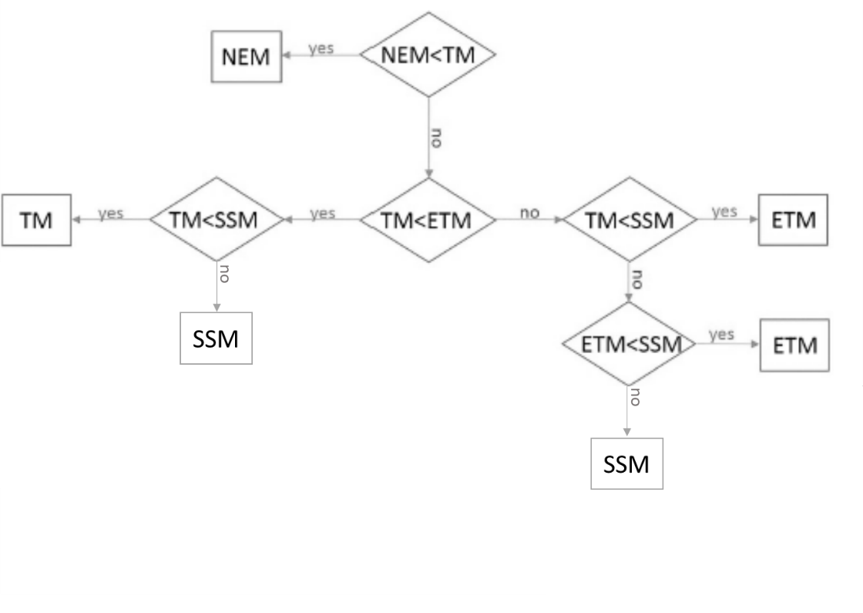

***Figure 1****: AIC model selection flowchart. The figure shows the hierarchical approach used to determine which model provided the best fit when using the Akaike Information Criteria (AIC). NEM is the non-exchange model, TM, ETM and SSM are the Tofts, extended Tofts and shutter-speed models, respectively*.

**The OSIPI-challenge**

The OSIPI clinical dataset includes a set of repeat DCE-MRI and T1-mapping scans from 8 patients with brain tumours. They have been acquired on a 1.5T scanner at two scan dates, typically a few days apart, and they have been selected from the RIDER Neuro MRI database [27, 28]. The OSIPI synthetic dataset includes two synthetic patient DCE-MRI datasets, derived from RIDER subjects in order to produce ground truth data that mimic actual data [27].

After a pre-processing step which included files conversions and coregistration, DCE-MRI data have been post-processed following the methods described in the previous section. The study workflow is shown in Figure 2.

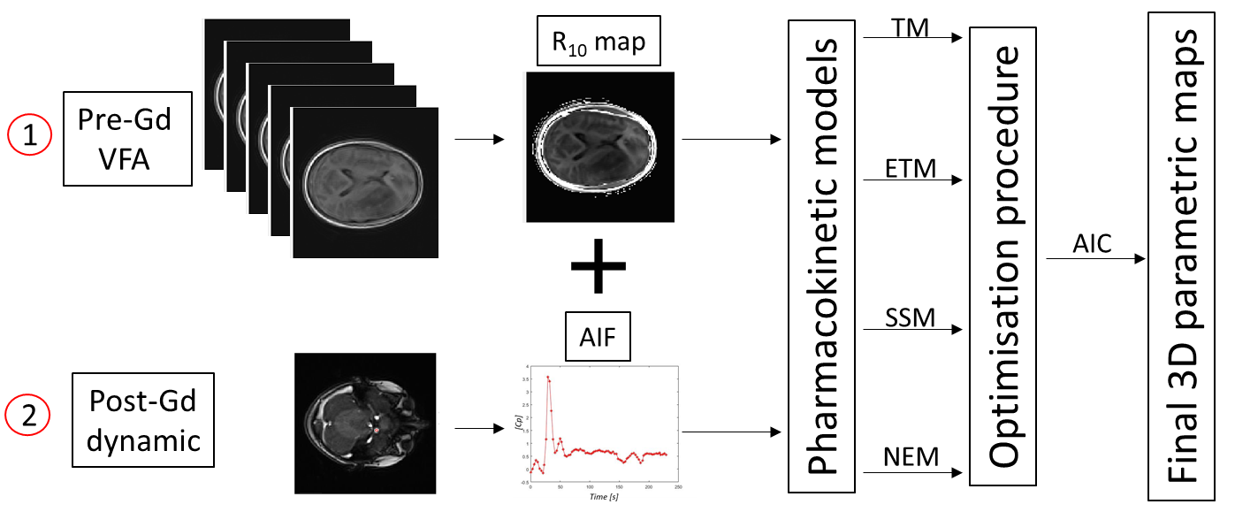

***Figure 2****: Study Workflow. DCE-MRI data were fitted using four pharmacokinetic models after the calculation of the R10 map and the extraction of an image derived arterial input function from the pre- and post-contrast injection sequences, respectively. For each patient, final 3D parametric maps were obtained as a result of an optimisation procedure which compared, at the voxel level, the goodness of fit of each model.*

**Step-by-step guide**

The software required for the analysis of the OSIPI challenge dataset are:

1. MATLAB (Mathworks, R2019b). A trial version is available at: <https://uk.mathworks.com/campaigns/products/trials.html>
2. FSL, an open software available at: <https://fsl.fmrib.ox.ac.uk/fsl/fslwiki/FslInstallation>

The required steps are:

1. Pre-processing: Conversion of DICOM files to NIFTI/ Volumes coregistration

Open MATLAB and add the provided Matlab_Packages folder to the path.

Type in the command window:

*osipi_script1*

and press enter.

This will open a pop-up window where the user will be asked to select the directory where the DCE-MRI DICOM files to be converted are. In detail, this MATLAB function converts the pre- and post-contrast injection MRI sequences to NIFTIs (for convenience) and uses the SPM8 “Coregister and Reslice” tool to coregister those volumes.

During this first step, the MATLAB function will also save an image that could be eventually used for brain extraction. This image is the result of the average of the coregistered VFA images. It will be called “VFAmean.nii” and will be stored as NIFTI file in the selected folder.

1. The background removal (optional)

The brain extraction has been included in the original analysis to reduce the computational load and time by removing the background. The brain extraction is performed in FSL:

* Run FSL
* Press on “BET brain extraction”
* Choose as input image the “VFAmean.nii” file (output of the osipi_script1)
* Set the Fractional Intensity threshold to 0.3
* Press on “Advanced options” and select first and second output options (output brain extracted image, output binary brain mask image)
* Press “Go”

This will automatically save in the input folder the two files selected in the “Advanced Options”.

1. Pharmacokinetic analysis

The pharmacokinetic analysis will be applied on the masked image, if the BET has been run, or on the entire volume.

In the MATLAB Command Window, type:

*osipi_script2*

and press enter.

The user will be asked to select again the folder where the NIFTI files are. After that, a pop-up window will show an image where the user will be asked to choose a good slice for the selection of the image derived arterial input function (and to type it in the Command Window). Once the slice is selected, the last pop-up window will show up and the user will be asked to draw a ROI in the chosen vessel (single click to draw, double click to stop).

This second MATLAB function will save the 3D map of the Ktrans in the selected folder. As a default, similarly to a convention used in the Siemens Syngo.via tool, Ktrans maps are multiplied by a factor of 1000 and then saved to NIFTI. The pharmacokinetic analysis of the entire brain will require a few hours.

**References**

1. Haris, M., et al., *Differentiation of infective from neoplastic brain lesions by dynamic contrast-enhanced MRI.* Neuroradiology, 2008. **50**(6): p. 531.

2. Jia, Z., et al., *Quantitative analysis of neovascular permeability in glioma by dynamic contrast-enhanced MR imaging.* Journal of Clinical Neuroscience, 2012. **19**(6): p. 820-823.

3. Bagher-Ebadian, H., et al., *Model selection for DCE-T1 studies in glioblastoma.* Magn Reson Med, 2012. **68**(1): p. 241-51.

4. Ferl, G.Z., et al., *An automated method for nonparametric kinetic analysis of clinical DCE-MRI data: Application to glioblastoma treated with bevacizumab.* Magnetic Resonance in Medicine, 2010. **63**(5): p. 1366-1375.

5. Zhu, X.P., et al., *Quantification of endothelial permeability, leakage space, and blood volume in brain tumors using combined T1 and T2* contrast-enhanced dynamic MR imaging.* J Magn Reson Imaging, 2000. **11**(6): p. 575-85.

6. O'Connor, J.P.B., et al., *DCE-MRI biomarkers in the clinical evaluation of antiangiogenic and vascular disrupting agents.* British Journal of Cancer, 2007. **96**(2): p. 189-195.

7. Rooney, W.D., et al., *Mapping human brain capillary water lifetime: high-resolution metabolic neuroimaging.* NMR in Biomedicine, 2015. **28**(6): p. 607-623.

8. Li, X., et al., *Dynamic-contrast-enhanced-MRI with extravasating contrast reagent: Rat cerebral glioma blood volume determination.* Journal of Magnetic Resonance, 2010. **206**(2): p. 190-199.

9. Liang, J., et al., *Diagnostic Values of DCE-MRI and DSC-MRI for Differentiation Between High-grade and Low-grade Gliomas: A Comprehensive Meta-analysis.* Acad Radiol, 2018. **25**(3): p. 338-348.

10. Kim, H., *Variability in Quantitative DCE-MRI: Sources and Solutions.* J Nat Sci, 2018. **4**(1).

11. Guo, Y., et al., *High-resolution whole-brain DCE-MRI using constrained reconstruction: Prospective clinical evaluation in brain tumor patients.* Medical physics, 2016. **43**(5): p. 2013-2013.

12. Fahlström, M., et al., *Dynamic contrast-enhanced magnetic resonance imaging may act as a biomarker for vascular damage in normal appearing brain tissue after radiotherapy in patients with glioblastoma.* Acta Radiologica Open, 2018. **7**(11): p. 2058460118808811.

13. Little, R.A., et al., *Evaluation of dynamic contrast-enhanced MRI biomarkers for stratified cancer medicine: How do permeability and perfusion vary between human tumours?* Magnetic Resonance Imaging, 2018. **46**: p. 98-105.

14. Jiang, J.S., et al., *Quantitative Assessment of Tumor Cell Proliferation in Brain Gliomas with Dynamic Contrast-Enhanced MRI.* Academic Radiology, 2019. **26**(9): p. 1215-1221.

15. Inglese, M., et al., *Reliability of dynamic contrast-enhanced magnetic resonance imaging data in primary brain tumours: a comparison of Tofts and shutter speed models.* Neuroradiology, 2019. **61**(12): p. 1375-1386.

16. Yuan, J., et al., *Quantitative evaluation of dual-flip-angle T1 mapping on DCE-MRI kinetic parameter estimation in head and neck.* Quant Imaging Med Surg, 2012. **2**(4): p. 245-53.

17. Liberman, G., Y. Louzoun, and D. Ben Bashat, *T(1) mapping using variable flip angle SPGR data with flip angle correction.* J Magn Reson Imaging, 2014. **40**(1): p. 171-80.

18. Li, K.L., et al., *Improved 3D quantitative mapping of blood volume and endothelial permeability in brain tumors.* J Magn Reson Imaging, 2000. **12**(2): p. 347-57.

19. Kety, S.S., *Observations on the validity of a two compartmental model of the cerebral circulation.* Acta Neurol Scand Suppl, 1965. **14**: p. 85-7.

20. Lagarias, J.C., et al., *Convergence properties of the Nelder--Mead simplex method in low dimensions.* SIAM Journal on optimization, 1998. **9**(1): p. 112-147.

21. D'Errico, J., *fminsearchbnd*. 2012: MathWorks File Exchange.

22. Akaike, H., *A new look at the statistical model identification.* IEEE transactions on automatic control, 1974. **19**(6): p. 716-723.

23. Landis, C.S., et al., *Equilibrium transcytolemmal water-exchange kinetics in skeletal muscle in vivo.* Magn Reson Med, 1999. **42**(3): p. 467-78.

24. Donahue, K.M., et al., *Studies of Gd-DTPA relaxivity and proton exchange rates in tissue.* Magn Reson Med, 1994. **32**(1): p. 66-76.

25. Li, X., W.D. Rooney, and C.S. Springer, Jr., *A unified magnetic resonance imaging pharmacokinetic theory: intravascular and extracellular contrast reagents.* Magn Reson Med, 2005. **54**(6): p. 1351-9.

26. Buckley, D.L., et al., *Prostate cancer: evaluation of vascular characteristics with dynamic contrast-enhanced T1-weighted MR imaging--initial experience.* Radiology, 2004. **233**(3): p. 709-15.

27. Barboriak, D., *Data From RIDER_NEURO_MRI. The Cancer Imaging Archive.* 2015.

28. Clark, K., et al., *The Cancer Imaging Archive (TCIA): maintaining and operating a public information repository.* Journal of digital imaging, 2013. **26**(6): p. 1045-1057.